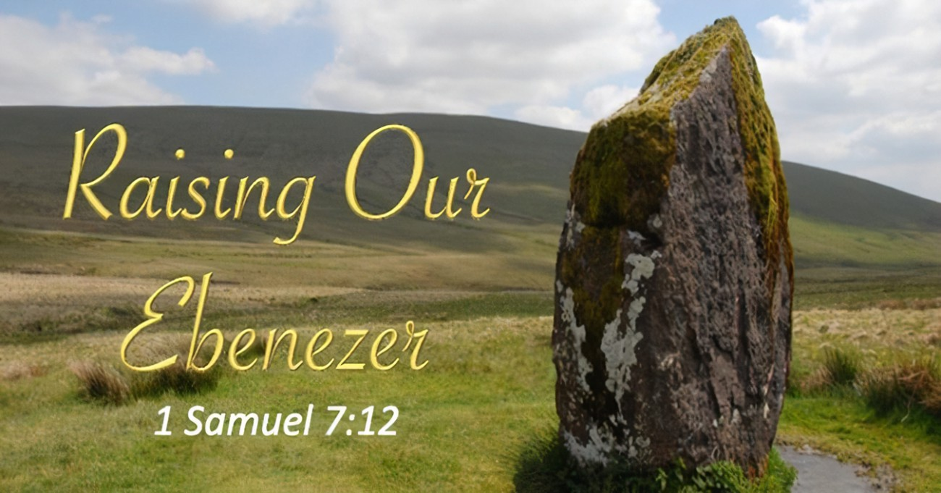

May 8, 2022

4th Sunday in Easter

Carson City United Methodist Church

10:30 am

Greeting/Announcements

Call to Worship
(Standing in unison)

We welcome you here today, LORD. We are your people, part of your body, to proclaim that you are the King of Kings, Lord of Lords and the only true and living God...Creator of the universe. You offer us salvation, forgiveness, grace, mercy, guidance, protection, healing and so much more! We stand in awe of your unconditional love for us. We offer
our love to you through singing, giving, prayer and the reading of your Living Word. We join the heavenly choir in singing how great you are.

Hymn: How Great Thou Art UMH pg. 77

Opening Prayer

We ask that you would wash over us with forgiveness and fill us again with your spirit.

Open our eyes, ears and hearts to a deeper understanding of your WORD and give us a hunger for it. Touch each one of us at our point of need today, Lord, with your healing.

Make us more aware of your presence in our singing, in the reading of your word, in our prayers and in our fellowship with one another. You are eternally faithful to us. Help us to be faithful in our love for you and in the things you've called us to do.

Hymn: Great is Thy Faithfulness UMH pg. 140

Offering
Doxology UMH 95
Sharing of our Joys and Concerns

Message: Raising Our Ebenezer

Ebenezer- “stone of help” (in our lives it symbolizes at least 3 things)

1.Reminder to be dependent on God's help before doing anything on our own.

2.Reminder of the consequences of unfaithfulness and blessings of obedience.

3.Reminder to thank and praise God for all the ways He takes care of us.

For what can you raise an ebenezer to God as a reminder of His unfailing help and love?

Scriptures used today:

I Samuel 4-7

Dependence on God - Galatians 2:20, John 5:19; 15:5

Consequences – Galatians 6:7-8, Proverbs 14:12, Matthew 6:33

Thanksgiving & praise – Psalms 8:2, 9:1-3, 22:3, 149:6-9; Romans 4:20

Closing Song: The Goodness of God
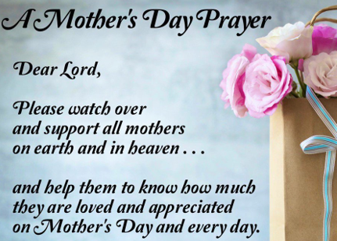

CCUMC – Announcements & Upcoming Events:
==========================================
As a courtesy to others please silence
or shut off cellphones
==========================================
United Women of Faith (UWF, formerly UMW): Salad Potluck, Mon, May 9th, 5:30 pm. Everyone is welcome to come learn about the Lutheran Quilt Project and what UWF is all about. Bring own table service and a salad to share. Drinks provided. For questions, call WalthaGaye at 989-640-0238.
==========================================
VBS meeting: Tues, May 10 @ 6:00 pm.
==========================================
Frontier Days Picnic Lunch: Mark your calendar for
Sat, June 4th 11:00 am to 1:00 pm. More details coming soon.
==========================================
LAST DAY REMINDERS BEFORE FOR SUMMER
Cool Hour & Children’s Church:
Last day for these two is Sun, May 15th,
which will also be Celebration Sunday.

ARK:
Last meeting is Wed, May 18th

Women’s Group:
Last meeting is Sun, May 29th

Serving & Supporting Sunday Worship
Audio/Video: Pat Monroe
Children’s Ministry Audio/Video: Colin Fitzpatrick

Joys, Concerns & Prayer Request
For those battling cancers:
Jim Dunlap, Carolyn Nykerk, Ray Seaman,
Dillan Abell, Andrew Hogan,
Amorena Newman-Wojciakowski

For all who needs support, guidance or has health concerns.

Monthly Giving
5/1 $4306.02

Nursery Schedule
5/1 & 5/8 Maryann Severson 5/15 Chris Benjamin
5/22 Jenna Benjamin 5/29 Alex Krantz

Lighting of Candles

Passing of Collections Plate

Children’s Church

Our Church in Ministry This Week
Sun: Women’s Group 6:30-8 pm
Mon: PT Class 6:30-8 pm
Tue & Thu: COA Meal @ Noon
Sat: Euchre 5:00 pm

Coloring Page

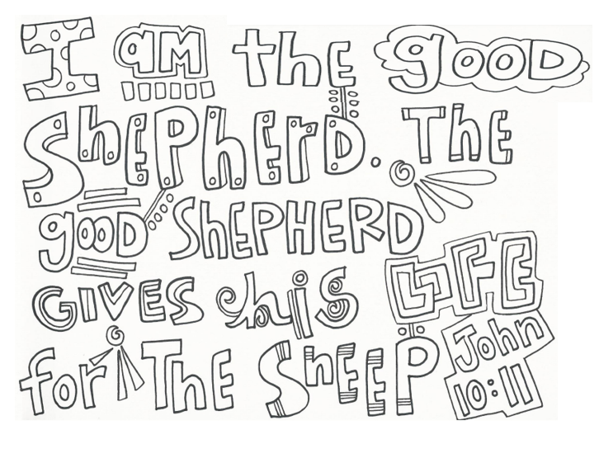

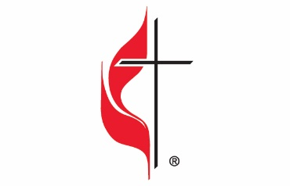

Carson City United Methodist Church
Location: 119 East Elm St., Carson City, MI
Mail: PO Box 298, Carson City, MI 48811
Phone: 989-584-3797 Email: carsoncityumc@gmail.com
Website: carsoncityumc.com
Sunday Worship Service: 10:30 am
Office Hours: Monday-Thursday, 9:00 am-12:00 pm
After hours by appointment
Pastor: Ian McDonald 906-322-5318
Secretary: Bonnie Seaman 989-763-1674

Weekly Sunday Bulletin now available on our website
@ www.carsoncityumc.com

“Father, help me to trust You and have a steadfast mind. Thank You for the perfect peace that comes
to me when I choose to trust You”

