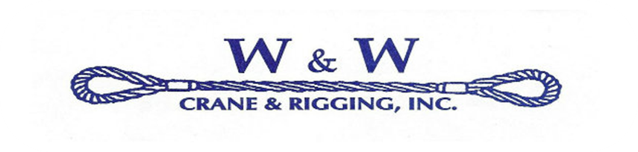
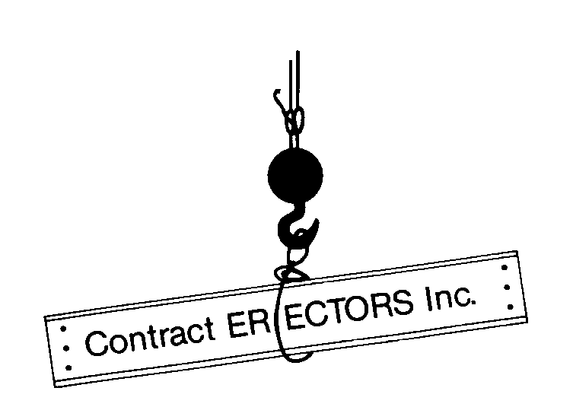

W & W Crane and Rigging, Inc. Receive
Women’s Business Enterprise Certification (WBE)

Randleman, N.C. — January 26, 2015

Amy Wall Mong, Owner and President of W & W Crane and Rigging, Inc., announced today that the company has achieved Women’s Business Enterprise (WBE) Certification by the North Carolina Department of Administration Office for Historically Underutilized Businesses.

Amy Mong stated, “Along with our sister company, Contract Erectors, Inc., and their support with man-power, equipment, and management, W & W Crane & Rigging aims to enhance our rental fleet, millwright work, and specialized rigging operations, while furthering our company’s diversification efforts into the field of Structural Steel Erection”.

The certification process closely examines every financial, administrative, and organizational detail of the company. Furthermore, certifying the legitimacy of the corporation while ensuring that the active and primary female owner controls the daily and long term efforts of the company.

In addition to her position with W & W Crane & Rigging, Amy is also serving on the Board of the Piedmont Chapter of NAWIC, The National Association of Women in Construction, a network for professional women in the field of construction.

About W & W Crane and Rigging, Inc.:
W & W Crane and Rigging has been serving North Carolina for over 15 years, offering rental cranes from 35 to 120 tons, up to 275 foot reach, with Certified Crane Operators and Rigging Specialists. We specialize in lifting Modular Homes, HVAC Units, Heavy Equipment, Electrical Maintenance, and more. Along with our sister company, Contract Erectors, Inc., who has been in business for over 25 years specializing in Structural Steel Erection in the Southeast and with their AISC Advance Certified Erection Certification, membership in the Steel Erectors Association of America, and highly skilled work force, W & W Crane will be able to meet any customers’ needs competitively, safely, and on schedule.

www.contracterectors.com www.wandwcrane.com

6944 Violet Ridge Rd Randleman, NC 27317 ● (o)336-674-8012 ● (f)336-674-1837

