Pleasant Township Board of Trustees Meeting
Date __February 14, 2023 Next Resolution No.__ 16-----02-14-2023_______

- Call to Order -- The meeting tonight will also be on WebEx.
- Please stand for moment of silence. --Pledge of Allegiance-----Roll Call (Paula not here due to illness)
- Minutes to approve- none
- Financial Reports – Motion to pay expenditures.
- Visitors –
- Hanna Poling with the Southwest Messenger via WebEx.
- Department Reports
- Franklin County Sheriff’s Report- Deputy Hamilton will not be attending tonight
  - Total calls for service for 1-31-23 to 2-14-23 were _123__
  - Total reports – 7
  - Arrest – 0
  - Tickets-2
  - Burglary/B & E- 0
  - Thefts – 1 for stolen gates, still under investigation.
  - Accidents – 13
  - Suspicious Activity –3
  - Alarm Drops –4
  - Traffic Stops –15
  - Disabled vehicles –4
- Road Department- Rick Haag in for Robert Bausch, Superintendent
  - Wind damage.
  - Filling potholes
  - Truck 21 at E.L.W.
  - 1 burial
- Fire Dept. – Fire Chief, David Whiting
New Medic
- Submitted paperwork for reimbursement to FEMA.
- Invoice to the clerk
- Warranty work being done on new medic
Training
- Completed training with EPA
- Weather has been cooperating to allow us to get back outside and train
- Working with Metro Parks for multi-agency training on a lost hiker in the park
- One firefighter scheduled for Officer I Class
Equipment
- Completed testing of SCBA bottles
Personnel
- Resolution 16 to hire Preston Heibel as parttime firefighter/EMT-B
Operations
- Modified response cards

- Old Business-
  - Received response back about Community Gardens, it is as follows:
“Thank you for making the Division aware of the continuing issues with PK000618. There are currently inspections in the works regarding complaints on this park. In regards to the below issue, the OEPA regulates the water system for this park & would be the best contact. They can be reached at (614)644-2752 or at www.epa.ohio.gov , the PWSID number for the park is OH2500512. If she references the Public Water System ID number upon contacting OEPA, they will be able to easily identify the park & its systems”.
This is from
Kyra Darfus
Administrative Professional II
Ohio Department of Commerce
Division of Industrial Compliance, Manufactured Homes Program
- New Business –
  - Resolution_17_ AUTHORIZING THE EXPENDITURES OF THE STANDARD ALLOWANCE PURSUANT TO THE AMERICAN RESCUE PLAN ACT for salaries not to exceed $660,782.71
    - We keep copies on file no need to send them in.
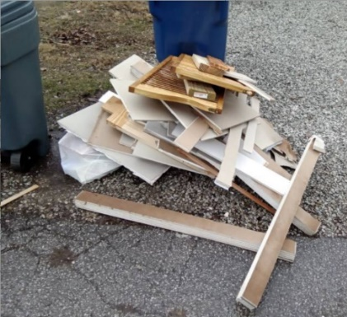
  - Tomorrow is the Franklin County Tech Review meeting with 6435 Young Rd on the docket for Mobility Practice for CDL School.
- Received email from Local Waste about a trash pick up—"Our Operations team have been running reports in an effort to follow up on the drivers and what is left behind. This will allow us to communicate what was left and why, or to have a plan to return prior to the resident reaching out. This was left out with trash last week, materials need contained or bundled” (This is in the trash hauling contract)

- Received this email-----"My name is Scott Raffeld and I work for Trebel Energy. I have attached a customer list request for AEP. Can you please have this signed and returned to me as soon as possible. This list request will allow Trebel Energy to start on the bidding process for your electric aggregation program.” Is it ok with you both for me to sign electronically? yes
- Received this email---
  - “ODOT has an upcoming project to repair the pavement on SR 665 between Darbydale and US 62 in southwest Franklin County. I want to highlight a couple things for your benefit:
- The work will occur this year, assuming bids come in favorably. I would expect a preconstruction meeting invite in the June timeframe, with work to occur over the summer and fall according to the contractor’s proposed schedule.
- The main items of work are to perform spot asphalt repairs to the roadway. Traffic will be maintained using flaggers and Law Enforcement Officers within intersections.
Bob McNeil is the ODOT Project Manager and Dan Wise is the Area Engineer for construction. Please reach out to them if you have any questions on the project or would like to see a plan set. Thanks, I’m looking forward to this improvement for the public. Anthony (Toni) Turowski, P.E.

- Announcements-
  - Ed attended the Ohio Township Conference in January

- Adjourn-

