Lavic is an area to the east of the Pisgah crater on the south side of I-40 between Newberry Springs and Ludlow. The jasper in this area is called Lavic Siding and is the same or very similar to jaspers found in the North and South Cady Mountains on either side of I-40. We went out there on 3/18/17 with expert guidance by Blaine Witte, a friend of ours and former field trip leader from the Victorville Gem & Mineral Society. Blaine took us along the power pole road to an area where people were digging jaspers. The material I pulled out of the trench had a lot of green. The recent rain gave a nice show of flowers.
Terri in the jasper trench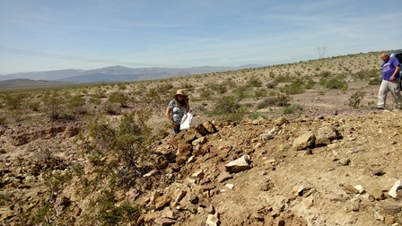
Jaspers in the trench (too big to dig)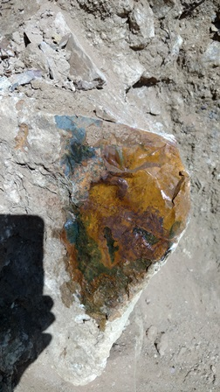
Jasper in the trench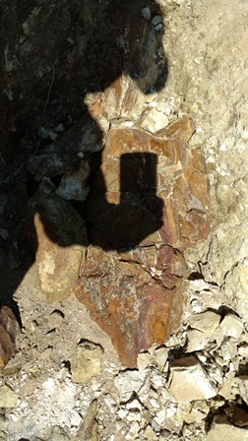
Green goodies from the trench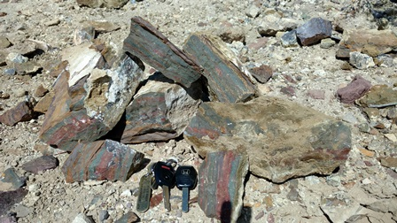

Really colorful jasper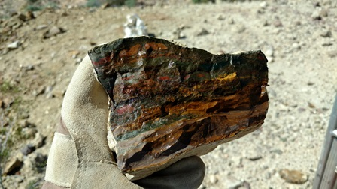
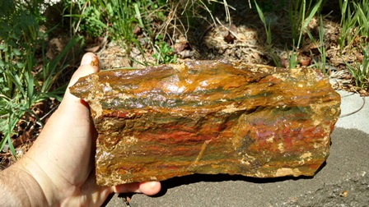
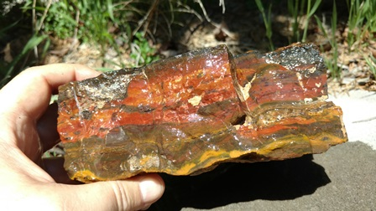
Stop and smell the flowers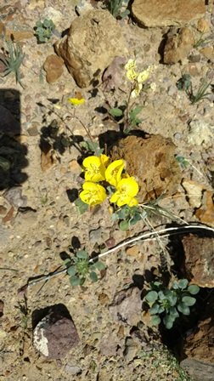
More flowers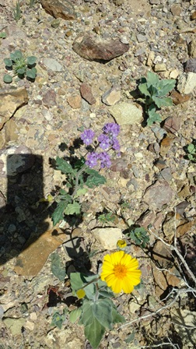
Next stop was surface collecting in the traditional Lavic area. We passed a caravan of fellow rockhounds from The Searchers out of LA. There were about 50 of them and they were taking a noon break. We figured they picked up all the good stuff by them and drove on a bit further.
Surface collecting at Lavic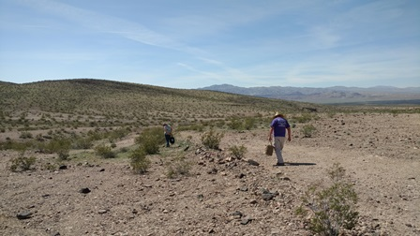
Most of the pieces of jasper we found around here on the small side, but there were some exceptions. The color of jasper in this area favored the red/orange/yellow range. Material was not plentiful, but if you walked around a bit you found enough good pieces to make your bucket happy. Definitely a good place.
Softball size jasper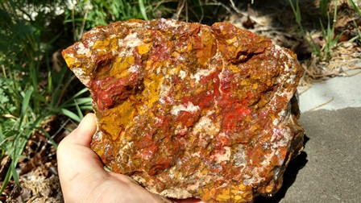
Softball’s brother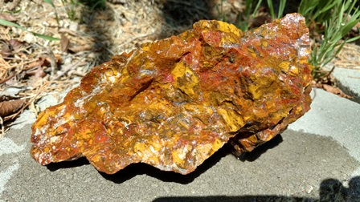
Really red jasper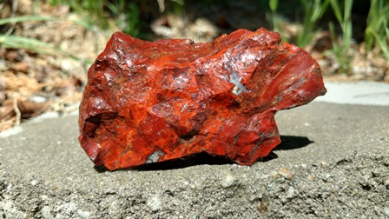
Storm on Jupiter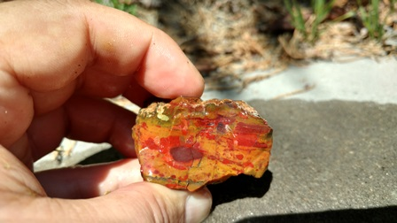
Hold the line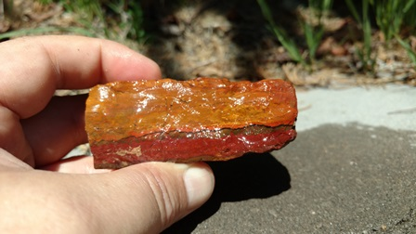
Red, yellow and purple, oh my! 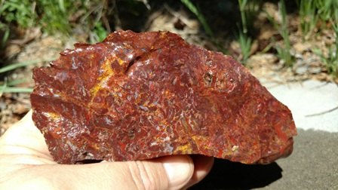
Love those red lines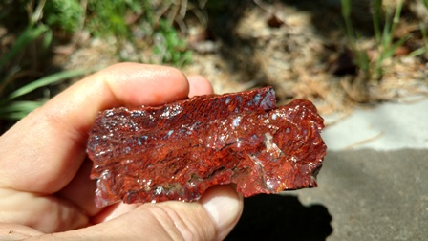
Neat-o yellow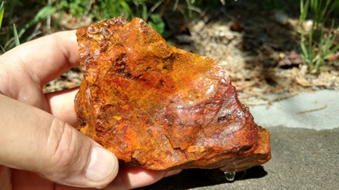
After collecting at Lavic for a bit we went to the Dairy Queen in Ludlow for a hot lunch and ice cream. Rockhounding is hard work From there we went east on I-40 for about 11 miles and took a non-descript turn off and followed the gas line road until we got to the hill full of thulite. At the top of the hill the thulite was a light green with light pink stripes. The colors seemed to get darker the further down the hill we went. The nice part is that you can drive right on the hill and start finding pieces 10’ away. There are a number of places on the hill where people have been digging up thulite and with a little work you can dig some fresh material. The club is not going to be hurting for thulite after this trip.
The hill and my dolly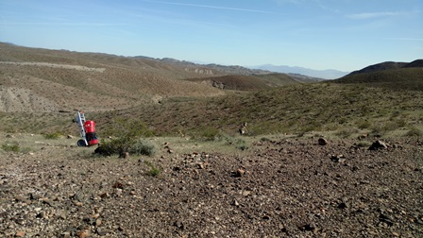

Looking down the other side of the hill (all thulite)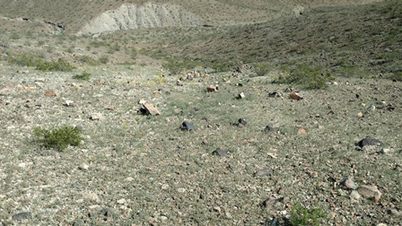
Thulite diggings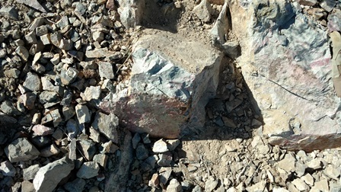

This one came home with me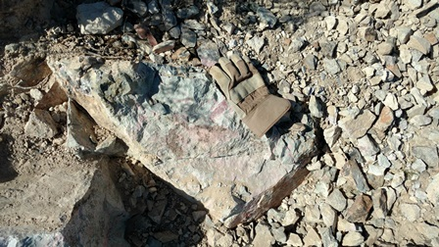
Nice dark color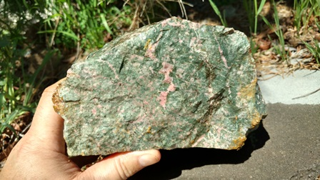
More pink here