HARBOUR ISLE EAST
Condominium Association, Inc.
c/o FirstService Residential Inc.
6A Harbour Isle Drive East
Fort Pierce, Fl. 34949
(772)595-3660 (772)595-8809 FAX
www.harbourisleeast.com
Julie.lynch@fsresidential.com

PURCHASE APPLICATION INSTRUCTIONS:

1. Fill out application & background check forms completely (each applicant must complete a separate background check form). Submit all documents to Harbour Isle East Condo. Association, 6A Harbour Isle Drive East, Fort Pierce, Florida 34949, fax to (772) 595-8809 or email to Julie.lynch@fsresidential.com

Please allow 10 days for review and action to be taken by the Harbour Isle Condominium Association, Inc. There is a $100.00 Non-Refundable application fee, payable to Harbour Isle East.

2. Above signed acceptance of the Rules and Regulations must be submitted along with the application, as well as, a copy of the purchase contract and warranty deed.

Every effort will be made to expedite the notification process.

3. All new owners are required to attend a brief orientation prior to moving into the unit.

ACKNOWLEDGEMENT

I agree to abide by the rules and regulations of the HARBOUR ISLE EAST CONDOMINIUM ASSOCIATION, INC. and am subject to the Declaration of Covenants of HARBOUR ISLE EAST CONDOMINIUM ASSOCIATION, INC. Failure to comply with terms and conditions thereof shall be a material default and breech of the lease agreement Owners are responsible for ensuring that all permits, approvals, and other rental requirements of the City are satisfied.

______________________________ _______________________________________
Owner Owner

______________________________
Date
HARBOUR ISLE EAST
Condominium Association, Inc.
c/o FirstService Residential Inc.
6A Harbour Isle Drive East
Fort Pierce, Fl. 34949
(772)595-3660– (772)595-8809 FAX
www.harbourisleeast.com
Julie.lynch@fsresidential.com

Purchase Application

Name: _____________________________________________Phone: ______________________________

Name: _____________________________________________Phone: ______________________________

Bldg/Unit #: ________________________________________ Move-In Date: ________________________

Full-time or Seasonal Resident: ______________________________________________________________

Mailing Address (for statements): ____________________________________________________________
_______________________________________________________________________________________

Name of Agent: ______________________________________Phone: _____________________________

In Case of Emergency:

Name: _____________________________________________Phone: ______________________________

Relationship: ________________________________________

Names and Ages of Children Living on Property:

______________________________________ ___________________________________________

______________________________________ ___________________________________________

Will anyone other than spouse or children listed above reside with you (if so, please provide names & ages):

______________________________________ ____________________________________________

Will you have any pets residing in the unit? _____ If so, please complete the attached pet registration information on the next page.

Driver’s License #: _____________________________ ________________________________________

Do you have any commercial or recreational vehicles (boats, campers, trucks, trailers, or paneled vans)? ___

THESE VEHICLES ARE NOT ALLOWED TO BE PARKED OVERNIGT ON ANY COMMON ELEMENTS!

HARBOUR ISLE EAST
CONDOMINIUM ASSOCIATION, INC.

Approved Guest List
Guests that visit you regularly that you want to allow to enter without having to contact the guard.

________________________________ ____________________________________

________________________________ ____________________________________

________________________________ ____________________________________

________________________________ ____________________________________

________________________________ ____________________________________

Pet Registration Information

PET #1 Pet #2

Name: ____________________________ ____________________________________

TYPE: _____________________________ ____________________________________

BREED:____________________________ ____________________________________

COLOR:____________________________ ____________________________________

WEIGHT:___________________________ ____________________________________

RABIES CERTIFICATION NUMBER:____________________________________________________

IS THE PET MICROCHIPPED: ____________ _____________________________________

REQUIRED: CERTIFICATION FROM VETERINARIAN VERIFYING PET

SECURITY DATABASE FORM

BUILDING NUMBER_____UNIT NUMBER_____

OWNER NAME (LAST)___________________________(FIRST)________________
PHONE NUMBER_______________

OWNER NAME (LAST)___________________________(FIRST)________________
PHONE NUMBER_________________

VEHICLE 1 VEHICLE 2________
MAKE____________ MAKE___________
MODEL__________ MODEL__________
COLOR__________ COLOR__________
TAG #____________ TAG#____________
STATE____________ STATE___________
BARCODE #__________ BARCODE #_________

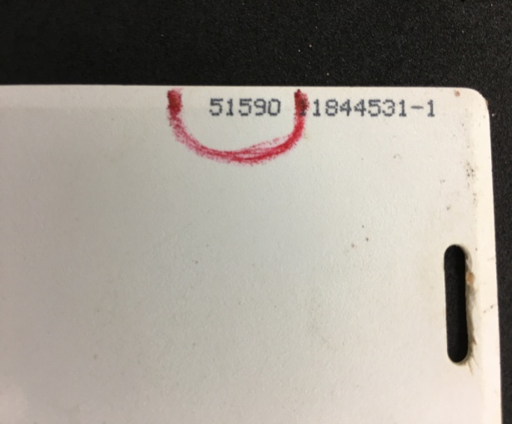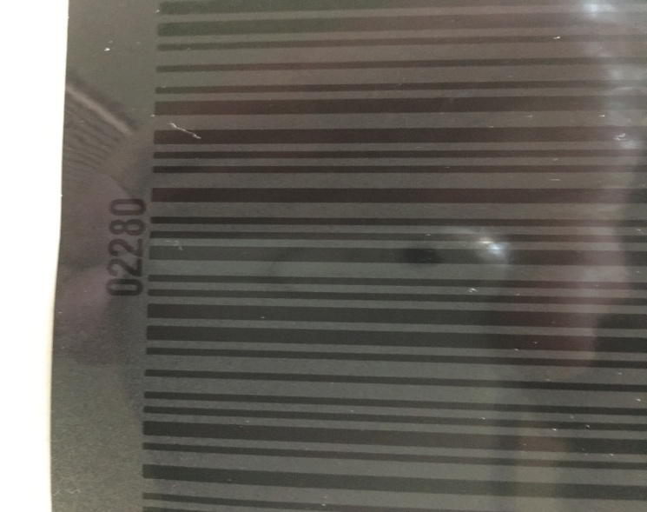

5 DIGIT SWIPE CARD#____________
5 DIGIT SWIPE CARD #___________



