WELCOME TO THE SPRING YAK CLASSIC
MARCH 28-29, 2020

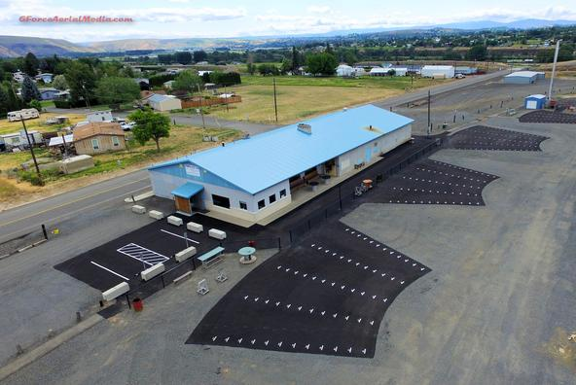

PITA Daily Fee of $4.00 will be charged on your 1st event of each the day.

Saturday, March 28, 2020 start time 9:00 a.m.

Event #1 100 16 yard Targets

4 classes (A-B-C-D) $50 class winner, $25 Sub Jr, Jr, Lady, Vet, S. Vet.
Entrance………………………………………………………………………..….$33.00
WSPITA Fee ……………………………….………………………….…………..$2.00
OPTIONS: Class Purse (Each class shooting for its own money. 1 pay each 7)…..….....$10.00
Lewis Class (3 classes) 60/40………………………………….……….……$12.00

Event #2 100 Handicap Targets

$150/100 ea. yardage gr 18-21.5, 22-24.5, 25-27
Entrance………….……………………………………………………………….$33.00
WSPITA Fee ……………………......……………………..…………..…….……$2.00
OPTIONS: WSPITA MAGNUM (no minimum entries)…..……………..……………..$12.00
Yardage Purse (18-21.5, 22-24.5, 25-27) 1 pay each 7 …………….….….. $10.00
25 Options ($2.50 on each 25, Divided 60/40)……………………….…… $10.00
50 Options ($3.00 on each 50, Divided 50-30-20)…………...…………... .$ 9.00
Lewis Class (3 classes) 60/40…………………………………………..…...$12.00

Event #3 50 Pair Doubles

3 Classes (A-B-C-D) $50 each class winner
Entrance……………………………………………………………….………….$33.00
WSPITA FEES…………….………………………………………….…….…….$2.00
OPTIONS: Class Purse (Each class shooting for its own money. 1 pay each 7)…….….$10.00
Lewis Class (3 classes) 60/40…………………………………………..…...$12.00

Sunday, March 29, 2020 start time 9:00 a.m.

Event #4 Lowell Rogers 100 16 yard Targets

4 classes (A-B-C-D) $50 class winner, $25 Sub Jr., Jr., Lady, Vet, S. Vet.
ENTRANCE.………………………………..……………..…………………...$33.00
WSPITA FEES…...........................................................................................…..$2.00
OPTIONS: Class Purse (Each class shooting for its own money. 1 pay each 7)…..….…$10.00
Lewis Class (3 classes) 60/40……………….…………………….………...$ 12.00

Event #5 Tom and Wilma Pratt 100 Handicap Targets

3 yardage groups 18-21.5, 22-24.5, 25-27
Trophies to winners $200/100/50 each yardage group
ENTRANCE………………………………………………………......……$33.00
WSPITA Fee……….……………………..…………………….…..…….… $2,00
OPTIONS: WSPITA MAGNUM ………..………..………….………………………$12.00
Yardage Purse (18-21.5, 22-24.5, 25-27) 1 pay each 7 …………………...$10.00
25 Options ($2.50 on each 25, Divided 60/40)…………………...….…… $10.00
50 Options ($3.00 on each 50, Divided 50-30-20)……..….………….…. .$ 9.00
Lewis Class (3 classes) 60/40……………………………...…...……..…...$12.00

Trophies
Event #4 Lowell Rogers 16 yard
Class Champs (A-B-C-D)
Sub Jr, Jr, Lady, Vet, S. Vet
Event #5 Tom & Wilma Pratt Handicap
Yardage Champs
18-21.5, 22-24.5, 25-27
HAA Champion
High all around Events 3, 4 & 5

We would like to thank
Tom Rogers and Tom & Wilma Pratt for their donations.
A big thanks to all the volunteers and all the shooters

This certifies that the Yakima Valley Sportsmen’s Association has been authorized to hold a registered shoot on March 28-29, 2020. The PITA rules will govern the shoot and scores will be included in the official records.

GENERAL INFORMATION
ADA shooting pads and walkways.
PITA Magnums on WSPITA.com
Handicap yardage will be determined by ATA & PITA cards Longest yardage.
This is a PITA Shoot with ATA cross-registration available.
3 Trap banks will be used (6 traps) and a practice trap.
All Orange Top White Flyers
If ties for cash prizes occur, money will be divided high gun system.
Trophies on Sundays 16 yard and Handicap
All Trophies shot off. High All Around Events 3 - 5
No withdrawal of option money after on event begins.
Errors in score must be corrected before moving to the next post.
Squads will not be called. Please watch the on-deck board for your squad.
Practice trap will be open all day both days. $5.00 per round.
No shells for sale.
All pay-offs will be made by mail.
Only Club Management will change traps.
RV hook-ups, $10.00 a day -- Kitchen will be open small breakfast and lunch.
Any question call Paul Klingele 509-945-0604
Pre squad email brakeman63@yahoo.com Club web site WWW.YVSA.net
Eye and Ears protection must be worn.

