

# Winter 2017-2018 Season

# Week 18

# 10th March 2018

**Club Winter Precision Shooting Competition**

The winter precision shooting competition took place on Saturday 10th of March. 17 members took part in the competition, a good turnout considering it’s the winter season.

Each player was allowed up to 3 goes at the shooting disciplines (each round consists of 20 shots, at 5 different targets, starting at 6.5 meters and moving 1 meter back per shot up to 9.5 meters.

Below are everyone’s scores. Please note that this is not a name and shame process or to see who’s the best, it is simply so that everyone can track their scores, so that they aim to get better scores in the next competition.

|  |  |  |  |
| --- | --- | --- | --- |
| **Player name** | **Round 1** | **Round 2** | **Round 3** |
| Mo De Gruchy | 0 | 0 | No attempt |
| Tom McMinigal | 4 | No attempt | No attempt |
| James Rondel | 7 | No attempt | No attempt |
| Ross Payne | 3 | 8 | No attempt |
| Jean Stewart | 6 | No attempt | No attempt |
| David Ibitson | 4 | 6 | No attempt |
| Richard Williams | 2 | 7 | No attempt |
| Toby Northern | 3 | 6 | No attempt |
| Keith Pinel | 17 | 12 | 3 |
| Cassie Stewart | 1 | 11 | 3 |
| Matt Pinel | 9 | 27 | No attempt |
| Andrew Bellamy Burt | 0 | 3 | 11 |
| Brian Harris | 3 | 9 | 10 |
| Alex Stewart | 1 | No attempt | No attempt |
| Callum Stewart | 4 | 4 | 9 |
| Chris Le Gallais | 1 | No attempt | No attempt |
| Geoffroy Buffetrille | 21 | No attempt | No attempt |

From these scores, the top 4 (and progressing to the semi finals) were:

Matt Pinel – 27

Geoffroy Buffetrille – 21

Keith Pinel – 17

Andrew Bellamy-Burt – 11 (after a shootout with Cassie, as they both had 11)

Interestingly, these were the same 4 people who made it through to the semi-finals in 2017. So everyone else knows what they need to do to improve for next time!

Unfortunately due to time constraints, we were unable to hold the semi-finals on Saturday 10TH due to catch up league fixtures. Therefore the semi-finals were run on Saturday 17th.

Keith was away on holiday for this date, therefore Cassie was called up to take his place in the semi-finals (due to being equal 4th with Andrew)

**Semi-final 1**

Matt Pinel 12 - 4 Cassie Stewart

**Semi-final 2**

Andrew Bellamy-Burt 14 - 1 Geoffroy Buffetrille

**3rd place playoff**

Cassie Stewart 16 - 17 Geoffroy Buffetrille

**Final**

Matt Pinel 14 - 1 Andrew Bellamy-Burt

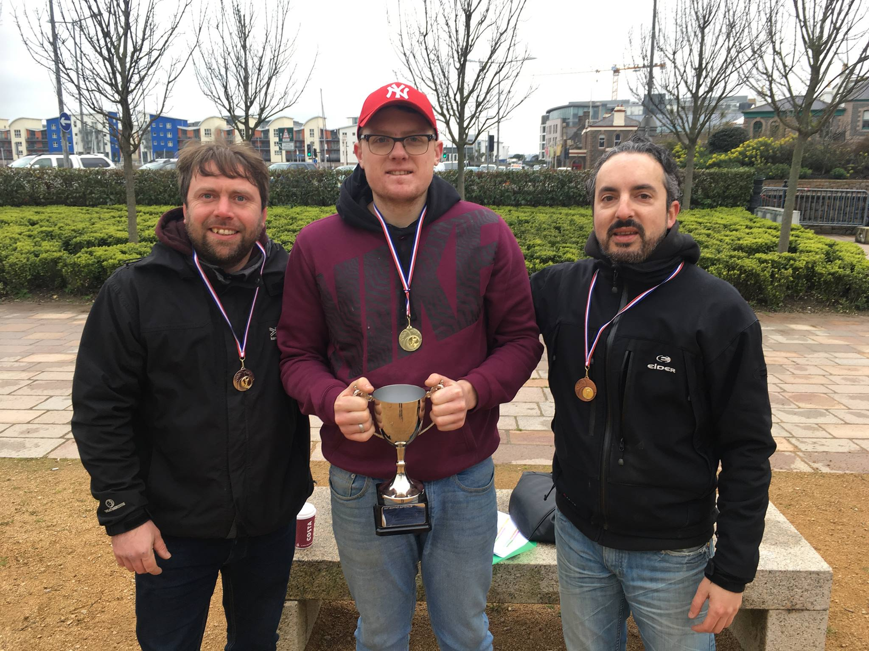

Special thanks to Matt Pinel for setting up running the competition and those who helped out with the scoring.

**WEBSITE** [**www.liberationpetanque.co.uk**](http://www.liberationpetanque.co.uk)

**EMAIL** [**liberationpc@gmail.com**](mailto:liberationpc@gmail.com)

**Kind Regards**

**Report Editor**

**Toby Northern**

**Liberation Petanque Club**

# SPONSORED BY

# http://nebula.wsimg.com/135a1bd6338e1b589a50cdec98bd84d1?AccessKeyId=C6E923731F1A482DD910&disposition=0&alloworigin=1