Texas Bird Breeders & Fanciers Association
Application for membership or renewal
This includes two persons at the same address.
A club roster is printed and distributes each year.
Please indicate at the bottom of this form if you do not want any information released.
*** TBBFA periodically distributes its membership list to TBBFA members and paid advertisers. If you do not want this information released by TBBFA, please indicate so on the application.
Annual Dues $20.00 (From January 1st to December 31st)
New Member:____ Renewal Membership: ____ Year: ______
(Please Print)
Name(s):

Address:

City: State: Zip:

Phone: ( ) Phone: ( )

E-Mail:

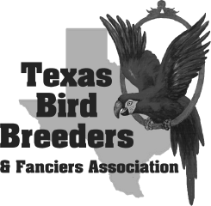
*** In order to maintain privacy, please do not publish my
Phone number
street address
on the membership roster. (check)

Please make checks payable to TBBFA.
Mail to: Alan Horton
1814 S. 47th St.
Temple, TX 76504
(254) 534-9845

Texas Bird Breeders & Fanciers Association (TBBFA) was established in 1947 and our first bird show was held in 1952. We were the first club in Texas organized for the purpose of showing birds. TBBFA is dedicated to supporting bird shows and exhibits. We are committed to encouraging and developing better care and breeding of caged birds; to creating a better understanding and closer relationship between breeders, exhibitors and retailers; and to provide assistance to beginners in the breeding and showing of quality birds.
Texas Bird Breeders and Fanciers Association members invite you to join our club or attend one of our quarterly meetings to get to know us.
***TBBFA periodically distributes its membership list to TBBFA members and paid advertisers. If you do not want this information released by TBBFA, please indicate so on the application.

