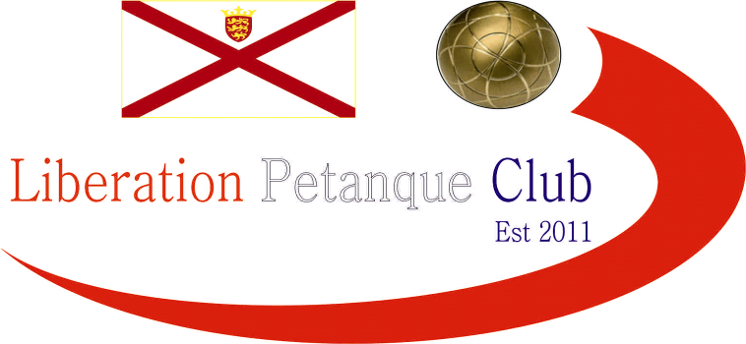

**2022**

**International Triples Open**

# Just eleven teams took part in our first International Triples Open after a late withdrawal in our first weekend of competitions.

# A good start for Island Triples champions Matt Buesnel, Laurent Pellaton & Geoffroy Buffetrille winning 13 – 6 over local players Andrew Limbrick, Stephen Leathem & Roy Noel.

# Good wins also for Callum Stewart, Paul Bell & Toby Northern 13 – 7 over Jay Geldert, Tony Griffiths & Dave Snook and Neil Selby, James Gennoe & Ross Payne also 13 – 7 over Gareth Smart, Clifton Gonsalves & Jim Page.

# Wins for all three Scottish trios as John Wilson, Robert Stronach & Derek Adam won 12 – 10 over Gary Cowburn, Wendy Ritzema & Colin Myers and Michael Watt, Laura Adam & Alec Davie beat Cassie, Jean & Alex Stewart 13 – 8. The latter trio of Shirley Legge, Lynn Jenkins & Gemma Foster had a bye.

# Round two saw some big wins as Derek, John & Robert beat Callum, Paul & Toby 13 – 1, Colin Gary & Wendy beat Jay, Dave & Tony 13 – 2 and Geoffroy, Laurent & Matt beat Michael, Laura & Alec 13 – 3.

# A good win for Cassie, Jean & Alex 13 – 10 over Gareth, Clifton & Jim.

# Round three saw a huge result for James, Neil & Ross winning 13 – 1 over Geoffroy, Laurent & Matt to make it three from three. A big win also for Derek, John & Robert 13 – 3 over Cassie, Jean & Alex.

# Callum, Paul & Toby recovered to win 13 – 10 over Gareth, Clifton & Jim.

# Round four saw James, Neil & Ross lose to John, Derek & Robert who now topped the Swiss rankings after four rounds with four wins.

# The first thirteen zero of the International Triples Open saw Shirley, Lynn & Gemma beat Callum, Paul & Toby. Another defeat also for Geoffroy, Laurent & Matt over Colin, Gary & Wendy for back-to-back defeats.

# Welsh team Jay, Tony & Dave got their second win after a bye in Round three winning comfortably 13 – 3 over Michael, Alec & Laura.

# With eight out of eleven making it into the Main competition plenty to play for in the final round.

# Top spot went to Derek Adam, John Wilson & Robert Stronach with five wins from five winning 13 – 3 against fellow Scottish team of Shirley Legge, Gemma Foster & Lynn Jenkins who finished fourth.

# Geoffroy, Laurent & Matt made their opportunity count winning thirteen zero against Cassie, Jean & Alex to finish sixth, with the latter finishing last. James, Neil & Ross recovered winning 13 – 5 against Colin, Gary & Wendy to finish second with the latter finishing third.

# Welshman Gareth & Jim playing with Englishman Clifton, won 13 – 0 over Welsh Trio of Dave, Jay & Tony to get into the Main in seventh.

# Callum, Paul & Toby win over Andrew, Stephen & Roy gave them fifth spot with Andrew, Stephen & Roy taking the last sport in the Main by six points on points difference.

# Well Done to Scottish trio of John Wilson, Robert Stronach and Derek Adam topped the rankings winning all five matches.

# Final Swiss Rankings

# Inline image

# The Main Competition

# Quarter Finals

# Ranked 1st John, Robert & Derek v Andrew, Stephen & Roy Ranked 8th

# Ranked 2nd Neil, Ross & James v Gareth, Clifton, Jim Ranked 7th

# Ranked 3rd Colin, Gary & Wendy v Geoffroy, Laurent & Matt Ranked 6th

# Ranked 4th Shirley, Lynne & Gemma v Callum, Paul & Toby Ranked 5th

# Well, what a surprise in the quarter-finals as top ranked team of John, Robert and Derek who only conceded an average of just 5.5 points per game- in the Swiss qualifying rounds were timed out losing to Andrew, Stephen & Roy 11 – 8! As the Swiss Curse truck again. They had only won two of their five matches with a minus points difference of eight.

# The second ranked team of Neil, Ross & James struggled against the Welsh team of Gareth and Jim who were playing with Englishman Clifton, but they did run out winners in the end 13 – 11.

# Third ranked team of Colin, Gary & Wendy could not repeat their qualifying form as favourites Geoffroy, Laurent & Matt won comfortably 13 – 4 gaining revenge for their 13 – 3 loss in Round four.

# The final quarter-final saw a repeat of round two with Gemma, Lynn & Shirley having beaten their opponents Callum, Paul & Toby 13 – 0. They started off where they finished leading 5 – 0 before Callum, Paul & Toby finally got on the scoreboard, a big shot by Toby firing the coche out for four points followed by a carreaux on the next end turned the match around as they ran out 13 – 7 winners.

# The Main Competition

# Semi Finals

# Ranked 2nd Neil, Ross & James v Geoffroy, Laurent & Matt Ranked 6th

# Ranked 5th Callum, Paul & Toby v Andrew, Stephen & Roy Ranked 8th

# Well, the first semi-final was a battle of skill all the way to 13 – 12 in favour of Geoffroy, Laurent & Matt as the latter trio gain another revenge after losing to their opponents 13 – 1! In round three.

# The second semi-final was running away from Andrew, Stephen & Roy who were losing heavily before a spirited fight back, but several missed chances saw Callum, Paul & Toby close out the match 13 – 11.

# Third place went to Neil Selby, Ross Payne and James Gennoe beating Andrew, Stephen & Roy 13 – 3.

# The final started off well for Callum, Paul & Toby picking up three points on the first end, but they struggled to keep a grip on the game with Geoffroy, Laurent & Matt running out 13 – 6 winners.

# 2022 – Winners – Matthew Buesnel, Geoffroy Buffetrille & Laurent Pellaton

# The Plate Competition

# Semi Finals

# Ranked 9th Jay, Tony & Dave v BYE Ranked 12th

# Ranked 10th Michael, Laura & Alec v Cassie, Jean & Alex Ranked 11th

# Due to only eleven teams the Plate went straight to the Semi-Finals with Jay, Tony & Dave being the highest ranked team in the plate getting a bye straight to the final.

# In the other semi-final Alex, Cassie & Jean hit top form winning comfortably 13 – 1 over Michael, Laura & Alec who finished third as a result.

# The final of the Plate was a close match, but it was the Welsh team of Jay Geldert, Tony Griffiths and Dave Snook who ran out winners 13 – 10.

# 2022 – Plate Winners – Dave Snook, Tony Griffiths, and Jay Geldert

# 

# Thanks to all those who helped, especially Dawn Buckley on the day to make it another great competition.

# Sponsored by

# [CoinShares | Digital Asset Investment Strategies for Professionals 🚀](https://coinshares.com/)

# Club email address - [liberationpc@gmail.com](mailto:liberationpc@gmail.com)

# Club Website - [www.liberationpetanque.co.uk](http://www.liberationpetanque.co.uk)

# Kind Regards

# Toby Northern

# Chairman

# Liberation Petanque Club