PISTOL RANGE USE:
- Sign in required, including date, name, time in / time out, caliber, description.
8/14/2021, John Doe, 6:30 PM – 7:30 PM, 38cal, SWC hand loads/preferred
8/14/2021, Jane Doe, 6:30 PM – 7:30 PM, 9mm, Rem UMC/approved
- Payment of per shooter per competition or practice session, based on posted schedule. Targets are included in the price of competitive event rounds, however not for practice sessions.
- Cartridge Restrictions – See posted guideline examples preferred/approved
- Magnums of any caliber (including .22) are NOT allowed.
- No steel jacketed or steel semi-jacketed bullets allowed.
- No cartridges with a muzzle velocity of over 1200 fps are allowed.
- No cartridges with a muzzle energy exceeding 400 ft. lbs. are allowed.
- Copper clad bullets (electroplated or equivalent) that are wrapped only for coating the lead bullet are allowed, providing that the above conditions are met.
- Combination of lead with frangible soft brass jackets are allowed, providing that the above conditions are met.
- The use of frangible, lead-free bullets is encouraged.

- All fire will be controlled aim at targets placed in the proper mounting area at the backstop.
- Paper targets only.
- No human silhouette targets.
- No cross lane firing.
- When two or more shooters are on the range, one of them shall function as a range officer to control the range. That person alone is in control of all fire.
- No loaded guns and all actions open when anyone advances downrange.
- No alcoholic beverages on the range.
- Police the range when finished. Place used brass in the designated container or take it out with you.
- Range hours are from 9:00 AM until 9:00 PM.

Any person caught in violation of these range rules will be brought before the Executive Board for disciplinary action which may include loss of use of the facility, loss of membership, or referral to law enforcement.

Skaneateles Rod and Gun Club
Pistol Barn Ammunition Guidelines

Preferred Ammo
- Lead or Copper Plated Lead - Brass Casing Soft point
Examples:
22 Cal. Rimfire
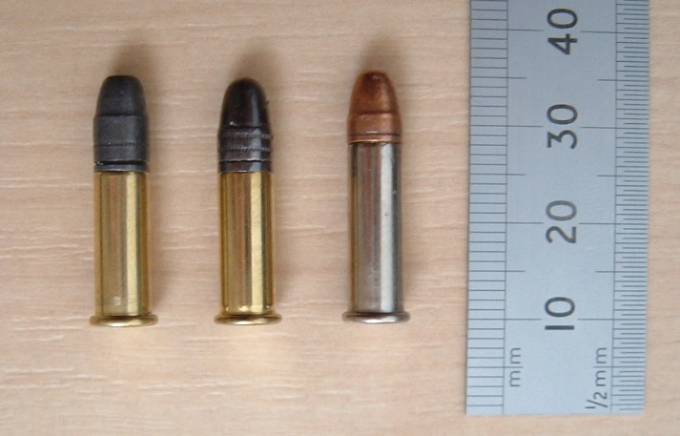

Centerfire

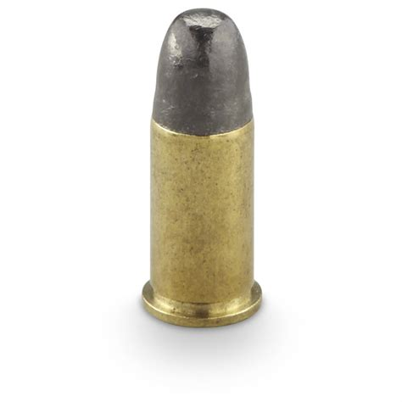
Skaneateles Rod and Gun Club
Pistol Barn Ammunition Guidelines
Preferred Ammo
- Synthetic: American Eagle Syntech
Semi-Automatic/ACP - 380, 9mm, 40, 45

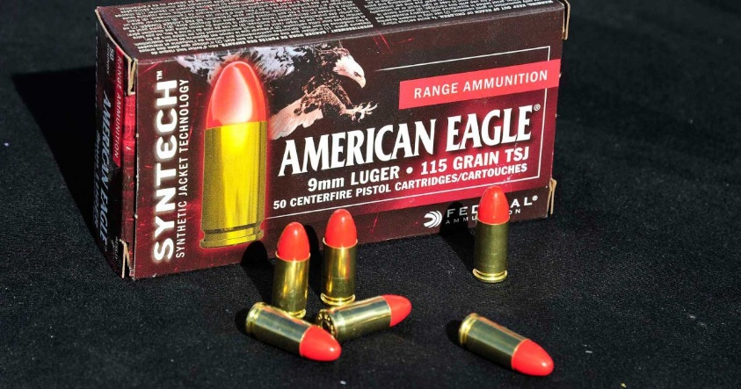

3. Composite Frangible
Semi-Automatic/ACP - 380, 9mm, 40, 45
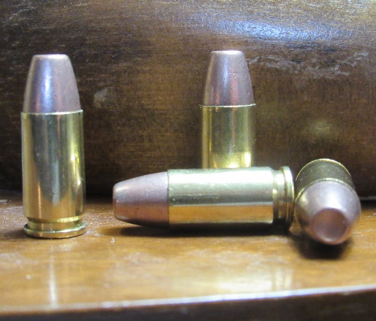
Order by mail/not available in stores
Skaneateles Rod and Gun Club
Pistol Barn Ammunition Guidelines
Approved Ammo
Brass Plated/Lead Soft Point Core FMJ
(Combination of lead with frangible soft brass jacket)
Semi-Automatic/ACP in 380, 9mm,40,45
Examples: Winchester White Box, Remington UMC,
Magtech, American Eagle, Sig Sauer, CCl Blazer, Aguila FMJ & Frangible Duty or Defense Ammo
(i.e., Hornady Critical Defense)
