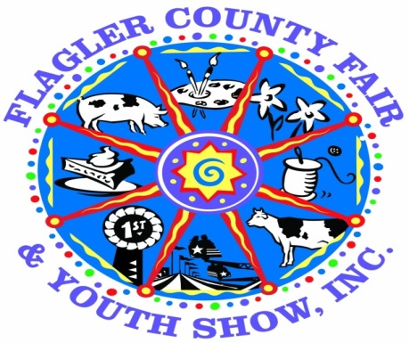
FLAGLER COUNTY FAIR & YOUTH SHOW, INC.
April 3th - April 7th, 2019

“Home & Family / Fine Arts / Photography / Straight from the Kitchen”
Divisions

Eligibility / General Information
- Entries must be residents of Flagler County
- Entries may be submitted by INDIVIDUALS only
- All items must have been completed after the 2018 Fair.
- Professionals may not enter items in any division
- Age Divisions (as of September 1, 2018)
Cloverbuds 5-7 Junior 8-10 Intermediate 11-13 Senior 14-18 Adult 19-Over
- All entries must be hand delivered to the Cattleman’s Hall on Sunday March 31st from 1 pm to 6 pm
- All entries will be on display at the fairgrounds during the upcoming Flagler County Fair & Youth Show
- All decisions affecting this competition and interpretation of its rules are vested in the Flagler County Fair.
- All articles entered will be displayed at the discretion of the Flagler County Fair.
- No changes may be made to any entry after it is received.
- Each entry must be registered in its proper division, class, and age division. The Flagler County Fair reserves the right to place any wrongfully registered entry into the proper category

Security
- While all reasonable security will be taken, all entries are submitted at the risk of the exhibitor. Precaution will be taken to protect exhibits. However, no claims for injury to any person or damage or loss of any property on account of fire, theft or any other crime, shall be made against the Flagler County Fair & Youth Show, Inc., its officers or agents by or on behalf of the exhibitors.
- The fair will not assume responsibility for returning such items as boxes, hangers or clothing bags delivered with items.

Release of Entries
- All entries must be picked up from the fairgrounds on Sunday April 7th after 6 pm and April 8th 2019 from 5 pm to 7 pm
- No article being exhibited will be released before the close of the fair.
- The fair is not responsible for any items left on the premises after Monday April 8th. Items not picked up during the specified date and time will become the property of the Flagler County Fair
- All premium monies and ribbons will be added to exhibitors checks and will be available for non exhibitors when picked up.

Judging
- Entries will be judged and awarded Ribbons and Cash Prizes
- Placing/Awards per class and per age division will be:
1st Place – Blue Ribbon & $15.00 Cash Award
2nd Place – Red Ribbon & $10.00 Cash Award
3rd Place – White Ribbon & $5.00 Cash Award
- An overall “Best of Show” winner for each class will be awarded a rosette and a $25.00 cash award
- Consideration of judging will be given to appearance, design, technique, workmanship and finishing.
- The decision of the judges is final.
- Judging results will not be given over the phone nor will exhibitors be allowed in the hall until the opening of the fair.
- Entries will be limited to one (1) item per class and/or five (5) per division

Contacts
Penny Buckles – Fair Manager (386) 931-6597
Ennasea Coute – (386) 627-4122
Email: flaglerctyfair@bellsouth.net or ennasea.coute@yahoo.com Website: www.flaglercountyfair.com
.

Drop Off Information
- Drop Off: Sunday March 24, 2019 (12pm-8pm) Brown Building – Exhibitor Building
Home and Family, Fine Arts, Photography
Drop off: Monday April 1 10am to 8 pm All perishable items, quilts and horticulture
- Pickup: Sunday April 7th after 6 pm and April 8th 2019 from 5 pm to 7 pm
- Judging: Tuesday April 2rd, 2019

All are entries are to be dropped off at the brown building – exhibitor building on Sunday March 24th from 12pm-8pm except
  - Horticulture
  - Quilts
  - All Perishable items except for Jams/Jellies

HOME & FAMILY DIVISION

Age Divisions (As of September 1, 2018)
Cloverbud….. Age 5-7
Junior….. Age 8-10
Intermediate….. Age 11-13
Senior….. Age 14-18
Adult….. Age 19 and Over
Awards Per Class/Per Age Division
1st Place ….. Blue Ribbon & $15.00 Cash Award
2nd Place …..Red Ribbon & $10.00 Cash Award
3rd Place …..White Ribbon & $5.00 Cash Award

Best of Show (Per Class with at least 3 entries)…..Rosette & $25.00 Cash Award

Class 1
Sewn Articles
- Needle
- Sewing machine
Class 2
Needle Work (Made with any other type of needle)
- Knitted
- Crocheted
- Hooking
Class 3
Hand Quilted Quilts
Class 4
Machine Quilted Quilts

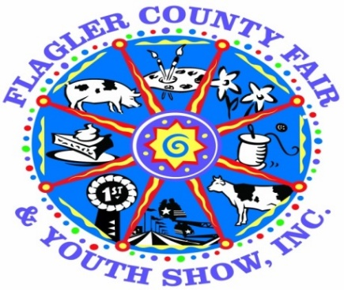

FINE ARTS DIVISION
Age Divisions (As of September 1, 2018)
Cloverbud….. Age 5-7
Junior….. Age 8-10
Intermediate….. Age 11-13
Senior….. Age 14-18
Adult….. Age 19 and Over

Awards Per Class/Per Age Division
1st Place ….. Blue Ribbon & $15.00 Cash Award
2nd Place …..Red Ribbon & $10.00 Cash Award
3rd Place …..White Ribbon & $5.00 Cash Award
Best of Show (Per Class with at least 3 entries). Rosette & $25.00 Cash Award

*Fine Arts entries should be original and no older than two years*
*No entry previously shown at the Flagler County Fair will be accepted*
Class 1
Paintings
- Water Color
- Oil
- Acrylics
Class 2
Drawings
- Pencil/Color Pencil
- Charcoal
- Ink
Class 3
Mixed Media
- Cut/Paste
- Paper Mache
- Collage

PHOTOGRAPHY DIVISION
Age Divisions (As of September 1, 2018)
Cloverbud….. Age 5-7
Junior….. Age 8-10
Intermediate….. Age 11-13
Senior….. Age 14-18
Adult….. Age 19 and Over

Awards Per Class/Per Age Division
1st Place ….. Blue Ribbon & $15.00 Cash Award
2nd Place …..Red Ribbon & $10.00 Cash Award
3rd Place …..White Ribbon & $5.00 Cash Award

Best of Show (Per Class with at least 3 entries)…..Rosette & $25.00 Cash Award

*Photographs that have been enhanced using software will not be accepted*
*Removal of red eye & cropping can be used as necessary*
*No nudes or vulgar displays – Judges have the right to disqualify at their discretion*
*ALL photographs must be 8” x 10” and must be mounted on standard 11” x 14” single weight white mount boards*
Class 1
Black and White
- Portraits
- Landscape
- Nature
- Architecture
Class 2
Color
- Portraits
- Landscape
- Nature
- Architecture
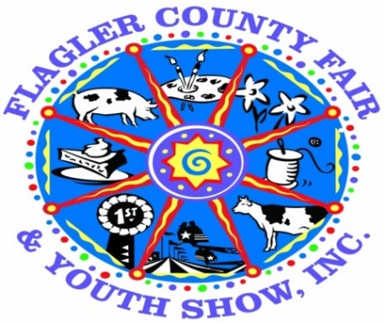

STRAIGHT FROM THE KITCHEN DIVISION
Age Divisions (As of September 1, 2018)
Cloverbud….. Age 5-7
Junior….. Age 8-10
Intermediate….. Age 11-13
Senior….. Age 14-18
Adult….. Age 19 and Over
Awards Per Class/Per Age Division
1st Place ….. Blue Ribbon & $15.00 Cash Award
2nd Place …..Red Ribbon & $10.00 Cash Award
3rd Place …..White Ribbon & $5.00 Cash Award
Best of Show (Per Class with at least 3 entries)…..Rosette & $25.00 Cash Award

*Entries must consist of (2) of the same product*
*Recipe, processing method and ingredients must be attached to product on 4x6 index card*
*All food must be prepared according to USDA recommendations*
*No mixes may be used. Items should all be homemade*
*Entries that require refrigeration will not be accepted*

Class 1 Class 2 Class 3
Cupcake & Cake Pies & Cobblers Breads
Class 4
Home Canned & Preserved Foods – 2 jars required for each entry 1 for tasting and one for display.
(Vegetables, Jams, Jellies, Preserves, Fruits, Pickles, Relishes, Sauces, Etc)
*Must have been canned or preserved within the last 12 months*
Class 5
Cookies
*Cookies should consist of (6) pieces in each container*
*All entries must be entered on disposable containers and placed in a plastic bag. (Ziploc preferred)
Class 6
Cupcake/Cake Decorating
Judged on looks not taste* *Only needs 1 entry not 2 and you don’t need an index card*

