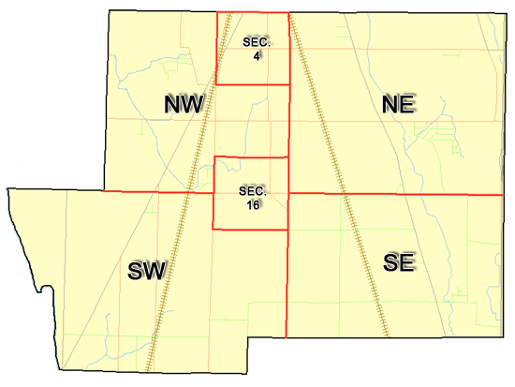 | Pleasant Township  Zoning Commission Minutes  1035 Owens Rd W.  Marion, Ohio 43302
Meeting called by: | Scheduled | Type of meeting: | Regular Monthly
Chairperson: | Mr. Williams | Secretary: | Tim Michael
Timekeeper: |  | Date: Nov. 21, 2019 | Time 7:30 pm
Call to Order by: | Mr. Williams Moment of silence followed by the pledge to the flag.
Roll Call: | Jack Dean, Dwight Williams, Harry Holler, Tom Leib  Tim Michael Secretary / Alternate
Minutes: | Read and approve minutes from previous meeting. (May pass out earlier)  Motion to approve minutes by: Mr. Leib Seconded by: Mr. Dean Roll call: All approved
Attendees Address Board: Have sign in sheet on desk by door.
Type in attendees and addresses:
.
----- Agenda Topics -----
Business
Zoning Reports: | Zoning Inspector goes over reports and provides copy to board.
Unfinished:
New:
Announcements: | Next meeting will be: January 16, 2020
Adjournment: | Motion to adjourn by: Mr. Leib Seconded by: Mr. Dean all in favor: all approved

Pleasant Township
Zoning Commission Minutes

1035 Owens Rd W.
Marion, Ohio 43302
Business Notes:

 | Discussion:
 | Conclusions:
 | Action items: |  | Minutes signed by: | Date approved:
 | Provide copy of approved minutes to Zoning |  | Chairperson:
 | Inspector. File original in township office. |  | Secretary:
Other Information
Trustees Present:
Zoning Inspector: |  | Mr. Baker
Special Guests:

Minutes
The Pleasant Township Zoning Commission met for their regularly scheduled monthly meeting on November 21st 2019 at the Pleasant Township Trustee Office. Zoning Commission Board members present were: Mr. Dean, Mr. Leib, Mr. Holler and Acting Chairperson Mr. Williams, Secretary Mr. Michael, and Township Zoning Inspector Mr. Baker.
- Minutes were read from the October 17th 2019 regularly scheduled Zoning Commission meeting. There being no stated corrections a motion to approve the minutes was made by Mr. Leib and seconded by Mr. Dean. All members present agreed to passage of the minutes.
- Mr. Tom Baker Pleasant Township Zoning Inspector submitted the following inspection report for the month of October 2019: there was 1 permit for an addition, one permit for an accessory building and 1 permit for a sidewalk. Dollar amount for new construction totalled $19,300.00, with income from permits totalling $225.00.

- After a discussion concerning the possibility of the building of a solar farm on property owned by Neidhart Farms it was discussed that the rewrite of the Pleasant Township Zoning Resolution currently being undertaken should include a section specific to issues pertaining to solar energy systems. Additionally, Mr. Leib expressed the need for the term “hardship” to be specifically defined in the Zoning Resolution rewrite particularly as it applies to consideration in possible decisions of the Appeals Board. Mr. Leib also suggested that the board consider if they could and/or should allow a subdivision to change established rules if all parties concerned ie. neighbors affected by the change agree to said change (for example distances of houses to property lines and/or other houses)?

- There was a discussion concerning officers for the Zoning Commission for the year of 2020. Mr. Williams made motion to nominate Mr. Holler for chairman and Mr. Leib for vice chairman, the motion was seconded by Mr. Dean and approved by all board members present.

- There being no additional business for discussion Mr. Leib made motion to adjourn, seconded by Mr. Dean all Zoning Board Members in attendance agreed and the meeting was adjourned. The next scheduled Zoning Board Meeting will be held on January 16th 2020 at 7:30 PM.

