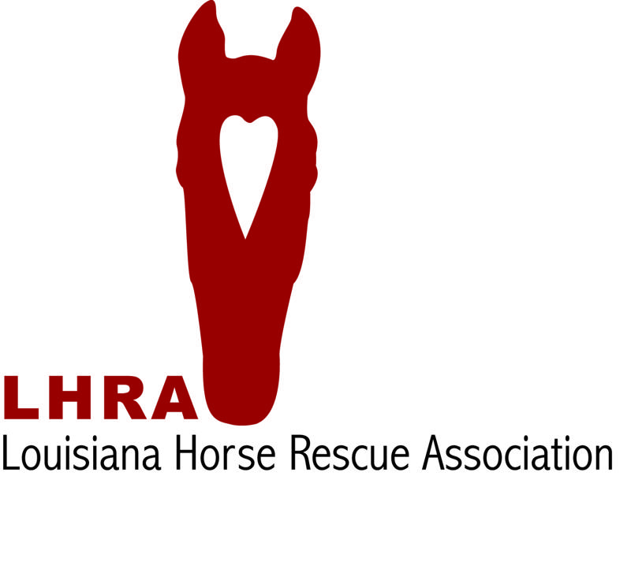
Adoption Questionnaire
We’re thrilled that you’re considering adopting a horse from Louisiana Horse Rescue Association. In an effort to make your adoption experience positive and successful, we ask that you complete the following questionnaire. Your honest answers are essential to the success of the adoption process.
First Name |  |  |  |  |  |  |  |  | Last Name
Mailing Address | Street Address
 | City |  |  |  |  |  | State |  |  |  |  |  |  | Zip
Physical Address | Street Address
 | City |  |  |  |  |  | State |  |  |  |  |  |  | Zip
Primary Phone# |  |  |  |  | Email Address
Occupation |  |  |  |  | If Student, Field of Study
LHRA Member? Y/N |  |  |  | How many horses do you own?
What are your plans for this horse?
Describe your horse experience.
Where will the adopted horse be kept? | Facility Name
 | Facility Address
Vet Reference | Name |  |  |  |  |  |  |  | Phone
 | Clinic Name |  |  |  |  |  |  |  | May We Call?
If Horse will be kept at your home or in a private pasture, please answer: | # Horses on Property |  |  |  |  |  |  |  | Pasture Size
 | How is water supplied?
 | Describe shelter.
 | Describe Fencing.
What is your monthly budget for horse care including vet and farrier?

