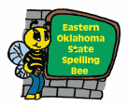

Our deepest thanks for your recent donation to the Eastern Oklahoma State Spelling Bee 501(c)(3) Organization. Generous gifts from donors like you provide the financial and moral support needed for our commitment to promote academic achievement in our state.

We look forward to a continuing partnership with you!

Sincerely,
Susan
Susan E. Hoog, Director

