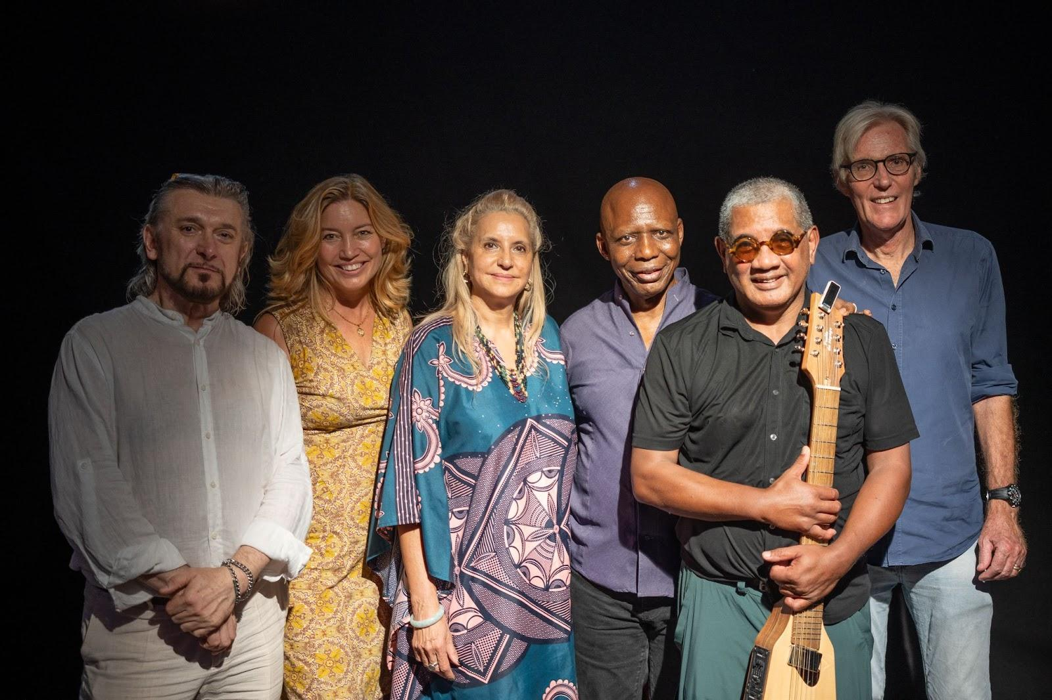

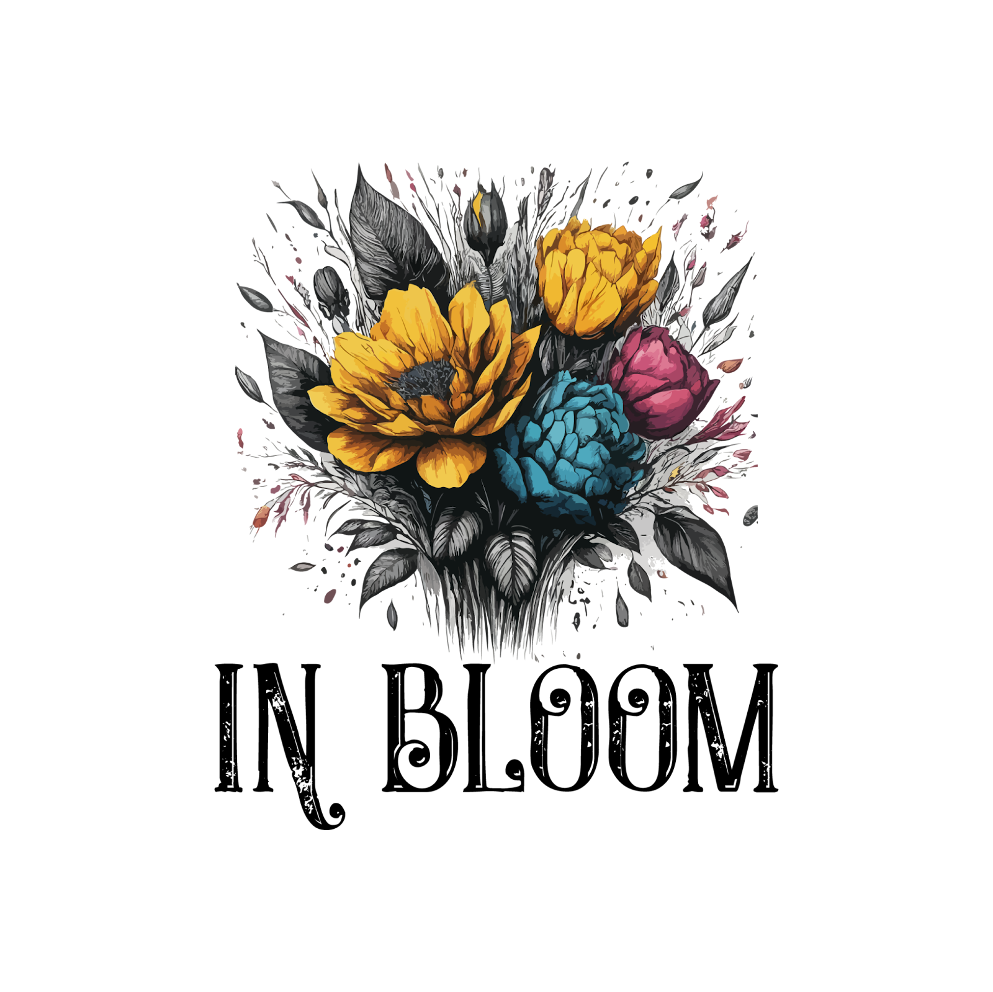 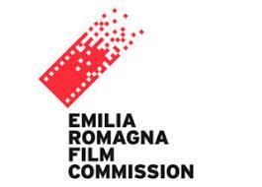 

**Shoot begins for “Miriam Makeba, The Voice of Africa”**

Venice, 4 September 2024

65 years after Miriam Makeba’s European debut in Venice and 30 years after the end of apartheid in South Africa, Millstream Films and Media is proud to announce the start of filming of “Miriam Makeba, The Voice of Africa”.

The documentary is a coproduction between Millstream Films and Media and Miriam Productions, a subsidiary of Raffaele Mincione’s WRM Group, Lorenza Veronica’s In Bloom SrL, and Moments Entertainment owned by Director Faith Isiakpere and Firdoze Bulbulia. It is supported by the Emilia-Romagna region through the Emilia-Romagna Film Commission.

The film celebrating the life and legacy of South African singer and activist Miriam Makeba is directed by Faith Isiakpere, a lifetime BAFTA member and lifelong friend of Miriam Makeba and Nelson Mandela.

Principal shoot kicked off in Reggio Emilia, Italy in mid August, including interviews with Roberto Meglioli, Makeba’s manager since 1987 and Solo Razafindrakoto, Makeba’s guitarist, who also played “Malaika” and “Pata Pata” on camera in her honor. Shoot will continue in South Africa with a concert in memory of Makeba, followed by filming in Guinea and New York City. Completion is expected for early 2025

“Miriam Makeba is Mama Africa - Africa is Miriam, Miriam is Africa”, said director Faith Isiakpere. Finally the moment has come for an African director to tell her story, and the story of her unrecognized but immense contribution to civil rights and the African independence movement.”

Millstream Films & Media

Millstream Production is a UK-based documentary film production company with editorial

operations in northern Italy. Our award-winning content is broadcast and distributed

worldwide, including on Netflix, Amazon Prime, Discovery Channel, History Channel and other

major brands. Our international team specialises in fast turnaround documentaries on history,

culture, current affairs, crime and big engineering for the global marketplace. The goal of

Millstream is beautiful, accurate and gripping storytelling.

Contact: Paul Russell or Andrea Vogt on [millstreamfilms@gmail.com](mailto:millstreamfilms@gmail.com) , Brewery House, High Street, Twyford SO21 1RG UK / Via Antonio di Vincenzo 1/E Bologna + 39 3288211718

WRM Group

WRM Group is an independent investment group with offices in London, Luxembourg and Milan.

WRM Group’s activity is focused on creating value in Special Situations, Private Equity and Real Estate. The company’s track record to date covers Food & Beverage, Commercial and Residential Real Estate, ICT, Telecoms & Media, Financial Services, Retail Trade and Renewable Energy.

Contact: Raffaele Fabiano – Communication & Media Relations, email: mediarelations@wrmgroup.net r.fabiano@wrmgroup.net , Corso Venezia 16-18 20121 Milano + 39 3316492017

In Bloom

In Bloom is a new cinema and Television production company run by Lorenza Veronica, film producer and executive producer, actress and singer with editorial and scriptwriting experience developed working with Iervolino entertainment. “Harvest”, executive produced by Lorenza Veronica, is premièring at the Venice Film Festival this year.

Contact: Lorenza Veronica, email: [Lorenza.Veronica@gmail.com](mailto:Lorenza.Veronica@gmail.com) Via Cavour 43, Conegliano (TV), Italy

Moments Entertainment

Moments Entertainment is a pan-African movie and documentary production company based in South Africa, focusing on strong African renaissance stories. Moments Entertainments has also branched out into youth programming via ABC (Africa’s Best Channel) on the of the MITV Channel in Nigeria. Moments is a non racial and equal opportunity employer and focuses on training and capacity building within disadvantaged communities in Africa with the goal of developing the true potential of Africa - its people.

Contact: Firdoze Bulbulia email: [moments@icon.co.za](mailto:moments@icon.co.za) +27 83 325 1857

Emilia-Romagna Film Commission

The Emilia-Romagna Film Commission supports the audiovisual industry in the region of Emilia Romagna through networking, logistics support and financial support. Miriam Makeba performed often in Emilia-Romagna, and her manager in her later years is from Reggio Emilia.

Contact : Anna Sbarrai [Anna.Sbarrai@regione.emilia-romagna.it](mailto:Anna.Sbarrai@regione.emilia-romagna.it)