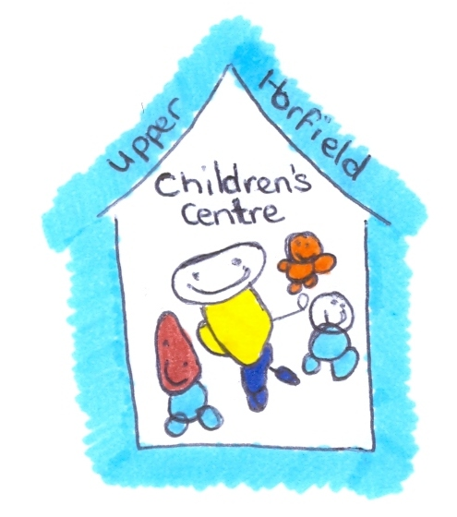
Upper Horfield Children’s Centre and Community School
Children’s Dietary Needs
January 2015-2018

The Centre will seek to ensure that all children are able to participate in meal times supporting cultural or dietary requirements.

Children’s dietary needs are recorded on their Child Profile Sheet which is completed when a child starts at the Children’s Centre.

The information is then given to the child’s Key Worker and any staff working in the room and the catering staff are also informed.

It is paramount that all staff working with the children are aware of any dietary requirements.

Information regarding dietary needs of individual children will be displayed in their room. All members of staff are made aware of this information.

If any member of staff is unsure at any time about what a child can or cannot eat they must seek advice from a senior member of staff and confirm with the parents/carers.

The Child Profile Sheet is filed in the children’s individual files which are kept in a secure cabinet in the Office.

Information from the Child Profile Sheet is recorded on an individual card in the children’s details box kept in the Office for quick reference.

Staff will be inducted to the children’s place mat system which will also indicate dietary requirements.

Review Date:

Reviewer:

