Kennedy High School
Advisor: Barry Wilson
4545 Wenig Rd. NE, Cedar Rapids, IA, 52402
319-784-7697
bwilson@cr.k12.ia.us
Jamie Voorhees, Grade 12, Driver/Crew Chief
John Tedesco, Grade 10, Crew Chief
Molly Sullivan, Grade 12, Documentation Writer
S30 Car : February 28th, 2018 – March 28th, 2018
A lot of progress has been made on the 30 car during the month of March. This included finishing the frame, assembling and installing the axle, wiring the entire car, and foaming the chassis. The belly pan was also added to the car prior to the wiring getting done. The main difficulty faced was Jamie’s inability to perform certain tasks. In the middle of March she was finally able to have her cast removed, but was still not cleared for heavy lifting. Despite these challenges, she made it work. John and Derek have helped her in any way possible to ensure that work on her car progresses.
The remainder of the month will be spent to get a body on her car, along with some testing to make sure it runs as expected/ wanted. There are no foreseen difficulties with what is left to do, and with the help of others, she is sure to get it done.
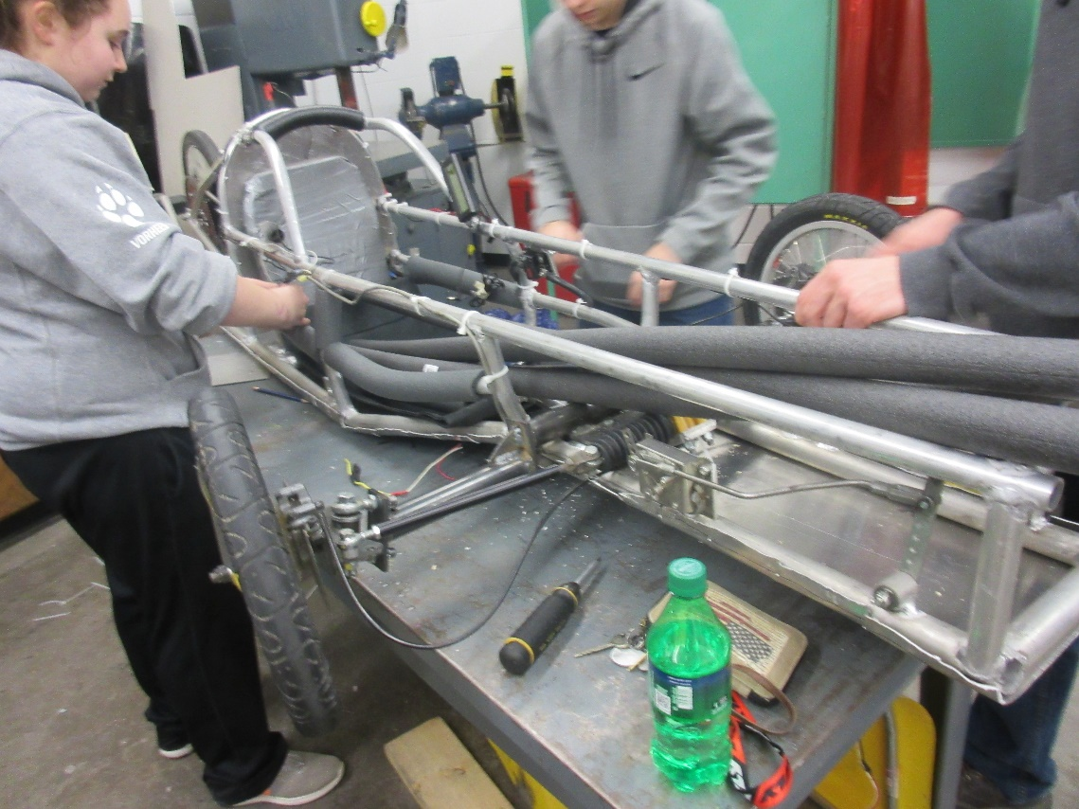

Kennedy High School
Advisor: Barry Wilson
4545 Wenig Rd. NE, Cedar Rapids, IA, 52402
319-784-7697
bwilson@cr.k12.ia.us
Derek Severson, Grade 11, Crew Chief
Molly Sullivan, Grade 12, Driver/Documentation Writer
40 Car: February 28th, 2018 – March 28th , 2018
During the month of March, the 40 team has worked on finishing the car. This included cutting and attaching the plastic for the canopy and installing the logger into the car. Both jobs took a bit of tame as there were delicate processes. Installing the logger involved lots of wiring as it was attached to the canopy this year, making it more practical for the driver during entering and exiting. The reason this is able to work is due to the canopy being attached to the car, where as our other cars have completely removable canopies.
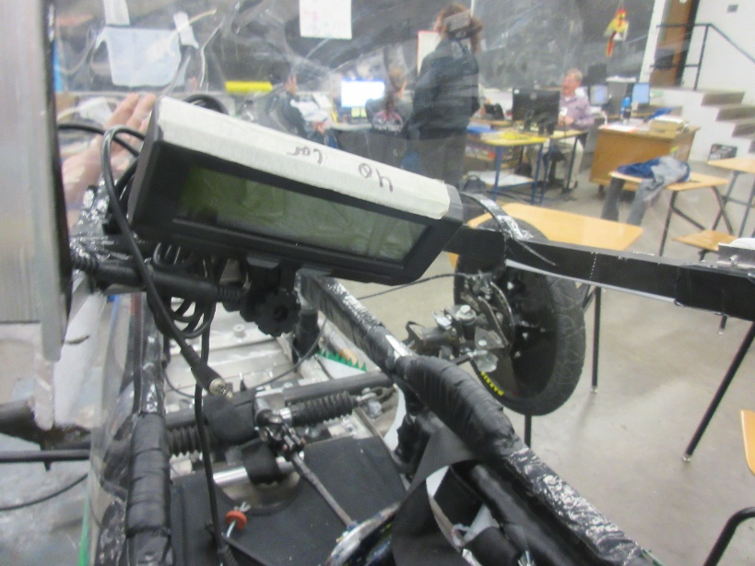
The goal for the remainder of the month is to do some final testing and ensure everything is where it needs to be, along with working as its supposed to. Derek has spent any extra time helping Jamie since she is not cleared to do much work after her surgery.

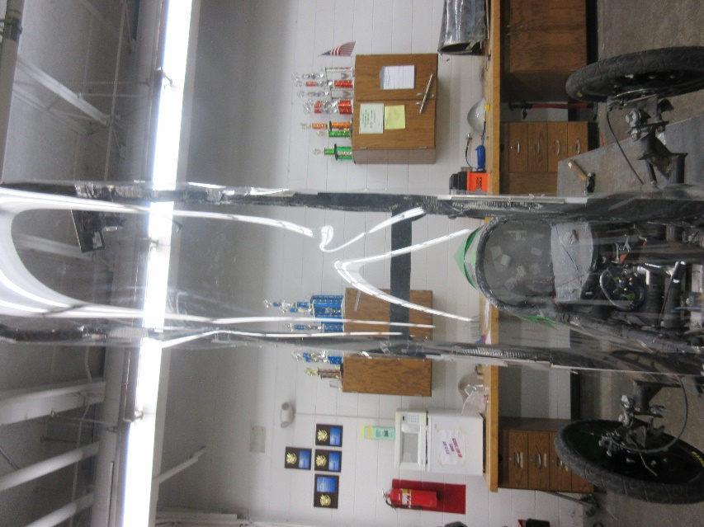

Kennedy High School
Advisor: Barry Wilson
4545 Wenig Rd. NE, Cedar Rapids, IA, 52402
319-784-7697
bwilson@cr.k12.ia.us
Natalie McAllister, Grade 12, Driver/Documentation Writer
Noah Matthews, Grade 12, Crew Chief
Lillie Wood, Grade 11, Maintenance
50 Car: February 28th, 2018 – March 28th, 2018
During the month of March, Noah worked on framing the tail and midsection for the car. By getting these framed, the body panels were able to be cut, painted, and attached. The only difficulties faced were getting the paint applied evenly and as desired.
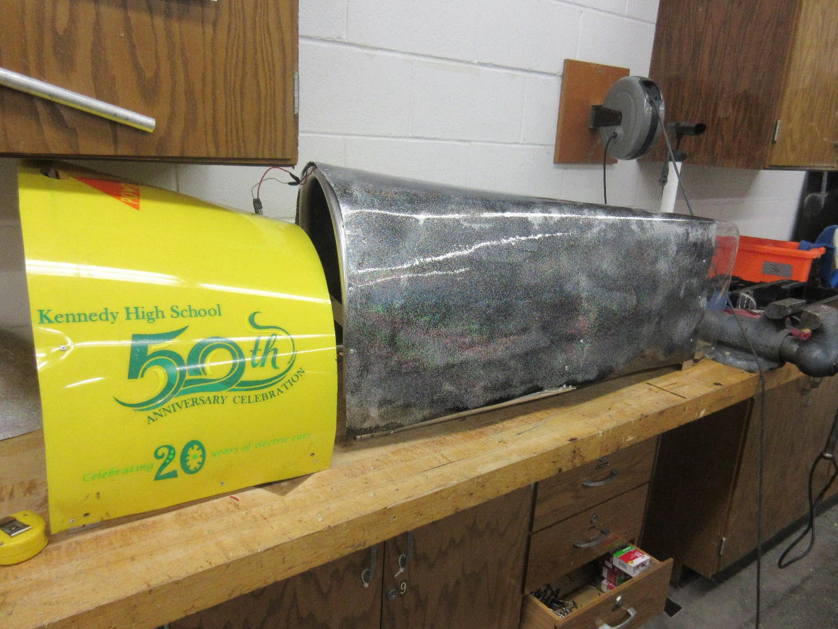
The goal for the remainder of the month and first couple weeks of April is to get the final touches done so that the car is ready to race. This will include final testing, and ensuring the wiring is all correct. Aside from anything found during testing, the car is ready to go.

