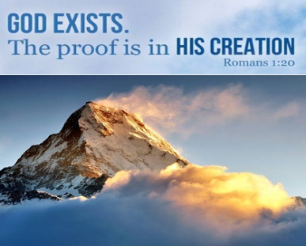

August 1, 2021 – 11th Sunday after Pentecost
Prelude/Greeting
*Indicates stand as you are able

Call to Worship
From Psalm 27

L: The Lord is our light and our salvation—
whom shall we fear?

P: The Lord is the stronghold of our life—
of whom shall we be afraid?

L: One thing we ask from you Lord,
this only do we seek:

P: That we may dwell in your house Lord
all the days of our lives,

L: To gaze on your beauty Lord
and to seek you in your temple.

P: For in our days of trouble
The Lord will keep us safe in his dwelling,
he will hide us in the shelter of his sacred tent
and set us high upon a rock.

*Hymn: This Little Light of Mine

Opening Prayer: (unison)
Gracious heavenly Father, when we don’t feel your presence, and your glory is hidden from our eyes: make, our hearts burn within us, until we recognize your presence. When we are feeling lost, may we cling in faith to your Word and the power of Christ’s sacrifice for us, until we are reminded through your Holy Spirit that we our yours. in the name of Jesus Christ our Lord, who lives and reigns with you and the Holy Spirit One God forever and ever. AMEN.
Gospel Reading: JOHN 1:1-5
Old Testament: PSALM 19:1
Epistle Lesson: ROMANS 1:20

THE MESSAGE

Sharing of our joys and concerns

Call to Prayer: Jesus Loves Me

Pastoral Prayer

Offering/Offertory Prayer

Doxology UMH 95

*Hymn: They Will Know We are Christians

BENEDICTION

Serving and Supporting Sunday Worship
Audio/Video: Pat Monroe

Joys, Concerns & Prayer Request
For those battling cancers: Wendy Crawfis,
Beth Grienke, Kale Litwiller, Jim Dunlap,
Carolyn Nykerk, & Ray Seaman

For everyone who needs support,
guidance or has health concerns.

Monthly Giving
7/25 $1814.45 8/1 $2095.57

Upcoming
8/14 On the Hunt for Romance 3:00-7:30 pm
8/20 Outdoor Move & Bonfire
9:20 pm (@ Lauren Monroe’s)
8/25 Ad Board, Finance & Town mtg 6:00 pm

Our Church in Ministry This Week

Mon 6:30 pm | Personal Transformation Class

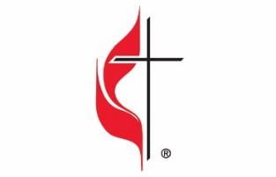

Carson City United Methodist Church
Location: 119 East Elm St., Carson City, MI
Mail: PO Box 298, Carson City, MI 48811
Phone: 989-584-3797 Email: carsoncityumc@gmail.com
Website: carsoncityumc.com
Office Hours: Mon-Thur, 9:00 am-12:00 pm
After hours by appointment
Pastor: Ian McDonald 906-322-5318
Secretary: Bonnie Seaman 989-763-1674

“Father, You’re the One I can always run to. Help me turn to You first”

Weekly Sunday Bulletin now available on our website @ www.carsoncityumc.com

