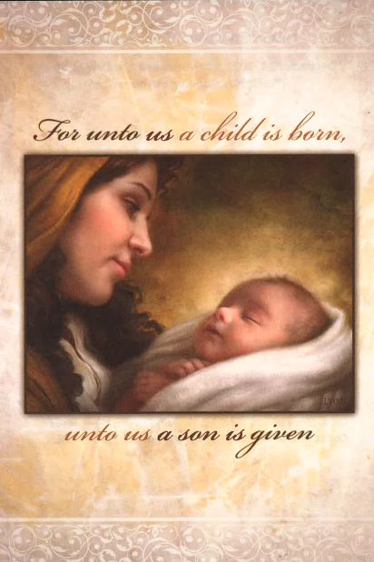

Carson City United Methodist Church
December 24, 2022, Christmas Eve Candlelight Service
(*indicates standing as you are able)

PRELUDE / GREETING

Call to Worship

Hark! the Herald Angels Sing UMH 240
Joy to the World UMH 246
It Came Upon the Midnight Clear (verses 1&4) UMH 218

Opening Prayer (unison)

Glory to you Almighty God, for you sent your only begotten son, that we might have new life. Glory to you Lord Jesus Christ, for you became flesh and dwelt among us that we might become your people. Prepare our hearts for your return Lord Jesus, keep us steadfast in hope and faithful service. Glory to you Holy Spirit for you direct and rule our lives. Glory to you almighty God and to your Son, Jesus Christ, and to the Holy Spirit, now and forever. AMEN.

First Reading: ISAIAH 9:2,6-7 and 11:1-4 JEREMIAH 23:5-6
*Hymn O Come O Come Emmanuel (verses 1,2,6) UMH 211
Second Reading: MICAH 5:2
*Hymn O Little Town of Bethlehem UMH 230
Third Reading: LUKE 2:1-20
*Hymn O Come All Ye Faithful (verses 1,2&6) UMH 234
*Hymn Angels We Have Heard on High (verses 1&4)
UMH 238
What Child is This UMH 219

A Christmas Message, Promise Kept

Lighting of the congregation’s candles from the Christ Candle.
*Hymn Silent Night, Holy Night UMH 239
Benediction
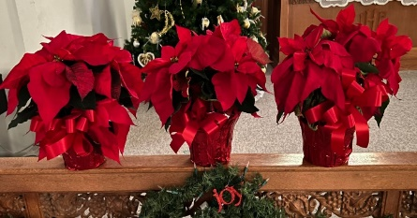
The flowers in our Chancel Garden were given to the Glory of God by:

Roberta Kile, in memory of Esther Mumby & Wallace Kile

Pastor Larry & Elaine Nalett, in memory of Gloria Beaune

