8th Annual
Rocky Mountain
Summer Nature Retreat
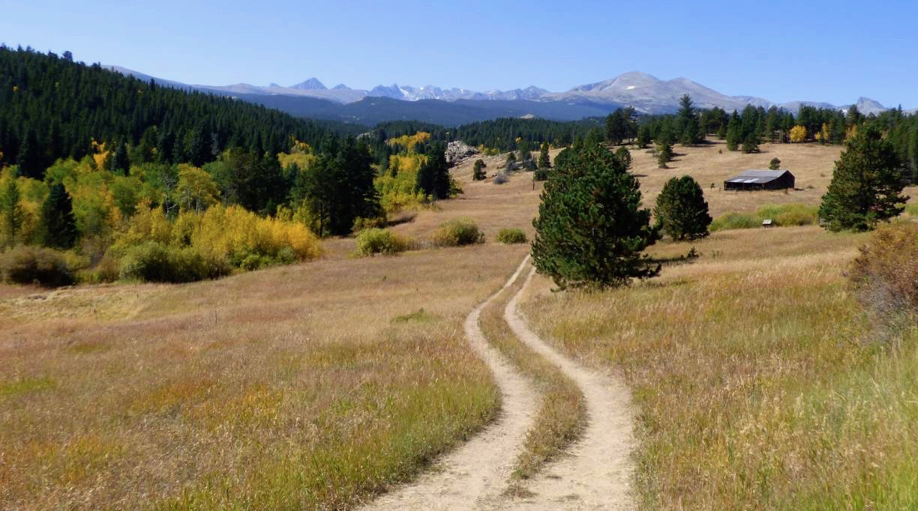

Vipassana Meditation in Nature
with Johann Robbins and Peter Williams

5PM Friday, June 23, 2016 to 5PM Sunday, June 25
Rocky Mountain Ecodharma Retreat Center, Jamestown, CO

The Buddha lived and taught outdoors, and most of the traditions of Buddhism were developed in nature. Mindfulness and silence deepen our experience of nature and beauty, while intimacy with plants, animals and the elements enhance our sense of oneness. On some of the longest days of the year, join us to hike, meditate, and experience the Dharma unfolding naturally.

This silent meditation retreat is for anyone with a desire to go deeper in their practice, from beginners to experienced meditators. The retreat will include instructions and sitting and walking (hiking) meditation, dharma talks, and small group meetings with the teachers. The retreat will be at the new , which has beautiful hiking trails and amazing views of Indian Peaks. Lodging options include camping, shared, or private rooms. Delicious vegetarian meals are provided.

For details and registration go to:

www.impermanentsangha.org

Registration form and easy payment online at www.impermanentsangha.org
For questions, email Peter Williams at <ptrwllms98@gmail.com>

Schedule: Please arrive by 5PM Friday June 23 to check in and get set up. Delicious vegetarian meals including beverages from dinner Friday through lunch Sunday will be provided. The retreat ends on Sunday by 5PM.
Lodging and Cost: There are two lodging options:
- Camping or Shared Room. $125 early discount, $150 after June 1. Bring your own tent, sleeping bag, sheets, pillow, and pad. No linens or bedding provided (just mattress in rooms). Very limited camping available, most people will sleep in the lodge building.
- Private Single Room. $180 early discount, $210 after June 1.

A limited number of scholarships to reduce shared room cost by $60 are available for those who need it.

Teachers are supported by donations (dana).

What to bring: All bedding for sleeping; tent if camping (there are very few camping spots, first come first serve), hiking shoes or boots, day pack, water bottle(s), and a chair (Crazy Creek, small lawn chair, ThermaRest chair, etc.) to sit on. Clothing for wind, rain, hot and cool weather, including hiking and nighttime clothes, sun hat and sunglasses, toiletries, sunscreen, and whatever else you may need. Your own eating utensils: cutlery, plate, bowl, mug. There are showers, but bring your own towel(s). Please bring a watch.
Noble Silence: The retreat will be held in silence to maintain the continuity of practice. As part of the silence, please don’t bring cell phones, computers, books, music players, etc., and plan on refraining from speaking, reading or writing during the retreat. If you come as a couple or with a friend, please pay special attention to not communicating with each other. Also please keep photos to a minimum, or don’t bring a camera at all. Being as fully present as possible is the practice. Note: there is no cell service where we will be.
Schedule and Format: The retreat is focused on practice in nature. There will be sunrise and sunset sits, sitting and hiking in nature, meditation instructions, your choice of day hikes into some beautiful areas, free time, Q&A, and group practice discussions. Evenings include an after dinner sit and Dharma talk under the sky in an amazing meadow. The tone of the retreat is relaxed, with a focus on continuous mindfulness and enjoyment of nature. The retreat is appropriate for all levels of experience, including total beginners.
“Dana” is the Pali word for generosity. The registration fee covers only expenses such as rent and meals. In the tradition of Buddhism, the teachings are offered at no set fee, so as to make them available to all regardless of finances. In turn, the teachers are supported through the generosity of the students. In considering your dana, there is no minimum amount. However, if you need a guideline, consider the cost of a weekend set-fee workshop or retreat and donate accordingly. Your generosity supports Johann and Peter’s ability to continue teaching and is much appreciated.

Directions FROM DENVER or BOULDER (30-40 minutes):

RMERC 8942 Overland Rd. Jamestown, CO

- • Take Hwy 36 West (28th St). thru Boulder
- • From light at the intersection of Hwy 36 and Broadway,
continue North on US 36 for 5 miles.
- • Bear right at the first junction (Don’t go up Olde Stage Rd).
- • Bear Right at the second junction onto James Canyon Dr.
DO NOT go left over the bridge toward Ward, but continue towards Jamestown.
- • When you enter Jamestown, you will come to a stop sign.
Please drive slowly (15 mph) as you continue thru the town.
- • Continue up road until it becomes graded gravel and pavement ends•
- Several more miles you will see turnoff to Glacier View Retreat on Right. Do not take that, but continue on Overland Road until you see the view. The parking lot is on the left in the trees, through the open gate. Please do not enter the driveway into the meadow on the left past the parking area; if you get to that turn around and come back to the parking under the trees.

***GPS & online mapping gives inconsistent results. ***Cell Phone signal will cease once you turn off of US 36 into the foothills. ***There are no gas stations in the foothills.

