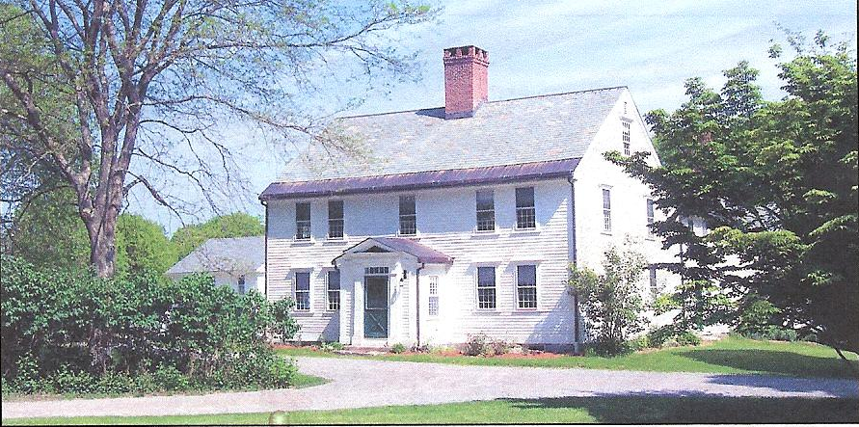

The Bullard Memorial Farm
presents

Wild Edible Plant Walk

Presented by
Russ Cohen

Thursday May 31, 2018
4 to 6pm
Bullard Memorial Farm

7 Bullard Lane
Holliston, Massachusetts

Come enjoy a walk in the woods while learning about wild edible plants.

Tickets are $10/adults, $5/children. To reserve your tickets, please email
bmfaprograms@gmail.com or call (508) 429-1638

and note the # of people in your party. For more information visit www.bullardmemorialfarm.org
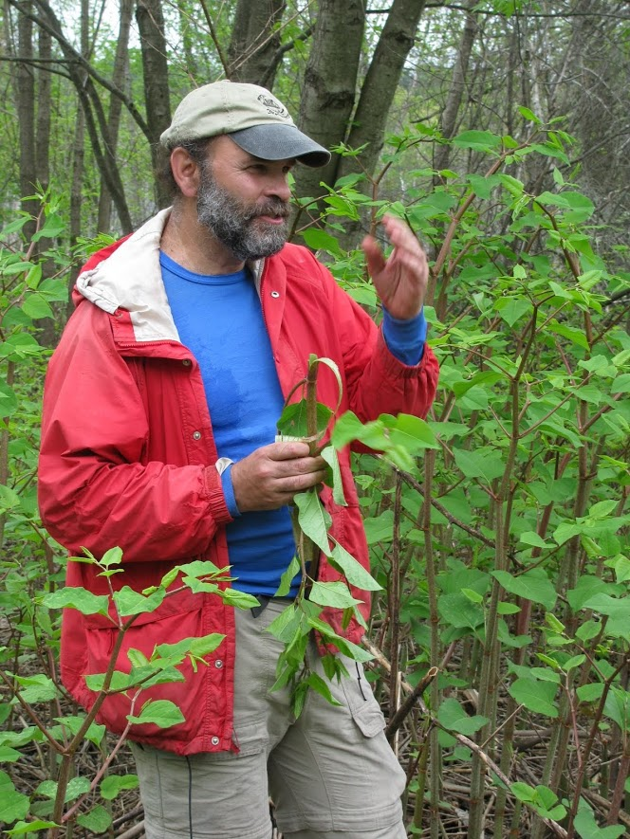

Russ Cohen is a naturalist and wild foods enthusiast. His website is http://users.rcn.com/eatwild/bio.htm

