Ladies in Training: Session 2– October 17th , 2014
Today’s lesson was all about mixtures!
Academics
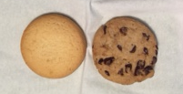
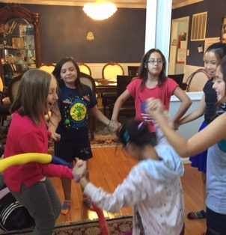
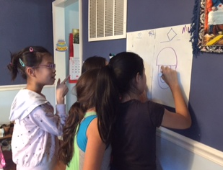
First, we discussed what mixtures are, the types of mixtures (homogeneous and heterogenous), and some examples . We did fun activities where we learned how to pronounce the different terms and identify their differences. Many of the kids used water and oil as a heterogenous example. They enjoyed receiving cookies when they identified which one was homogenous and which one was heterogeneous (sugar and chocolate chip cookies).

Creative/ Teamwork Activities
Then we played some teamwork games. One with a hula-hoop where they held hands in a circle and tried to pass a hula-hoop around without letting go of their hands. Their record time was 8 seconds! Next, they played team pictionary and competed to see who could guess the picture first!

