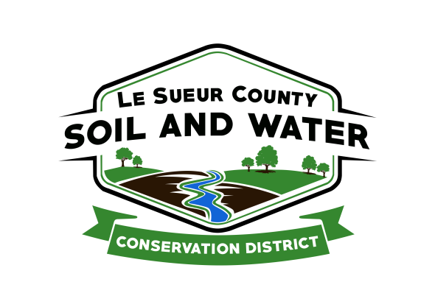

Le Sueur County Soil & Water Conservation District

Le Sueur County SWCD Tel. (507) 419-0365
181 W Minnesota St Website: www.lesueurswcd.org
Le Center, MN 56057

Minutes from July 12, 2022 regular meeting of the Le Sueur County SWCD Board of Supervisors. Le Sueur SWCD Building, Le Center, MN.

Meeting was called to order by Chairman Struck at 8:00 am.

Members present: Chairman, Jim Struck
Vice-Chairman, Greg Entinger
Secretary, Earle Traxler
Treasurer, Cletus Gregor
PR&I, Glendon Braun

Others present: District Manager, Mike Schultz
NRCS Team Lead, Chris Schmidt
District Technician, Joe Jirik
Soil Technician, Goeff Popkin
Resource Technician, Karl Schmidtke
District Conservationist, Steve Breaker
Le Sueur Co. Commissioner, Steve Rohlfing
Program Specialist, Sue Prchal
Bryanna Ramos, NRCS summer intern
Ditch Specialist, Nik Kadel

The Pledge of Allegiance was recited.

Secretary’s report form June 14, 2022 was read and approved.

Treasurer’s report for June 2022 was read. Motion by Entinger, second by Traxler to approve as read and to pay bills.
Affirmative: All
Opposed: None
Motion carried

Mike gave the board a recap of the following:

Area 6 Meeting – JAA (job approval authority), technical training, TSA projects and the leadership grant he received in the amount of $700 for leadership training.

Cannon River Watershed tour – septic inventories, Fox lake (lake management plan), pollution data and a demo of stream sampling

Administrative training – quickbooks, taxes, round table discussions with other SWCD’s

TSA meeting – retaining staff, wage increase for current staff, internship program for new hires

Leadership training – 1st training is in August in Moorhead, MN

Carbon Credit Summit – Joe attended and discussed new technology for farms to qualify that is calculated by soil type and vegetation

There will be a Lower East Minnesota River 1W1P kick off meeting on July 26, 2022 at Cedar Lake Farms in New Prague, MN.

The SWCD will be going through a financial audit on July 27, 2022.

SWCD equipment to possibly sell was discussed. Mike contacted Brent Christian, Le Sueur Co. Attorney, regarding the selling process, if items can be sold open market or competitive bids.

The Polaris ATV won’t be of any value for a trade in so a motion was made by Traxler, second by Entinger to sell as is, outright, for $4000.00 or as close as possible.
Affirmative: All
Opposed: None
Motion carried

The Tomahawk 18” trailer can be sold outright for $5500.00 or as close to that as possible. Traxler making the motion to sell the trailer, second by Entinger.
Affirmative: All
Opposed: None
Motion carried

The South Central TSA would be able to use the GPS survey equipment that the SWCD doesn’t use so a motion was made by Traxler, second by Entinger to give the survey equipment to the Le Sueur Co. GIS.
Affirmative: All
Opposed: None
Motion carried

Mike discussed the possibility of purchasing a drone in the future and using buffer funds to do so.

Motion by Entinger, second by Gregor to encumber $3580.00 for Nathan Traxler cover crop cost-share contract #CC-2022-3 using FY22 Capacity grant dollars. Nathan will be seeding 35 acres of cover crops.
Affirmative: Struck, Entinger, Gregor, Braun
Abstained: Traxler
Opposed: None
Motion carried

Motion by Gregor, second by Traxler to encumber $67,467.94 for Daryl Schoemaker Lake Washington CWF and $22,489.31 Lake Washington Match cost-share contract #WASH-6. Daryl will be restoring a wetland.
Affirmative: All
Opposed: None
Motion carried

Mike informed the board that the Water Quality and Storage Pilot Grant that the SWCD applied for was funded in the amount of $408,187.00. Motion by Traxler, second by Entinger to give Mike Schultz authority to sign the grant agreement.
Affirmative: All
Opposed: None
Motion carried

Steve and Chris gave an NRCS report. Steve discussed EQIP, construction projects, assisting FSA with 1026’s and CRP, SWCD assisting NRCS with CRP plans and introduced Bryanna Ramos who is the NRCS summer intern from California. Chris informed the board of new staff in the Area and talked of EQIP.

Commissioner Rohlfing discussed grants from the State for installing fiberoptic, Lake Washington County Park, ATV ruling of driving on county roads.

County Ditch #54 mowing and spraying, was discussed as was the buffer deadline, which was 7/7/2022, with some landowners being noncompliant in the county.

The regular board meeting was closed to discuss the 2023 budget. Motion by Traxler, second by Entinger to accept the budget for 2023.

The board and staff attended the 2022 Outstanding Conservationist tour. Luke Retka was chosen as the 2022 Le Sueur County SWCD Outstanding Conservationist.

____________________ _____________________________________________
Date District Secretary

