Eco Orca’s OCTOBER 2023 Forest, Harvest, Thanksgiving, Halloween
SUNDAY |  | MONDAY | TUESDAY | WEDNESDAY | THURSDAY | FRIDAY | SATURDAY
 | 1 | 2 | 3 | 4 | 5 | 6 | 7
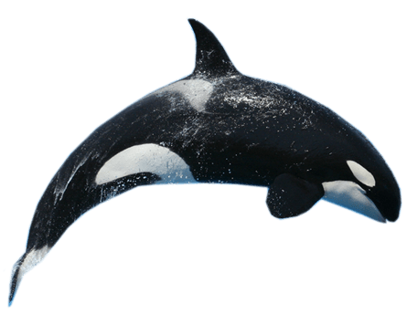 |  | Closed  Stat | Elk Lake | JDF Trails and Park | Island View Beach | Devonian Beach
 | 8 | 9 | 10 | 11 | 12 | 13 | 14
 |  | Closed Stat  Thanksgiving Day | Ed McGregor Dock | Gyro  Park | Ruby Creek Hike | Central Saanich Park and Farm
 | 15 | 16 | 17 | 18 | 19 | 20 | 21
 |  | Francis King Park  Forest Walk | Matheson Lake Trails | Highlands Park | Beacon Hill  Park and Moss Lady | Pro-Day | 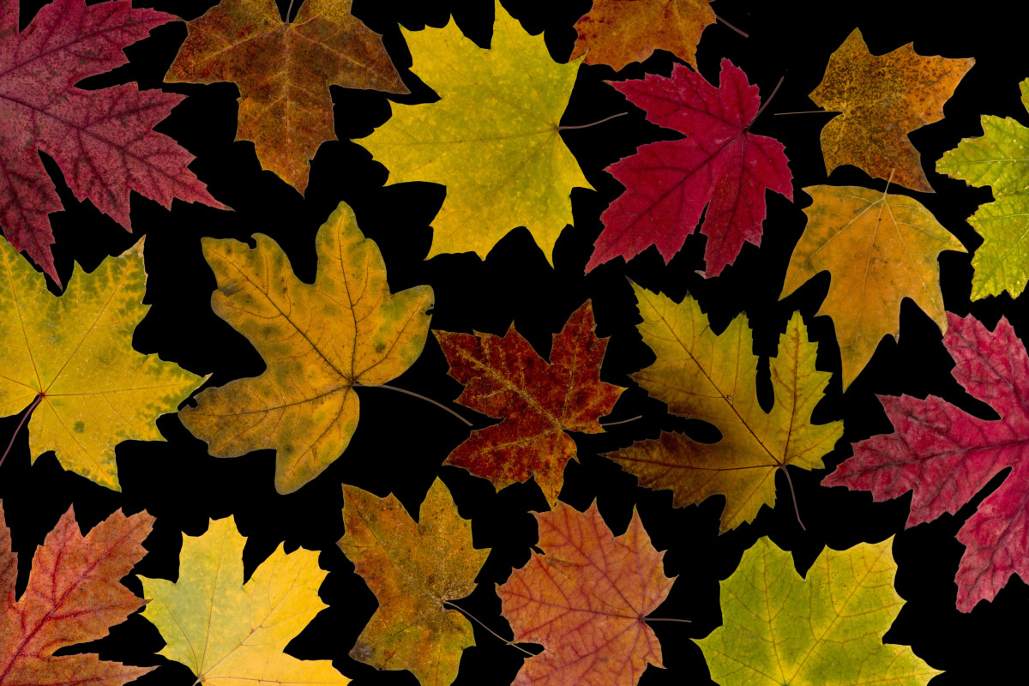
 | 22 | 23 | 24 | 25 | 26 | 27 | 28
 |  | Honey Crisp Park | Royal Roads Charlies Trail | Esquimalt Lagoon | Kelly Rd Park | Royal Roads Trails
 | 29 | 30 | 31 | 1 | 2 | 3 | 4
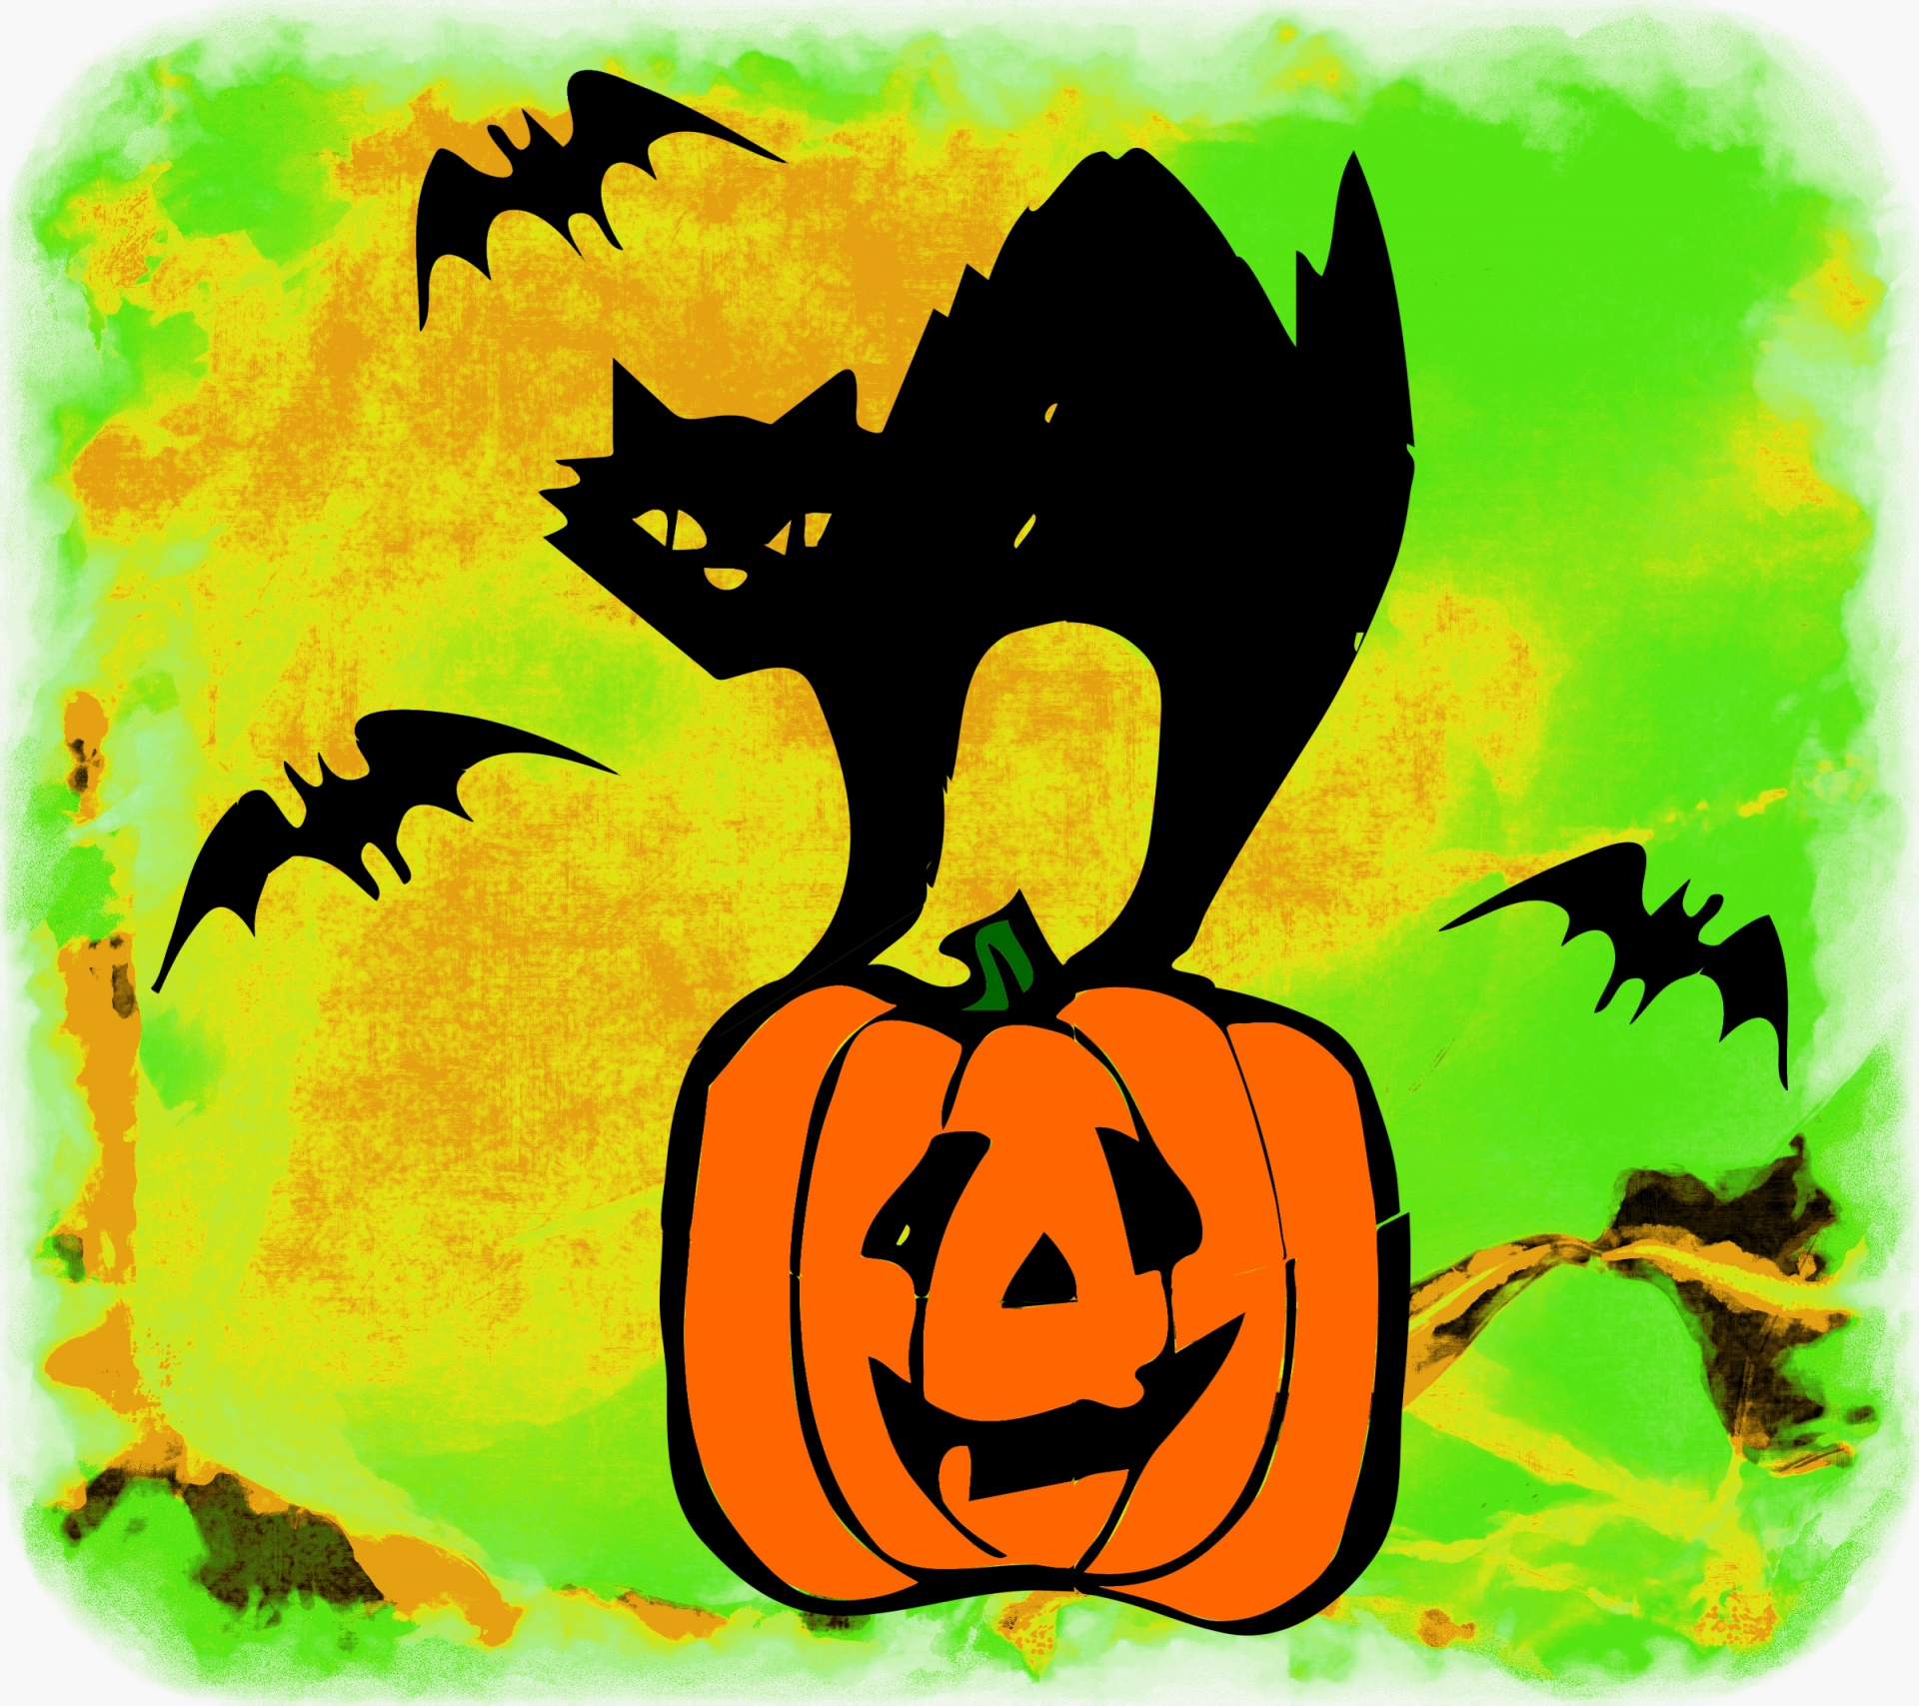 |  | Mitchell’s Farm Pumpkins $5 | Halloween Party!

