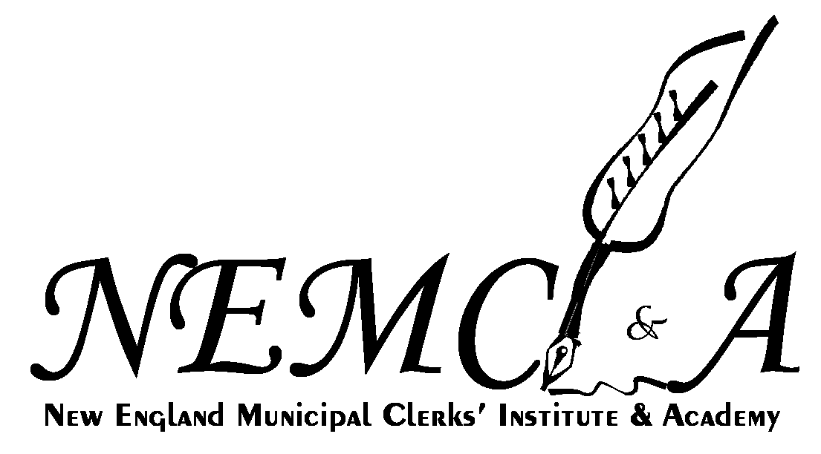

Grow and Learn with us…


2017
HANDBOOK

The purpose of this handbook is to familiarize you with some of the traditions and policies that have been established at the New England Municipal Clerks’ Institute and Academy, and to give you an idea about what to expect during the NEMCI&A Program.

It is important for you to work as a team with your class members. We encourage communication between the classes, the faculty and the NEMCI&A Board of Directors. We are here to help you.

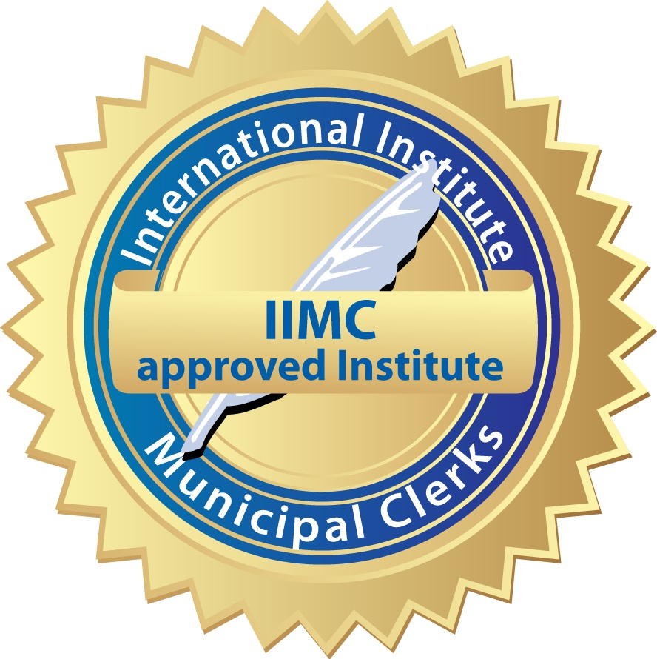
1.
******************************
New England Municipal Clerks’ Institute & Academy
POLICIES AND PROCEDURES

NEMCI&A Policies:

ABSENCES: There are no provisions for being absent and you must be at your classes on time. There is strict adherence to IIMC requirements for satisfactory completion of the courses.

CHECKOUT: You must be out of your room by 10:00 a.m. on Friday morning. Checkout consists of placing your completed evaluation in the box provided and dropping your key –in its original envelope—in the key box. Both boxes will be in the lobby next to the main door.

CONDUCT: Participants are expected to conduct themselves in a professional, mature and responsible manner that reflects highly on themselves, their municipality, and this organization.

EARLY ARRIVALS: Early arrivals cannot be accommodated. Private arrangements must be made on your own at a local establishment.

HOUSING: Housing accommodations for the Institute and Academy are for students, faculty and board members only. Your tuition includes housing. All institute students are required to stay in the dormitory.

ID BADGE: You must wear your ID badge at all times outside of your room.

IN CASE OF EMERGENCY: Plymouth State University’s main office number is (603) 535-5000. Students are asked to check the bulletin board in the multi-purpose room for messages.

KEYS: Keys are to be kept with you at all times. You will receive two keys, one for the front door, and one for your room. Do not discard your key envelope. Keys must be returned in the original envelope on Friday. There is a $25.00 charge for lost keys and/or lost envelopes.

LATE ARRIVALS: If you cannot arrive before 4:30 p.m. on Saturday, please contact a Board member.

REFUNDS: In cases where the applicant makes a payment and scholarship monies received create an overpayment, a request for a refund must be accompanied by a copy of the cancelled check mailed by the applicant, as well as a letter from the source of the scholarship. There will be no pro-rating of tuition/fees for students attending the Institute or Academy. The $75.00 registration fee is non-refundable.

REFUNDS DUE TO ILLNESS: If a student does not appear on the opening date of the Institute or Academy due to hospitalization, NEMCI&A will refund the room, board and tuition fee less $50.00 for processing. Documentation will be required before refunds will be given.

Academy Procedures:
There will be three registration sessions for the Academy, all at Langdon Woods:

SATURDAY, JULY 8, 2017  FROM 2:30 TO 4:30 PM | Academy A -4 day Sun/Mon/Wed/Thurs
SUNDAY, JULY 9, 2017  FROM 3:15-4:30 PM | Academy B -2 day Mon/Tues  Academy C – 2 day Mon/Tues
TUESDAY, JULY 11, 2017  FROM 2:30 TO 3:30 PM | Academy D -2 day Wed/Thurs

2.
******************************
Institute Procedures: Here's what to expect...

Day 1   | Registration, Reception, Orientation and First Class for Year I Students  REGISTRATION: 2:30 to 4:30 p.m. Saturday July 8, 2017  Additional assignments, schedules and information will be available at that time. Please make every effort to arrive on time. Late Arrivals should contact a Board Member.  RECEPTION: Join us for some light refreshments.  There will be a welcome reception sponsored by Kofile Technologies in Langdon Woods Residence Hall Media Room Saturday from 2:30 to 4:30 p.m. There will be no dinner on this night.  ORIENTATION: Mandatory orientation for all students will begin promptly at 6:15 pm on Saturday at the Hyde Hall Theatre Room 220. Last minute details, special meetings and possible schedule changes will be announced at this time.  FIRST CLASS: Year I students will attend their first class on Saturday night.  They meet with their Class Advisor immediately after Orientation.
  Langdon Woods Residence Hall
  7 Armory Road
  Plymouth, NH 03264

Day 2   | Classes, Classes...  PRE-WORK: Pre-work assignments are to be brought to your first class.
Day 3 | Monday evening provides the opportunity for dinner on your own with friends or classmates. Check out www.lakesregion.org to further explore the region.

Day 4 | ...and More Classes

Day 5 | Party
 | Wednesday evening from 7 to 10 pm is reserved for the graduating class party at Newfoundland Room. You won't want to miss it! See the invitation in the information packet. Creative costuming is encouraged!

Day 6   | Graduation Evening
GRADUATION AND BANQUET: Thursday evening at The Common Man Inn,

231 Main Street, Plymouth, NH 03264

***Cocktails at 6:15 p.m., Graduation at 6:45 p.m., followed by dinner***

- Those preferring a vegetarian meal or those with special dietary restrictions should email the Banquet Chair as soon as possible at caquilante@smithfieldri.com

- Additional banquet reservations must be made and paid for at registration. All reservations are final after that date.

3.
******************************

Dormitory Life | Things to know...  CHECKOUT ON FRIDAY is at 9:00 a.m. This consists of handing in both your evaluation form and your key with its original envelope.  CLASS BREAKS: There are soda/water machines in some of the classroom halls. The snack bar in the HUB is open Monday – Friday from 7:30 a.m. to 1:30 p.m. The Book Store is open all week. A travel coffee mug and refillable water bottle come in handy.
 | COFFEE CAFÉ AT LANGDON WOODS LOBBY: available at 6:30 a.m.
 | KEYS: Keys are to be kept with you at all times. You will receive two keys, one for the front door, and one for your room. Do not discard your key envelope. Keys must be returned in the original envelope on Friday. There is a $25.00 charge for lost keys and/or lost envelopes.
MEALS:
- No dinner will be served on Saturday or Monday and no breakfast on Friday.
- The regular daily dining hours are:
Breakfast 7:00 – 7:45 a.m., Lunch 12:15 – 1:15 p.m., Dinner 5:30 – 6:15 p.m.
- On Wednesday we will have dinner, then join the third-year class for their Graduation Party.
- Tuition includes breakfast, lunch and dinner for all Institute and Academy students with the exception of Saturday and Monday night.

ROOMS: Rooms are air-conditioned, pre-set to 76 degrees. There are double and suite rooms (quads). Your room will be pre-assigned. You may request a roommate on your registration form; otherwise we will place you with a classmate. A limited number of single rooms are provided to those students that have medical issues, for an additional $40.00 per night charge.
*Bring a fan with you if you want to feel cooler. The room temperatures cannot be changed.

 | SNACKS AND DRINKS: Bring your own – and don't forget your own plastic or paper goods, as none are provided.
 | TOWELS AND LINENS: A bath towel, hand towel, wash cloth, pillow, blanket and set of sheets will be provided. They will not be exchanged during the week. You may want to supplement the linens by bringing additional towels and dorm length single bed sheets. Plan to bring your favorite pillow and a blanket or coverlet, since the rooms are air-conditioned. Beds will be made prior to arrival.
WHAT TO PACK: See Page 5.

WHAT TO WEAR:
- Casual comfortable clothes
- Comfortable shoes for walking
- Dress clothes for the Banquet and Graduation
Note: The dormitory is air-conditioned, many classrooms are not.
Be prepared for both hot and cool weather.
You will be walking between buildings
and should prepare for rain as well.

WIFI: Langdon Woods Resident Hall is WIFI accessible. The password will be provided.

4.
******************************

YEAR I

Traditionally, the first year class will organize and elect representatives such as a president, spokesperson, treasurer, and secretary, etc. Some classes collect dues and plan fund-raising events to purchase class shirts or hats and to pay for their third-year party, a long-standing NEMCI&A tradition.

A picture display of your town, staff, office and anything else you can add to tell us the story of your Municipality is required by each first year student. Please see the Picture Display in the information packet on the website.

In order to apply for CMC status, you must be a dues paying member of the IIMC for two years. Year I students should make sure they are enrolled in IIMC if they are working towards their CMC certification.

Your schedule of classroom locations and class times will be provided at the time of registration. Bring your own office supplies such as staplers, scissors and tape. You must wear your identification badge at all times.

YEAR II

Year II students should review finances and plan your third year party. You will meet with your Class Advisor immediately following the Orientation Meeting. Party plans for your third year must be approved by the Board of Directors.

Other things you should also consider:
- Arrange location, theme, entertainment and presentations.
- Coordinate food with Food & Banquet Chair.
- Charge responsibilities of invitations (design, information and mailing).
- Choose your color guard (member of each state plus the American Flag).
- Are you leaving a gift to the Institute at graduation? (NEMCI&A tradition).
- Make arrangements to speak with members from Year 3 regarding the costs associated with the party.
- Discuss who your graduation speaker will be. This person will represent you at graduation and deliver your class speech. The Board of Directors will need this information no later than May 1, 2018 to prepare the Graduation Programs.

YEAR III

The Third Year Class will vote on the recipients of the Lobster Award, the Henry Paquin Memorial Scholarship and the Clyde McKee Scholarship Award. Please let your Class Advisor know who was chosen no later than Tuesday afternoon.

Graduation:
- All class members must attend graduation rehearsal.
- Your class is responsible for the music played at graduation. (Prior approval by the Board is required. See your Advisor for suggestions.) This needs to be arranged well before arriving at NEMCI&A.
- Select three members to represent your class in a meeting with the Board of Directors to discuss your experience at NEMCI. We welcome your comments and/or suggestions about the program.
- Dress for the occasion. It is Graduation Night – this is a night you will want to remember.
- Remember to make arrangements for your guests. A list of local bed and breakfast facilities, hotels and motels can be found at: www.lakesregion.org If you need assistance, you may contact any member of the Board of Directors.

5.
******************************

THINGS TO BRING:

1. Your Medical Release Form.
2. Your Sexual Harassment Policy Acknowledgment.
3. Your Press Release, if desired.

For Class  - Your Pre-Work  - Display Poster (Year 1)  - USB Flash Drive  - Travel mug and water jug/bottle  - Network cable (if you bring a laptop without a wireless connection)  - Office supplies  (binder, notebook, scissors and tape, etc.) | For Your Bed  - An egg crate foam pad  - Mattress pad  - extra sheets, blanket or comforter  - Pillow | For Your Room  - Coat hangers  - Alarm clock  - Small Mirror  - Extension cord  - Radio  - Small coffee maker  - Fan  - Small lamp for reading  - Trash bags  - Printer & paper  (work this out with your roommates/classmates)
For The Bathroom  - Towel, facecloth  - Bathroom toiletries  - Beach towel  - Bath mat  - Hair dryer  - Extra Toilet Paper (-there's never enough!)  - Paper towels/tissues  - Soap | For the Lounge/Suite  - Cash (raffles, drawings)  - Lawn chair  - Iron, Ironing Board if desired  - Snacks  ◻ Cooler or dorm-size refrigerator (work out with your roommates)  ◻ Insect Repellent | Clothes  - Jacket, sweater/sweatshirt  - Umbrella or rain poncho  - Sneakers (there is a 24-hour exercise room)  - Dress outfit for Thurs.  - Party outfit for Wed.

And last, but not least:

- Dolly or cart to transport all this stuff from car to dorm!

None of the items listed above are required, merely suggestions. There are many shops in town, as well as a Wal-Mart, Dollar Store, and grocery store.

NO MICROWAVES, TOASTER OVENS OR HOT POTS ARE ALLOWED. A microwave is available in the dormitory kitchen.

