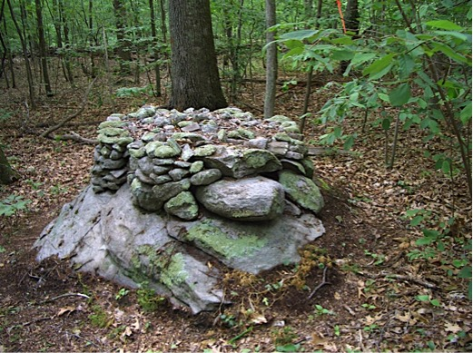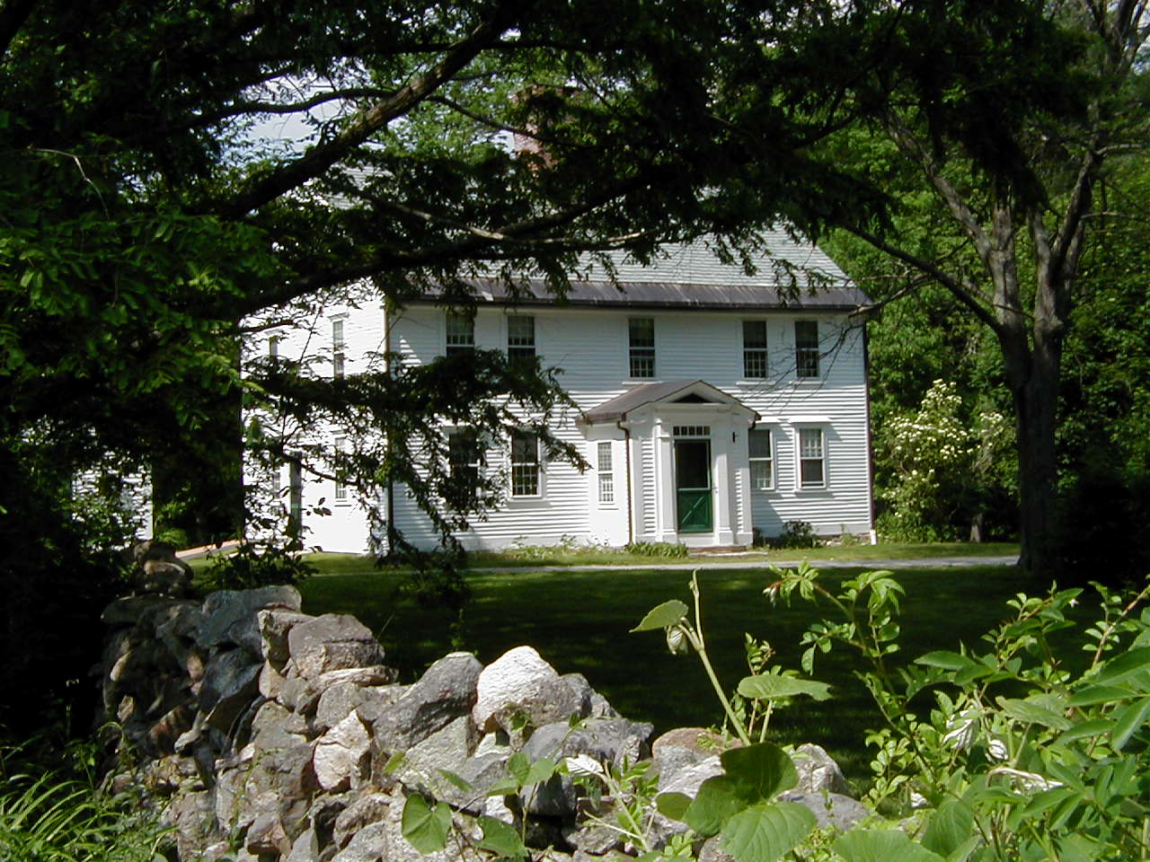

Saturday, April 7, 2018

2:00-4:00

7 bullard lane, holliston, ma

Tickets are $5/person, children free. To reserve your tickets, please email

bmfaprograms@gmail.com or call (508) 429-1638

and note the # of people in your party. For more information visit www.bullardmemorialfarm.org

Bullard Memorial Farm

Presents

LET THE LANDSCAPE SPEAK

✹

✹

FEATURED SPEAKER

Doug Harris, Deputy Tribal Historic Preservation Officer,

Narragansett Indian Tribal Historic Preservation Office

The Indigenous Ceremonial Stone Landscape is of cultural significance to the Tribes of the northeast. Mr. Harris will explain why these ceremonial features should be preserved, and what to do if you would like to help protect this important landscape.

# THE IMPORTANCE AND MEANING OF THE INDIGENOUS CEREMONIAL STONE LANDSCAPE

✹