|  |  |  |
| --- | --- | --- |
| C:\Users\ParkTKD\Dropbox\TKD\케릭터\ParksLogo.jpg  September 2017  Volume 5, Issue 4 | Park Times  Long Beach Edition  World Hong Ik Tae Kwon Do  Quarterly News Letter | C:\Users\ParkTKD\Dropbox\TKD\케릭터\TKD Art\attack2.wmf |

**\* Upcoming Events \***

Grandmaster’s Message

Grand Master Park’s message for fall is self-love. Loving yourself is an important part of enjoying and getting the most out of your life. It's also crucial for getting and maintaining satisfying relationships with others. Loving yourself is mainly having self-respect, which is the only dependable way to create love in your own life. In order to be loved, you must love and respect yourself as much as you do others.

Loving ourselves is not done as an expression of the ego where we centralize only on ourselves, but as a genuine appreciation of our humanness in a world that is constantly changing.

**9/5-8 – Breaking Week**

**9/8 & 12/16 – Color Belt Test**

**9/25-30 – Buddy Week**

**9/30 Open House/Fundraiser**

**10/7 – Overnight Training**

**10/9 – Closed for Columbus Day**

**10/22 – Bear Mountain Hike**

**10/31 – Halloween Party**

**11/4 – 4th Annual Island Cup Championship**

**11/18 – Black Belt Test**

**11/23-25 – Closed for Thanksgiving**

**11/24 – Black Friday Camp (But, no Reg. Class)**

**12/13 – Tiny Tigers Test**

**12/14 – Little Tigers Test**

**12/25 – Closed for Holidays. Until New Year 1/1**

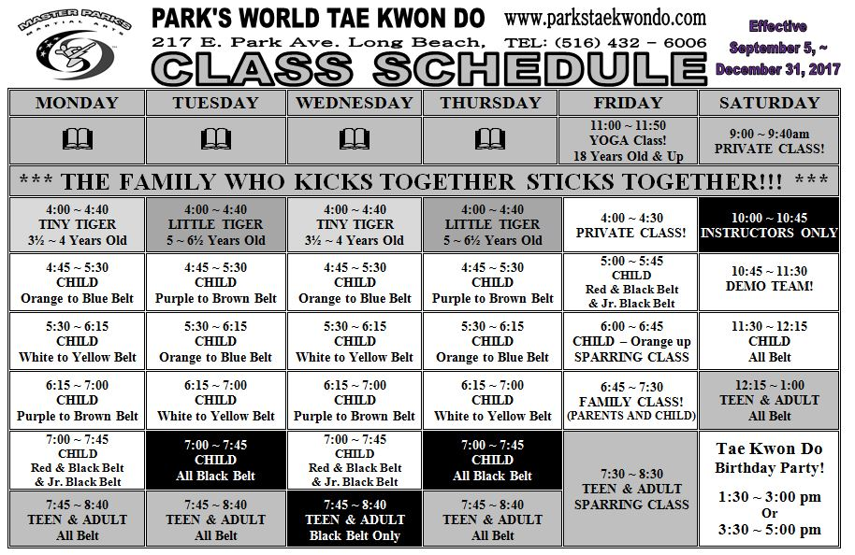

|  |  |  |  |  |  |  |  |  |  |
| --- | --- | --- | --- | --- | --- | --- | --- | --- | --- |
| September 2017  **Anti-Bullying Message**  TKD training teaches us to be leaders. Not just in class but to bring leadership skills to every aspect of our lives, children and adults. When you see someone being bullied, **DO SOMETHING!** It is not good enough to simply avoid the situation and not participate in the bullying. A martial artist should have the confidence to help someone who is being bullied. You must at least bring it to the attention of a teacher or adult in charge. Remember the 1st Pillar of TKD: RESPECT. Treat others as you would like to be treated. If it was you being bullied, wouldn’t you want some help?  **Black Belt News**  Good luck to the following students who will be  testing for Black Belt on Saturday, November 18th .   |  |  |  | | --- | --- | --- | | |  |  | | --- | --- | | **1st Degree**  Jonathan Berzner  Lina Diamond  Matthew Diamond  Matthew Huaco  Emily King  Daniel Malul  Shamia Williamson | **2nd Degree**  Aidan Bolger  Kevin Chumpitaz  **3rd Degree**  Romeo Alolor | |   Black Belts testing for stripes will also be tested on Saturday, Nov 18th in Long Beach.  **Color Belt News**  To reach the full potential as a martial artist, you must begin by training your mind. One way to accomplish this task is through sitting meditation. Through meditation your awareness, calm, and focus will increase. These are all very important factors in martial arts. Without awareness, you will not be able to fight in a battle without getting hit or even killed. Without focus, you will not be able to catch the right opportunity to strike or defend, which could be disastrous. Without calmness, you will not be able to focus or relax. If you tense up out of fear, you will burn out quickly. You must learn how to manipulate your energy so it will not disperse unused. Also you can activate more energy when it is really necessary.  **Welcome** to all of our new students. When you become a student here at Park’s Martial Arts Tae Kwon Do School, you become a member of our Tae Kwon Do family. | | | | | | |
| Sunday | Monday | Tuesday | Wednesday | Thursday | Friday | Saturday |
|  |  |  |  |  | 1  Closed for Labor Day | 2 |
| 3  Closed for Labor Day | 4 | 5  Board Breaking Week | 6 | 7 | Color 8  Belt Test | 9 |
| 10 | 11 | 12 | 13 | 14 | 15 | 16 |
| 17 | 18 | 19 | 20 | 21 | 22 | 23 |
| 24 | 25  Buddy Week | 26 | 27 | 28 | 29 | 30  Open House  Fundraiser |

|  |  |  |  |  |  |  |
| --- | --- | --- | --- | --- | --- | --- |
| October 2017 | | | | | | |
| 1 | 2  Board Breaking Week | 3 | 4 | 5 | 6 | 7  Overnight Training |
| 8  Closed for  Columbus Day | 9 | 10 | 11 | 12 | 13 | 14 |
| 15 | 16 | 17 | 18 | 19 | 20 | 21 |
| 22  Bear Mt Hike | 23 | 24 | 25 | 26 | 27 | 28 |
| 29 | 30 | 31  Halloween Party |  |  |  |  |

|  |  |  |  |  |  |  |
| --- | --- | --- | --- | --- | --- | --- |
| November 2017 | | | | | | |
|  |  |  | 1 | 2 | 3 | 4  Island Cup  Championship |
| 5 | 6  Board Breaking Week | 7 | 8 | 9 | 10 | 11 |
| 12 | 13 | 14 | 15 | 16 | 17 | 18  Black Belt Test |
| 19 | 20 | 21 | 22 | 23  Closed for Thanksgiving | Camp 24  Black Friday | 25 |
| 26 | 27 | 28 | 29 | 30 | Dec 1 | Dec 2 |

|  |  |  |  |  |  |  |
| --- | --- | --- | --- | --- | --- | --- |
| December 2017 | | | | | | |
| **3** | 4  Board Breaking Week | 5 | 6 | 7 | 8 | 9 |
| 10  **Our Staff**   |  |  | | --- | --- | | **Grand Master Su Hyun Park** | **OM & Instructor: Lisa Dexter** | | **Master Won Chan Jang**  **Master Doo Jin Park Instructor: Maxwell Dexter**  **Instructor: Erin Kelly**  **Instructor: Alfred Calambo** | **Instructor: Romar Delauta**  **Instructor: Damon Park**  **Instructor: Winter Landman-Herd**  **Instructor: Jordan Moses**  **Secretary: Christine Cazzola** | |  |  | |  |  | | 11 | 12 | 13  Tiny Tigers  Test | 14  Little Tigers  Test | 15 | 16  Color Belt  Test |
| 17 | 18 | 19 | 20 | 21 | 22 | 23 |
| 24  **\* Closed for Holidays/Vacation * Happy New Year!! \*** | 25 | 26 | 27 | 28 | 29 | 30 |