Bodywork in End of Life Care: Journeys in Dying © 16 CE hours
Mary Meg Robsahm, M.Ed., LMT, BCTMB, NCTMB approved provider #586
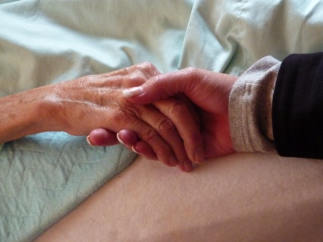
350.00 early bird by:
375.00 thereafter; all fees include one very full class materials binder
This two day course offers fundamental concepts in palliative and hospice care massage. Participants will:
- Understand the spectrum of care needs and learn how to adapt our work
- Gain practical information about the dying process, pain & end of life symptoms
- Develop mindful communication skills including working with the verbally impaired
- Learn the massage adjustments necessary to work safely with this clientele
- Engage in a supervised massage peer clinic as a therapist and as receiver
- Develop our healing presence with the dying
- Examine personal perceptions and self-care tools that inform our professional boundaries
This is an interactive course that includes a blend of lecture, case studies, small group discussion, presencing skill development, and hands on time. It will help the practitioner move beyond their concerns in working with this clientele, allowing us to open to sacred moments and presence deep peace with the dying. Because this is a highly interactive course, everyone walks away with something meaningful for them self and/or their clients. It is as personally enriching as it is professionally challenging.

Meg Robsahm, M.Ed., LMT, BCTMB, has specialized in oncology and hospice massage since 2001 and believes that massage can bring an olive branch of peacefulness to the soul. Her current practice includes in home/facility hospice and palliative care clients in Rochester, MN. She has developed and teaches Bodywork in End of Life Care: Journeys in Dying©. Meg holds a master’s degree in Counseling Psychology, and is certified as a Bereavement and End of Life Care Specialist through the University of Wisconsin-Madison. She has co-authored chapter 11, End of Life Care, in the 3rd Edition of Medicine Hands: Massage Therapy for People with Cancer with Gayle MacDonald; as well as articles on end of life care for the Washington State AMTA Journal. She is the First Past President of the Society for Oncology Massage and a 2007 Graduate of the Peregrine Institute of Oncology Massage Training. Prior to her massage career she was an instructor and counselor in higher education leadership positions.

