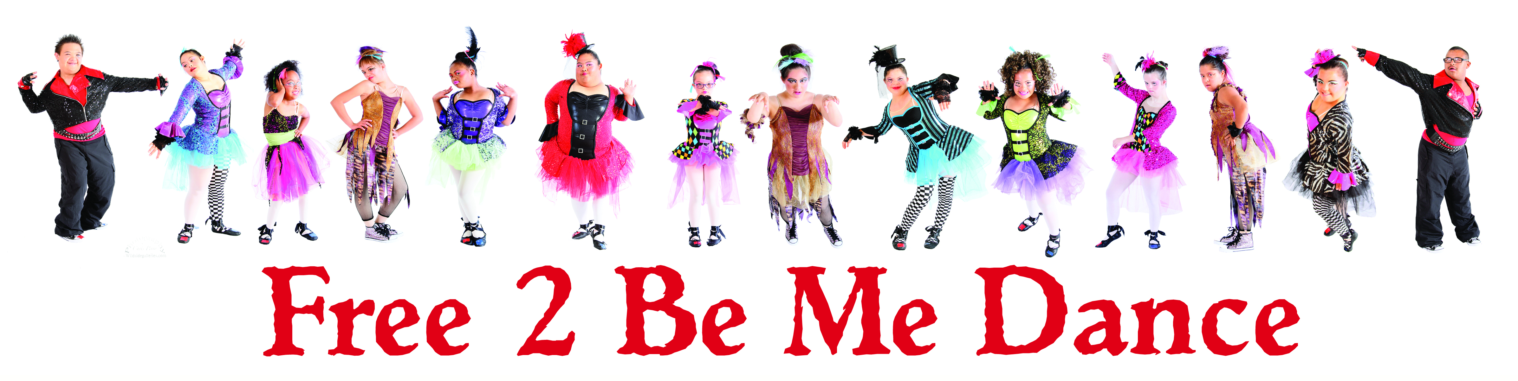
Free 2 Be Me Dance Volunteer Application

Name:
Age:
Phone:
Email:
Address:
School or work affiliation:
What is the best way to contact you? Text Phone call Email
Volunteering for community service hours? Yes or No

How did you hear about Free 2 Be Me Dance?

What sparked your interest?

Are you interested in short-term or long-term commitment?

Would you be interested in teaching in the future?

What else would you like us to know about you?

-------------------------------------------------
Signature/date

