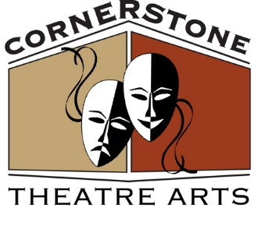

**PROUDLY PRESENTS:**

**William Shakespeare’s**

**“The Taming of the Shrew”**

**(twisted and turned)**



**July 20, 21, 27 & 28 at 2:00PM**

**Script adaptation by Brittany Pierce-Caiazza**

**Directed by Ken Tschan**

**SALESIAN PARK-GOSHEN, NY**

**RAIN OR SHINE UNDER THE BIG TENT**

**FREE ADMISSION-BRING A LAWN CHAIR**

**Sponsored by The Goshen Public Library & Historical Society**