**CHELMSFORD & DISTRICT BOWLING ASSOCIATION**

**PRESIDENT’S TOUR 2025**

**The Presidents Tour will go on Saturday 5th July to Sunday 13th July.**

**Eight nights, at The Hotel Prince Regent, Weymouth.**

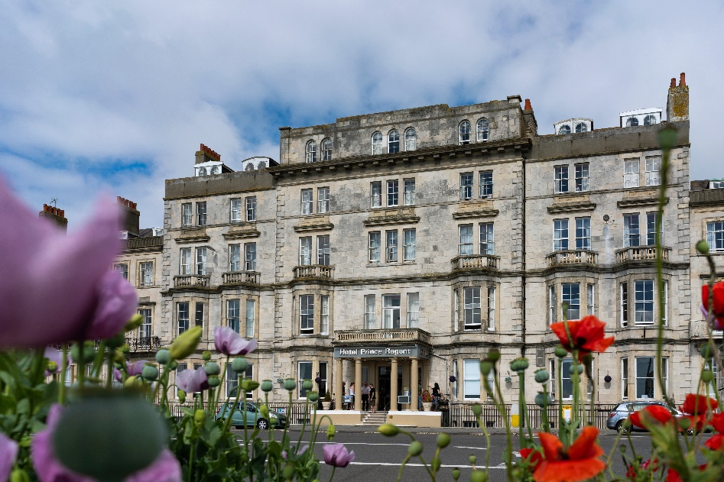

The cost of the tour will be **£670 per person, All Double and Twin rooms have sea view. Single rooms will be £ 665 or £650 I will explain for single you need to contact me.** The price includesall coach travel to and from Chelmsford, half-board terms at the hotel, travel to all games, green fees and driver gratuities. I can email you a deposit form and information on the tour for you to send in with your deposit.

We will be playing 6 games with 1 day free to explore Weymouth and surrounding areas.

If you would like to reserve a place, please complete the application form below and return it to Mavis Gardiner. 7 Orchard Road. Southminster. CM0 7DQ. **as soon as possible as single rooms are ln demand.** together with your deposit of **£50 per person (final balance payment to be made no later than 15 May 2024.** You can pay by BACS Barclays Bank quoting name as reference, sort code 20-19-95. Account no 80270474. Or by cheque.

Please reserve ………. Place(s) for me (us) on the Chelmsford & District Bowling Association Presidents Tour 2024 I enclose my cheque for £……… as a deposit.

Male-Bowler…... Playing Position ...... Lady-Bowler.…. Playing Position…...

My/Our accommodation preferences are as follows:

Twin bedded room …… Double room ……. Single room. Please enquire. 01621778487

Please indicate any special accommodation/dietary requirements, which we will endeavour to meet.

Please email a copy to Alby at: [albert.evans44@gmail.com](mailto:albert.evans44@gmail.com)

And to Mavis at: [mavisgardiner7@gmail.com](mailto:mavisgardiner7@gmail.com)

NAME (s) ………………………………………………….…. Club …………….………….………

Address……………………………………………………………………………………….……….

………………………………………………………………………………………………………….

Email Address…………………………………………………………………………………………

Telephone No.