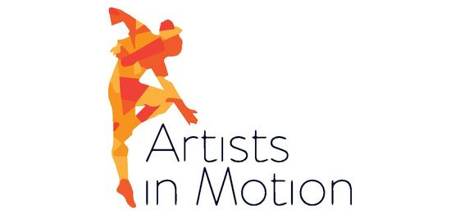
Calling all 4th graders and up to join our community outreach dance performance group!
-AIM will take place on Wednesday’s 4:30-5:30pm (Jan-May)
-AIM performances include…
Dance-a-thon Benefit at the studio (March 9th – definite date)
Iron Pigs Game (April 13th – definite date)
Nursing Home (April 28th – tentative)
Spring Showcase (opening number of the show!)
*Members will have to be enrolled in a winter Jazz class to participate, as that is the main technique/choreography for AIM. Parent Meeting before rehearsals begin.
No more than 2 absences will be allowed from Jan-May. Performers can only miss 1 performance. Please inform us of prior commitments before we begin rehearsing, so we can re-block the spacing in advance.
If your child cannot fully commit, please DO NOT JOIN! It is not fair to the other performers when members are repeatedly absent from rehearsal & performance events. If a member is asked to leave, a refund will not be given.
All absences will have to be communicated directly to Ms. Colleen via email. If attendance becomes an issue, your child will be asked to leave the company or not perform.
COST - $100 (includes all rehearsals & costume top)
We take pride in our performances at Movement Theater and want to present the best routines and performers we can! Commitment and full participation with repeated practice will bring the best results. This is our focus in Artist In Motion, as we share our hard work & talents with the community!

