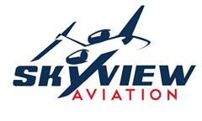
2009 CTLS
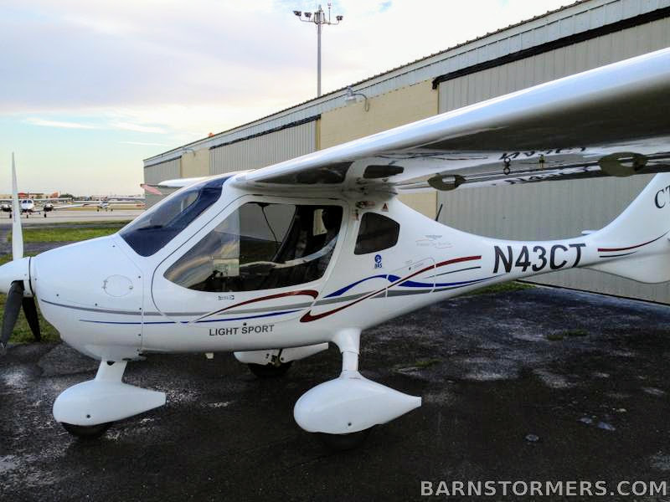
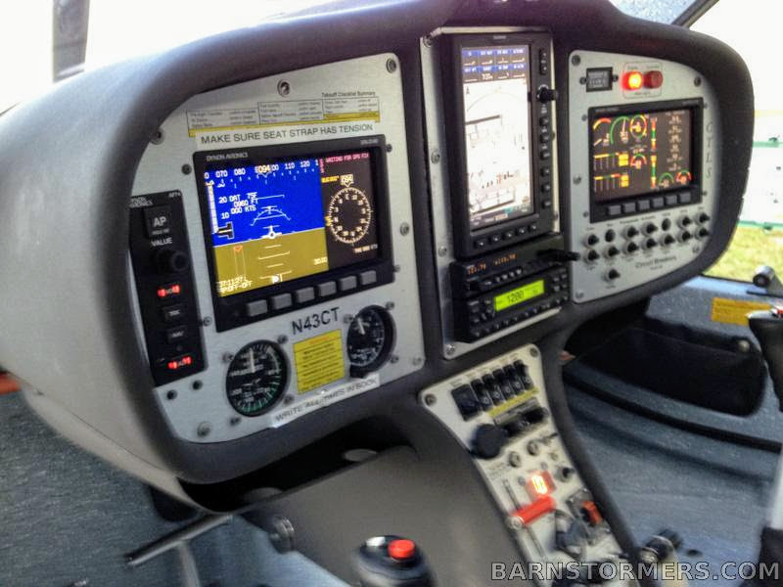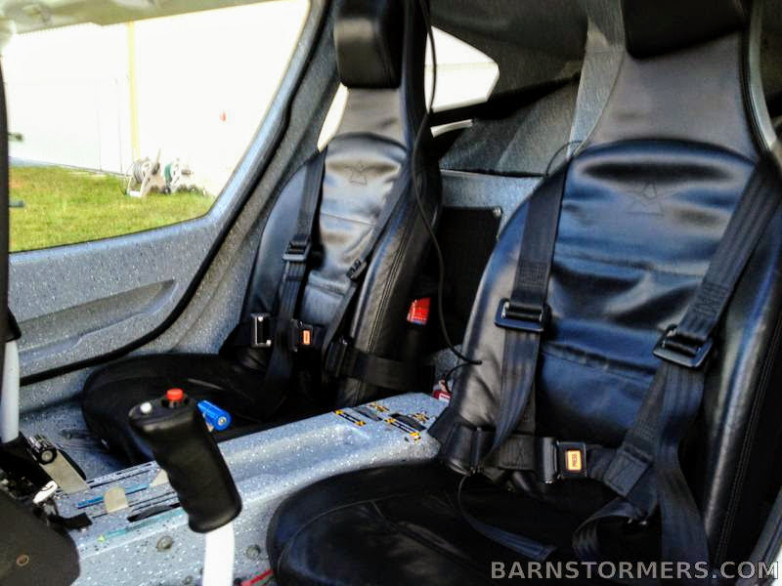
$69,900 OBO

- TTAF: 1778
- Engine TBO: 2000 hours
- All Airframe and Engine Logs
- Annual: 11/30/17

- Parachute Repacked 1/31/15
- Wing Inspection Done 11/1/16
- Rotax Hose Replacement Done 2/12/14

_____________________________________________________________________

For more information contact rfkrentz@skyviewaviation.com
Or call at 209-830-7666
FAX 209-835-7667

2009 CTLS
Operational Specs
Registration: N43CT
TTAF: 1778 HRS
SN: f-09-01-08
Engine
- Engine TBO: 2000
- 4 Cycle
Parachute
- Repacked 1/21/15
- Next due 1/31/21
Wings
- Inspection completed 1/21/15
- Next due 11/30/18
Rotax Hose
- Replaced 2/12/16
- Next due 2/12/19
Avionics:
- Dynon D100 EFIS
- Dynon D180 EFIS/EMS
- Garmin SL40 com
- 696 GPS with weather and TIS traffic
- Artex ME 406 MHz ELT
- CT Pilot Digiflight II VS autopilot
- Black leather interior
- LED landing light
- Heavy duty Tundra tires
- Cabin heat
- Garmin GTX 330 Mode S Transponder with TIS traffic

