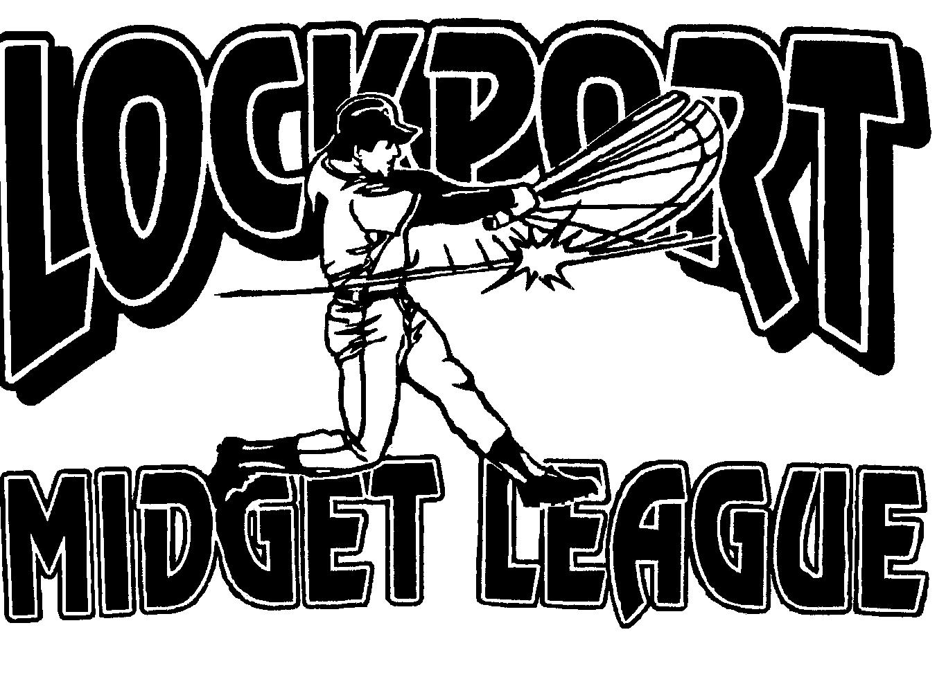
Lockport Midget Baseball League
www.lockportmidgetbaseballleague.com

Player Contract
“A” League “B” League
16-17-18 13-14-15

I, ____________________________, the undersigned, being permitted to play with _________________

Team, hereby certify on my honor to the truth of the following:
Name: ______________________________________________ | Date of Birth: __________________
Address: ____________________________________________ | Age: | _______________
City, State: __________________________________________ | Phone: ________________________

As a member of the Lockport Midget Baseball League, I pledge myself to: |  | Age Cut off Dates:
 |  | A League – June 1st
1. | Player is responsible for completing contract and return to coach. | B League – June 1st
- Demonstrate at all times the highest ideals of sportsmanship.
- Give my best effort no matter what the score or playing conditions may be.

- Respect all league officials, rules, fellow athletes, and spectators.

- Conduct myself in such a manner as to be a credit to my team, my sponsor, the Lockport Midget Baseball League, and myself.

- Carry on the high ideals of fair play and clean competition that have been established by the Lockport Midget Baseball League.

Player’s Signature: ________________________________________

Athlete Release by Parent /Guardian

I, _______________________________, individually and as a parent and/or guardian of the above named athlete/player, do consent to such participation, assume all risks in connection therewith, release and discharge you, your agents, servants, and employees, jointly and severally, from any and all liability, claims and actions what so ever for damages or injury (including fatality) to said minor by reason of such participation or otherwise and said minor shall be subject to all reasonable rules and orders in connection therewith. I further agree to indemnify you and hold you jointly and severally, forever harmless against any loss or damage which you may sustain in consequences of such participation or otherwise, and that no other agreements, either verbal or written, shall in any manner affect this release. This release shall be binding upon the heirs, executors and administrators of the said minor and myself.

I also hereby give permission to the Lockport Midget Baseball League to use my name and photographic likeness in all forms and media for advertising, trade and any other lawful purposes.

Signature of Parent/Guardian: ____________________________________________________

Counter Signature of Coach/Manager

I, __________________________________, manager of the __________________________________ team,

hereby certify that the above information is accurate to the best of my knowledge.

Signature of Coach: __________________________________

