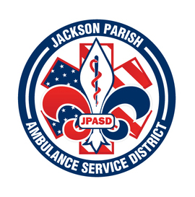
JACKSON PARISH AMBULANCE SERVICE DISTRICT
115 Watts Street
Jonesboro, LA 71251
Office: (318)-259-2877 Fax: (318)-259-2099
jacksonparishambulance@jpasd.com
Aaron Johnson BOARD MEMBERS
EMS Director Allen Lindsay, Chairman
Paula Parkerson , MD Joe Vail, Vice-Chairman
Medical Director Conchita Doyle
Alma Williams
Deidre Hollis
Notice Posted: Tuesday, March 12, 2024 @ 1:00 pm

NOTICE OF PUBLIC MEETING
A public meeting will be held as follows:
DATE: March 14, 2024
TIME: 12:00 PM
PLACE OF MEETING: Jackson Parish Ambulance Service District
115 Watts Street, Jonesboro, LA 71251
Public Meeting AGENDA
1. Call to Order
2. Roll Call
3. Invocation
4. Pledge of Allegiance
5. Recognition of Guests/Public Comments
6. Approval of Minutes from February 8, 2024
7. Approval of Financials and payment of bills February 2024
8. EMS Director’s Report
9. Old Business
10. New Business
A) Surplus Ambulance chassis 1FDWE3FS5KDC33174, 1FDWE3FS5KDC72833
11. Adjournment
Reminder: Next Meeting: April 11, 2024 @ 12 Noon
In accordance with the Americans with Disabilities Act, if you need special assistance, please contact Aaron Johnson, EMS Director at 318-259-2891 describing the assistance that is necessary. Due to the Covid-19 virus visitors are asked to not present to the meeting with fever, cough, diarrhea, or general weakness. Masks will be provided for visitors.

