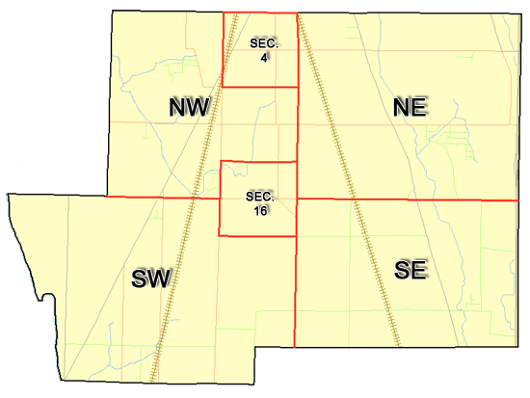 | Pleasant Township  Zoning Commission Minutes  1035 Owens Rd W.  Marion, Ohio 43302
Meeting called by: | Scheduled | Type of meeting: | Regular Monthly
Chairperson: | Mr. Holler | Secretary: | Stephanie Barkley
Timekeeper: |  | Date: Jan 19th, 2023 | Time 7:30 pm
Call to Order by: | Mr. Holler Moment of silence followed by the pledge to the flag.
Roll Call: | Jack Dean, Harry Holler, Tom Leib, Dwight Williams, Joe Thompson, Tyron Canterbury  Stephanie Barkley
Minutes: | Read and approve minutes from previous meeting.  Motion to approve minutes by: Mr. Leib Seconded by Mr. Dean: All approved
Attendees Address Board: Have sign in sheet on desk by door.
Type in attendees and addresses: see attached
.
----- Agenda Topics -----
Business
Zoning Reports: | Zoning Inspector goes over reports and provides copy to board.
Unfinished:
New:
Announcements: | Next meeting will be Feb 16th ,2023
Adjournment: | Motion to adjourn by: Mr. Leib Seconded by Mr. Dean, all in favor all approved

Pleasant Township
Zoning Commission Minutes

1035 Owens Rd W.
Marion, Ohio 43302
Business Notes:

 | Discussion:
 | Conclusions:
 | Action items: |  | Minutes signed by: | Date approved:
 | Provide copy of approved minutes to Zoning |  | Chairperson:
 | Inspector. File original in township office. |  | Secretary:
Other Information
Trustees Present: |  | Mr. Creasap, Mr. Schrote
Zoning Inspector: |  | Mr. Baker
Special Guests:

Minutes
The Pleasant Township Zoning Commission met for their regularly scheduled monthly meeting Jan 19th, 2023 at the Pleasant Township Senior Centre Zoning Commission Board Members were present: Mr. Dean, Mr. Leib, Mr. Thompson, Mr. Holler, Secretary Miss Barkley and Township Zoning Inspector Mr. Baker. Trustees Mr. Creasap, and Mr. Schrote Absent was Mr. Williams and Mr. Canterbury.
- Minutes were read from the Nov 17th,2022 regularly scheduled Zoning Commission meeting. There were no corrections to be made. A motion to approve the minutes was made by Mr. Leib and seconded by Mr. Dean. All members present agreed to passage of the minutes.
- The Zoning Commission Board members voted for Chair and Co-Chair. Mr. Thompson made a motion to appoint Mr. Holler as Chair and Mr. Leib as Co-Chair Mr. Dean 2nd the motion all members present passed the motion. Mr. Tom Baker Pleasant Township Zoning Inspector submitted the following inspection report for 2022 construction total was $8,535.256.00, $8329.60 was from 75 permits and $300 from appeals. There was additional 9 violations sent out for property owners for cleaning up their properties. 8 of the 9 have already made some progress on the properties.
- Board members started going back through the zoning book started with 11.07 and ended at 11.15. There being no additional business for discussion Mr. Leib made motion to adjourn, seconded by Mr. Dean Board Members in attendance agreed and the meeting was adjourned. The next Board Meeting will be held on
Feb 16th ,2023 7:30 PM.

