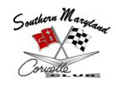

May 11, 2015
(NO MEETING HELD)

- Instead of holding a formal meeting on May, 11, 2015, members gathered at Solomon’s Pier, located in Solomon’s Island, MD, for a casual dinner and social.

*Recorded by: Patrice Hopkins, 2013-2015 SMCC Corvette Club Secretary*

