PRESS RELEASE

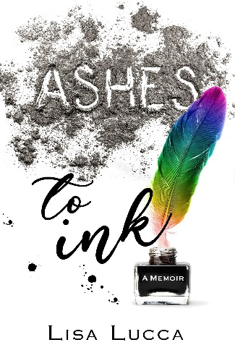
Contact Information:
Publicist
Lexi Rose
1524A Clark St. Manitowoc, WI 54220
920.860.1447
alexafiona@pm.me
Twitter: @RoseRhigo
IG: @alexafionarose

FOR IMMEDIATE RELEASE

Memoir of LGBTQ Family Acceptance Coming this October

LAS CRUCES, NM – Author Lisa Lucca’s memoir Ashes to Ink releases on October 19, 2021, in print and digital formats.

During the 1970s, the LGBTQ community struggled and fought for awareness. At the same time, Lisa’s father came out as gay. The secrecy and tumult that followed her father’s truth led Lisa on a path of rebellion and self-discovery. Written after her father’s passing, Ashes to Ink recounts the challenges Lisa and her family faced as they came to understand her father’s complexities during a time when openly queer people were shunned, mocked, and attacked.

Author talks are in the works to feature this memoir in independent bookstores and libraries across the United States. On October 19, the Oak Park Public Library will virtually host a release-day event with Lisa honoring LGBT History Month. Jordan Budd, Executive Director of COLAGE, a National LGBTQ+ family organization says Lisa has written “…a raw and gripping memoir which perfectly captures the unique ripple effects of life with a gay parent.”

If you would like to know more about Ashes to Ink, please contact Lexi Rose at alexafiona@pm.me. To learn more about the author, please visit her website at lisalucca.com.

###

