Color Guide to Branding

Poetry can make people swoon, and a shocking image can enrage people to action. But one of the lesser-known, but no less powerful, ways to invoke emotion is simple, everyday colours.
The psychological effects of colours have been studied by scientists since the Middle Ages, but you only need to look at the world around you to see – and feel – their impact. Every colour elicits a different and unique emotional response, and the clever web designer (and any visual professional in that regards) will know the effect of each colour, plus how and when to use each. While the discipline of colour theory is broad, this article will teach you the fundamentals in a single, quick-reference source. If you'd like to learn how to use colour and contrast to make strong first impressions on users, check out our free e-book Web Design for the Human Eye.
But before we delve into the emotional nuances of 12 separate colours (then explain a quick case study), but we need to first make a quick note about vibrancy.

A note about vibrancy
Simply put, a colour's vibrancy is how dark or light it is.
The tricky part about vibrancy is that, just like each individual colour has its own properties, so does each shade of the same colour.
While light green and dark green have more in common than green and purple, they will still have smaller, more subtly different effects on the user.
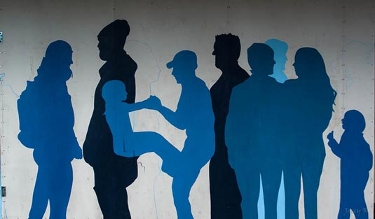
Image courtesy of Jocelyn Kinghorn, www.flickr.com/photos/joceykinghorn
Below, we'll explain all the noteworthy differences between a colour's shades, regarding their impact on web design.
As a general rule, though, brighter shades tend to be more energetic, while darker shades more relaxing. The brighter shades of calls-to-action attract the eye, while the darker shades in backgrounds help create an immersive effect.
Picking the right colour is not enough – you must also consider hue. Keep this in mind when reading about each colour below.

Red - Passionate, Aggressive, Warmth, Warning
This is a notoriously difficult colour to own in any sector, especially in its primary form. It's the colour of anger and danger, but also warmth and passion. And since it's also scientifically proven to increase your heart rate and raise your blood pressure – and represents the color of blood - it's a bold choice to use it extensively., Important as a dominating colour, red adds gravity and heightened awareness – quite literally, as the colour increases blood circulation, breathing rates, and metabolism. Think of warning signs – stop, emergency, no entry – are in red to attract attention to dangers. Red can take on a variety of meaning, associated with both love and war, but the unifying factor in all meanings is a sense of importance, like a red carpet.
Red is a colour best used cautiously. Its knack for attracting attention makes it a priceless tool for designers, but excessively it will inhibit relaxation. Lighter shades emphasize the energetic aspects of red – including youthfulness – while darker shades emphasize power, and even durability, such as a brick wall.
Coca-Cola
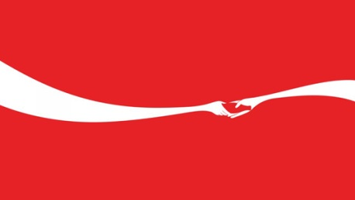 Coke has made red its signature colour
Vodafone
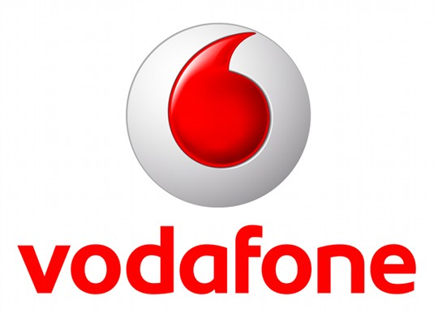
The colouring of Vodafone's logo is designed to signify communication and sophistication
Designed in 1997 by Saatchi & Saatchi, Vodafone's logo features a distinctive speech mark symbolising conversation and speech communication, while the red stands for sound, talking and passion. It's set against a silver backdrop representing sophistication and perfection. In the new Brandz Global Brand Ranking, Vodafone is listed as the UK's most valuable brand, worth $36 billion.
Orange - Playful, Energetic, Cheap

Bright, fun and friendly, orange has a playful, childlike appeal. Sharing red's energizing aspects, but to a safer degree, orange is a good way to add excitement to a site without severity. It is generally playful, and some claim it creates haste and plays on impulse. It can even signify health, suggesting vitality and vibrance. Three very different brands claim ownership of it in their respective sectors.
Orange mobile phone service
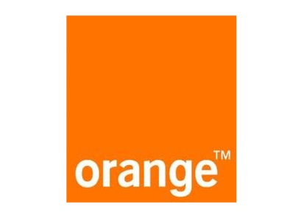
Mobile phone company Orange has taken the colour and run with it. There's no better place to start than the brand that's actually named after this colour. Few telecommunications companies would be foolish enough to try and out-orange Orange.

easyGroup
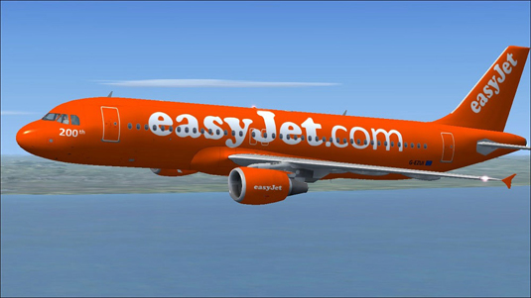
EasyJet splashes orange everywhere it can
Everyone's favourite budget service provider, easyGroup – another ocean of orange, spanning everything from the original low-cost airline to car rental, finance, hotels and more. It's also the only contender to have tried to out-orange Orange: anyone remember easyMobile?

ING Bank
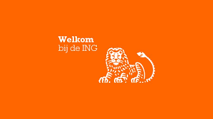

ING's orange lion goes way back to the bank’s Dutch roots, a reflection of the color of the Dutch Royal Family, which hails from the House of Orange.
Yellow - Happy, Friendly, Warning
Yellow is a strange colour: it is often associated with happiness, but also activates the anxiety center of the brain. Like red and orange, it's able to stimulate and vitalize – it's the colour of warning signs and taxis – but use bright yellow sparingly because of the potential negative connotations. Lighter shades play on the happiness aspects, reminding users of summer and the sun. Darker shades, including gold, add more weight and give a sense of antiquity. Positive, sunny and optimistic, yellow is energetic and eye-catching – and particularly effective for point-of-sale messaging, as it's proven to catch the eye quicker than any other colour. Yellow, of course, is an excellently eye-catching colour for potentially dangerous heavy machinery
Veuve Clicquot
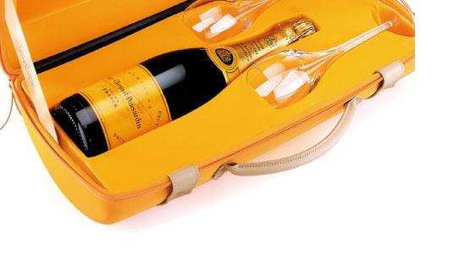
Champagne brand Veuve Clicquot adds punch to its packaging with yellow
Yellow provides standout for premium champagne brand Veuve Clicquot – cutting through a sea of green, gold and cream with a punchy shot of bright yellow.

Caterpillar
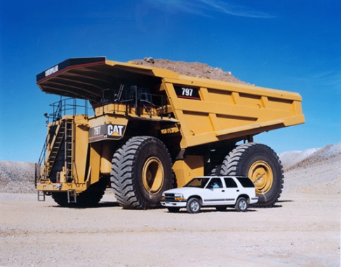
Caterpillar vehicles are instantly recognisable by their colour
Meanwhile, in a sector that couldn't be more different, construction equipment manufacturer Caterpillar has a very distinctive, trademarked shade of yellow connected to its brand – featured in the triangle on its logo, and also on the liveries of its vehicles. Of course, in the field the colour is invariably faded by constant weathering on construction sites, so it's rare to find a perfect match.
Barcelona Taxis
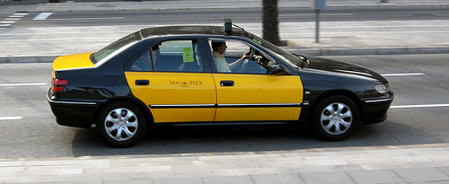
These guys are everywhere in Barcelona, conforming to the color code of the local industry.

Green - Natural, Stable, Prosperous

Green mostly represents the environment and outdoors, making it the clear choice to suggest nature and an organic quality. As the bridge between stimulating warm colours (red, orange, yellow) and calming cool colours (blue, purple), it is the most balanced of colours, lending it an air of stability. It's also a popular choice as an accent or for calls-to-action because it stands out, but more softly than the warmer colours. In Western Culture, it also represents money and financial safety. Green is an emotionally positive colour, signifying growth and rebirth. It also represents endurance.

John Deere
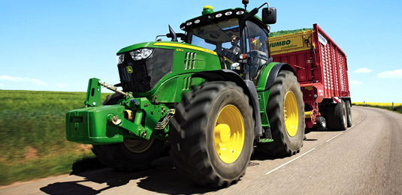
Deere has used green successfully to distinguish itself
Joining Caterpillar and JCB in the large-scale vehicle corner is farm machinery firm John Deere, whose iconic bright green-painted tractors (with a touch of yellow) are instantly recognisable

Harrods
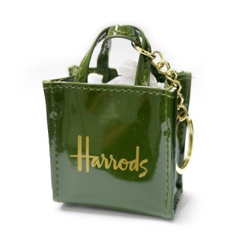
At the other end of the market, rich, dark green has associations with wealth and prestige – so it's no surprise that luxury department store Harrods has chosen it as a key part of its branding scheme. From bags and signage to all manner of own-branded products, the shade exudes class and sophistication.

Starbucks
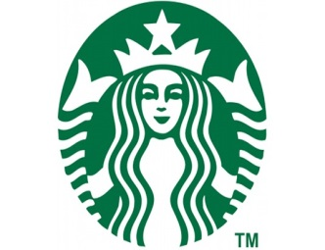
Starbucks started life in 1972 with a brown logo – appropriate enough considering the coffee beans that it originally sold before introducing the crazy concept of selling actual cups of coffee – then in 1987 the colour of its stylised woodcut of a siren was changed to green. The reason? It's a reference to the University of San Francisco, where all three founders were educated.

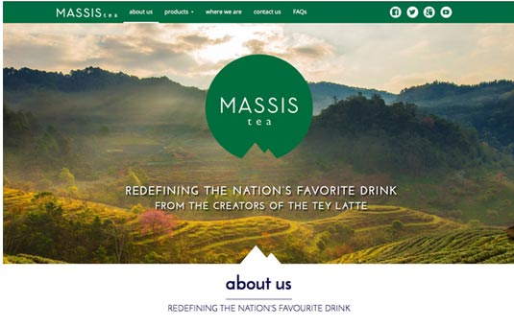
Massis Tea plays on its natural qualities with the green scheme for its
site. The green top navigation bar, green logo, and photograph of greenery all work together to accents the brand's ties to nature.

Blue - Serene, Trustworthy, Inviting
Blue is one of the most popular colours in web design – and for good reason. You see blue on a lot of websites because it is the colour of trust. Blue is the colour of calm and serenity, and as such inspires security and a feeling of safety. For this reason, blue is a colour often used by banks: CitiBank, Chase, Capital One. However the calming effects also make blue a friendly and inviting colour, which explains its adoption by Facebook and Twitter. Blue is also incredibly versatile; its vibrancy has more drastic effects than other colours. Light blue is the colour of water and the sky, so it generally has a refreshing and free feeling – even energizing if bright enough, but still retaining that reliable calm. Darker blues tend to be more somber, heightening the security aspects, which makes them an excellent choice for professionalism.
All this comes at a small price, though: blue shouldn't be used for food-related sites. Because blue foods aren't common in the wild, studies show that blue actually acts as an appetite suppressant.
NHS
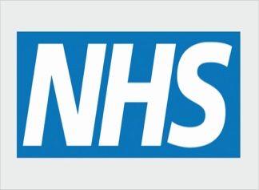
Britain's National Health Service uses a dependable blue to enagage its users In the UK, the National Health Service uses a distinctive shade of blue that takes advantage of its cool, reassuring and secure characteristics.

Tiffany & Co
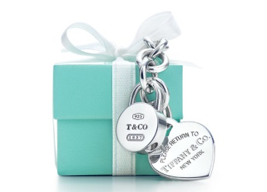
Tiffany has trademarked its own shade of 'robin's egg' blue. Like red, of course, blue is used so broadly in different kinds of branding that standout in a particular sector is difficult: Tiffany's solves this problem with its own iconic shade of 'robin's egg' blue, trademarked as Tiffany Blue and ubiquitous on everything from jewellery boxes to shopping bags to advertising.
Social Media

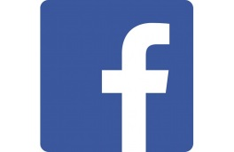
The logo's changed over the years, but Facebook retains its blue colouringOriginally designed by Cuban Council in 2006, the Facebook logo has been tweaked over the years – most recently in 2013 when it pulled the 'f' down to the edge of the box, and lost the pale blue line running beneath it – but has retained its blue colour, which Mark Zuckerberg originally chose based on his colour blindness. The Twitter bird, although officially blue, often takes on the color of a website scheme and can even be found in multi colors and pixelated colors.

Purple - Luxurious, Mysterious, Romantic
Long associated with royalty, purple creates an air of luxury, even decadence. Using a purple dominantly is a quick way to create a sense of elegance or high-end appeal, even if your product is budget-minded (an “expensive” effect that's quite the opposite of orange). Lighter shades of purple bring to mind spring and romance, especially lavender. Darker shades of purple add more mystery, and can even symbolize creativity. Darkening the shade will also turn the romantic elements more sensual.
Yahoo
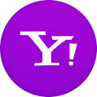
Purple captures Yahoo's whimsical sensibility. It's something that unites. It's something that's really recognizable and defining for Yahoo. They also have a punctuation mark, their exclamation point. If you see an exclamation point on the web, you think of Yahoo, that owns a piece of punctuation, a color, and a sound, yodeling

Woo Commerce
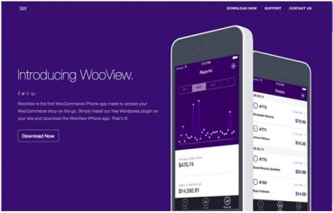
With its ties to personal wealth, Woo Commerce chose purple as the colour to represent their app, playing on themes like royalty and panache that fit the function of checking how much money you're making in real time.

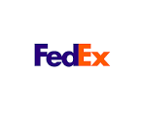
FedEx

The “Purple Promise” logo is a prominent graphic expression of the FedEx culture and a promise to deliver excellent customer service. It can be used across a variety of mediums to portray their pride and conviction in serving customers.

Pink - Feminine, Young, Innocent, Vibrant
Pink is a specialized colour that won't work for a lot of sites, but will work perfectly with the right audience. Because most people interpret people as feminine, the colour is quite popular for targeting female users. The connotations with childhood and with sugary treats gives it a sweet, sometimes innocent appeal (not surprisingly a self-perpetuating cycle). It is also traditionally used with love and romantic themes, alongside red and light purple, and it is a softer version of red that can stir up visions of little girls, bubble-gum and cotton candy. The color pink is also widely associated with breast cancer awareness. It is often used in logos to add a feminine flare.
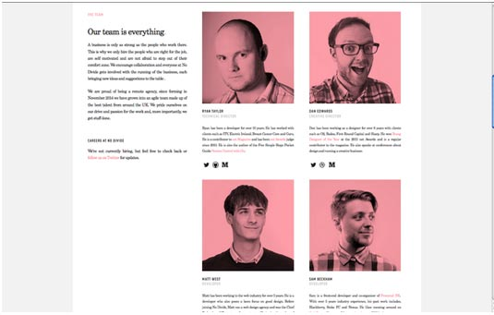I
mage courtesy of No Divide Studio LTD

However, don't overdo the pink-femininity connection, or else you're walking a fine line between appealing to users and pandering to traditional gender roles.While not exactly manly, the site for No Divide Studio shows off its quirky youthfulness and playfulness with the pink flourishes throughout, including the filters on their team pictures.The site clearly shows that dashes of pink create a fun and unique vibe, so don't be afraid to be unorthodox.
Deutsche Telekom
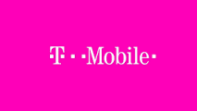
The total hue domination by T-Mobile and its bigger Deutsche Telekom (DT) has been going on for several years, but has gained more attention lately. DT not only trademarked magenta, they also have a trademark on the use of their two 2 color logo.

Dunkin Donuts
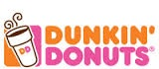
The logo and color scheme for this popular donut chain started out as brown, and in the 1970s was changed to pink. Today’s logo combines pink and orange in a distinctive color combination that ties into the steam coming from the cup of coffee.

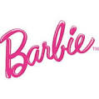
Barbie and PINK

One of the most successful lines of dolls in the world, Barbie selected pink for its feminine values and because the product lines appeal to young girls. Pink, on the other hand, is Victoria Secret’s attempt to appeal to older women.

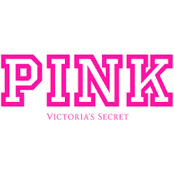
Brown - Earthy, Sturdy, Rustic
While not a popular choice in web design, brown can, under the right circumstances, be effective nonetheless. As the colour associated with the earth and trees, brown can add an outdoorsy feel, maximized by a pairing with green. The tree connotations also give a sturdy and reliable feeling. In web design, brown is most often used in conjunction with wood texturing, giving the same old-fashioned and rustic atmosphere of a wooden cabin.
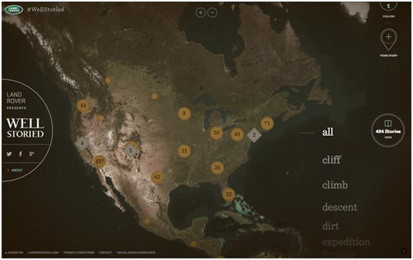

The brown filter and buttons suit the rugged and outdoorsy theme of Land Rover's Well Storied site.

UPS

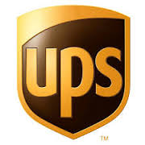
The brown color that UPS uses on its vehicles and uniforms is called Pullman Brown. The color is also mentioned in their former advertising slogan: “What can Brown do for you?” Originally founder James E. Casey wanted the trucks to be yellow, but one of his partners, Charlie Soderstrom stated they would be impossible to keep clean, and that Pullman railroad cars were brown for just that reason.

M&M Candy

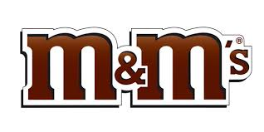
It’s mostly chocolate candy, so the logo colors reflect the product.

Yves St. Laurent



Identify a color with its designated html code by visiting http://html-color-codes.info/
__________________________________________________
Source: Creative Bloq / June 11, 2015
Author: Jerry Cao

Retrieved from: http://www.creativebloq.com/web-design/12-colours-and-emotions-they-evoke-61515112

And
Source: Creative Bloq / March 26, 2015

Retrieved from: http://www.creativebloq.com/branding/amazing-uses-colour-6133196

