2021 RALEIGH RINGERS SUMMER LEAGUE RECAP
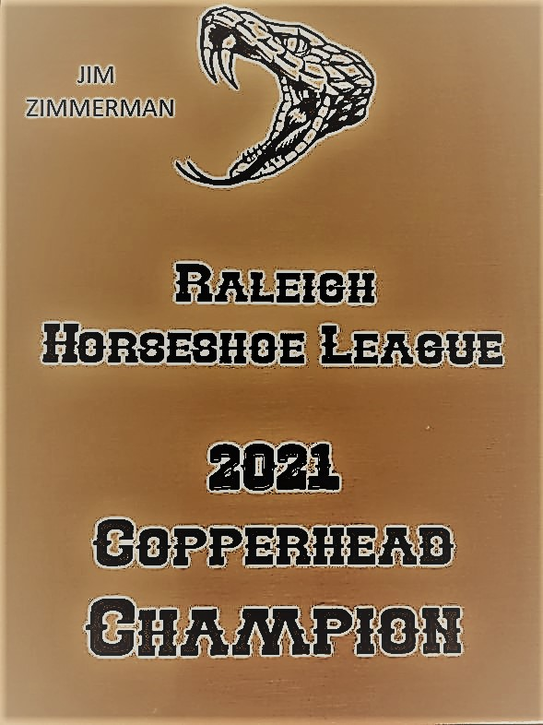 | JIM ZIM—THE BEST OF NORTH CAROLINA. STILL THE ONLY PLAYER WITH A 80% GAME (MATCHED HIS AGE THIS TIME). HIS 65% AVERAGE THIS YEAR IS THE HIGHEST SO FAR IN RALEIGH LEAGUE PLAY.  OTHER SEASON HIGHLIGHTS:  RAYMOND CALLAHAN, SPORTSMANSHIP AWARD, NOTHING BUT ENCOURAGEMENT TO ALL OPPONENTS SINCE DAY ONE AND HAS CONTINUED FOR NINE YEARS.  STEVE DOERNBERG, 30% GAME, A BIG WIN AGAINST JIM.  JOE WORK, HIGHEST POINT GAME WITH HANDICAP. WHAT LEAGUE PLAY IS ALL ABOUT.  JULIUS BARTELL, JOINED THE 60% GAME CLUB.  JOHN JEIDY IS BACK TO PITCHING 50%.  CHARLIE ALSTON—58% GAME, I’M STILL TRYING TO FIND HIM ONE MORE RINGER  AWARDS:  LEAGUE CHAMPION—JIM ZIMMERMAN  SPORTSMANSHIP—RAYMOND CALLAHAN  HIGH AVERAGE—JIM ZIMMERMAN  HIGH GAME—JOE WORK  HIGH GAME OVER AVERAGE—JEREMY SMITH
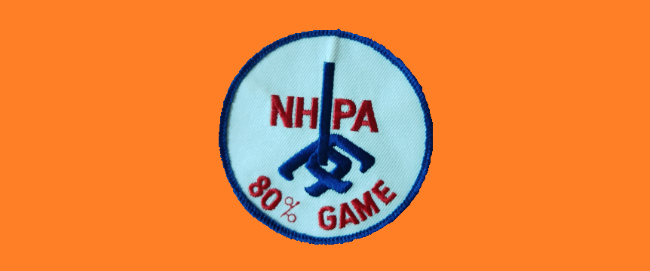
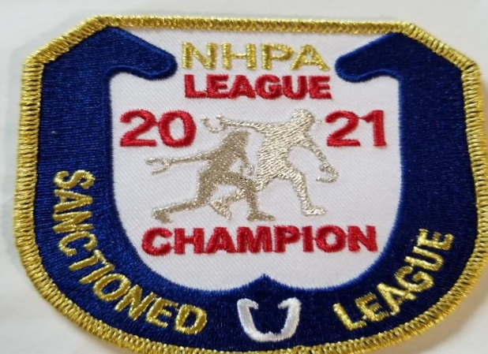 | 