REGULAR MEETING
MAY 20, 2021

The Regular Meeting of the Town Board of the Town of Hampton, County of Washington and the State of New York was held at the Town Hall, 2629 State Route 22A, Hampton, New York, also via Zoom and live streaming on the You Tube Channel for “Town of Hampton New York” on the 20th day of May 2021.

Due to the Corona Virus, occupancy inside the Town Hall is limited at this time. Supervisor O’Brien did provide a link to join the meeting via Zoom.

PRESENT: David K. O’Brien------------Supervisor
Donald Sady-----------------Councilman-came at 7:55pm
Tamme Taran----------------Councilwoman
Andrea Sweeney------------Councilwoman – absent
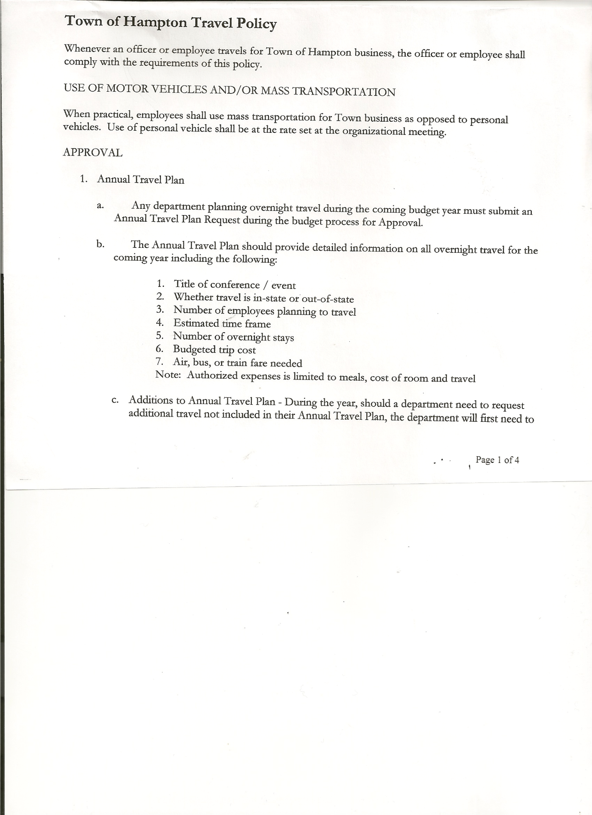
Michael Pietryka------------Councilman
Rebecca Jones---------------Town Clerk
Camilla Shaw----------------Tax Collector/Deputy Town Clerk
Herbert Sady, Jr.-------------Highway Superintendent

Planning Board Member(s): via Zoom… Bonnie Hawley, Chair; and Matthew Pratt (logged in at 8pm)
Others present at the Town Hall: Artie Pratt, Aaron Reed and Leonard Reed
Others present via Zoom: Travis Dean

The Regular Meeting was called to order by Supervisor O’Brien at 7:30pm, followed by the Pledge of Allegiance. Location of Fire Exits were given. Quorum of board members present.

RESOLUTION NO. 42-2021
APPROVAL OF THE MINUTES
On a motion of Councilwoman Taran, seconded by Councilman Pietryka, the following resolution was ADOPTED:
By Roll Call Vote: Supervisor O’Brien AYE
Councilman Sady ABSENT
Councilwoman Sweeney ABSENT
Councilman Pietryka AYE
Councilwoman Taran AYE
RESOLVED, that the Regular Town Board Minutes for April 15, 2021 are approved.

Larry Carman, Dog Control Officer submitted his report, which was read by Supervisor O’Brien, copy of report is attached.

Camilla Shaw, Tax Collector….no activity. Submitted Bank Statement to the Board for review and signatures.

Bonnie Hawley, Chair gave Planning Board Report… May 12th meeting was attended by only Matthew Pratt and Bonnie. Discussed the Rt 4 issues. She had printed out what she had from the previous report on Route 4. The next meeting is June 9th.
Bonnie also shared that Maggie Ingerson will have a food truck at the Flubberbuster’s lot on Route 4. She has spoken to Code Enforcement to get requirements for sanitation and fire safety.
Jeff Kehoe says the date for the grant award is October 1st. Pattie’s Patch on Rt 4 is now open for the season from 8a.m. to 6p.m.

TOWN BOARD MEETING
MAY 20, 2021 PAGE 2

Herbert Sady, Jr., Highway Superintendent submitted his report, copy of which, is attached.
Following a discussion on plans for CHIPS money, the following Resolution was introduced:
RESOLUTION NO. 43-2021
AGREEMENT TO SPEND TOWN HIGHWAY FUNDS
On a motion of Councilman Pietryka, seconded by Councilwoman Taran, the following resolution was ADOPTED:
By Roll Call Vote: Supervisor O’Brien AYE
Councilman Sady ABSENT
Councilwoman Sweeney ABSENT
Councilman Pietryka AYE
Councilwoman Taran AYE
RESOLVED, to accept the Agreement to Spend Town Highway Funds as submitted by the Highway Superintendent.

Supervisor O’Brien stated that all agreements and contracts in the future should be in writing.

It is also proposed to have a tour of the town roads with Herb and Tyler and the town board members to look them over and see the conditions and needs to be able to make long term plans.
Proposed Job Description for Highway Superintendent was handed out. Civil Service needs to approve. State Civil Service looking at Exempt status (no overtime). Ads and the hiring process will start in mid-June. Planning for 2022 Highway and appointing a council member as a liaison with the Highway Superintendent will also need to be discussed.
A credit card is needed for the Town to be able to get better prices. It would have a $2,500.00 limit. Limited for use by Supervisor and Highway Superintendent only.

RESOLUTION NO. 44-2021
CREDIT CARD FOR TOWN USE
On a motion of Councilman Pietryka, seconded by Councilwoman Taran, the following resolution was ADOPTED:
By Roll Call Vote: Supervisor O’Brien AYE
Councilman Sady AYE
Councilwoman Sweeney ABSENT
Councilman Pietryka AYE
Councilwoman Taran AYE
RESOLVED that, a town credit card for use by the Town Supervisor and Highway Superintendent be approved.

Highway Superintendent, Herb Sady will be ordering speed limit signs for the roads that have been approved for speed limits.

TOWN BOARD MEETING
MAY 20, 2021 PAGE 3

SUPERVISOR’S REPORT/ COUNTY UPDATES/ COMMUNICATIONS
RESOLUTION NO. 45-2021
APPROVAL OF SUPERVISOR’S MONTHLY REPORT
On a motion of Councilman Sady, seconded by Councilwoman Taran, the following resolution was ADOPTED:
By Roll Call Vote: Supervisor O’Brien AYE
Councilman Sady AYE
Councilwoman Sweeney ABSENT
Councilman Pietryka AYE
Councilwoman Taran AYE
RESOLVED that, the Supervisor’s Monthly report be accepted as submitted for APRIL
3/31/21 4/30/21
ACCOUNT BALANCE RECEIPTS DISBURSEMENTS BALANCE
General Fund $ 60,252.03 $ 7,176.69 $ 8,587.24 $ 58,841.48
Highway Fund $269,135.79 $ 10.77 $ 41,054.75 $ 228,091.81
Equipment Reserve $ 54,904.79 $ 25,002.39 $ 0.00 $ 79,907.18
Fire #1 $ 43,297.00 $ 0.00 $ 0.00 $ 43,297.00
Fire #2 $ 10,200.00 $ 0.00 $ 0.00 $ 10,200.00
Cemetery $ 1,745.89 $ 2.27 $ 0.00 $ 1,748.16
Totals $439,535.50 $ 32,192.12 $ 49,641.99 $422,085.63
All Board Members present signed Supervisor’s Report.
(the Budget Amendment on page 1 was negated)

OLD BUSINESS
Stimulus Funds….. Supervisor O’Brien attended a meeting about the use of stimulus funds. Several approved uses are for any organization that lost revenue during COVID, animal shelters, food banks, etc. (list is attached)

Ramp Covering….Looking for quotes for ramp cover. One quote has been received, $11,500.00 for labor only. The materials have already been purchased.

NEW BUSINESS
The town has received a letter from our attorney about the sale of cannabis in town. Members were asked whether the town should opt out of sales in the town or not. The decision will be tabled until next month.

PUBLIC COMMENTS/COUNCIL COMMENTS
Questions about CDL drivers and if they get tested. Can employees be told they cannot use cannabis?

Bonnie Hawley asked when SLIC will be in Low Hampton? “Soon” was the answer.

TOWN BOARD MEETING
MAY 20, 2021 PAGE 4

RESOLUTION NO. 46 -2021
AUDIT OF CLAIMS
On a motion of Councilwoman Taran, seconded by Councilman Pietryka the following resolution was ADOPTED:
By Roll Call Vote: Supervisor O’Brien AYE
Councilman Sady AYE
Councilwoman Sweeney ABSENT
Councilman Pietryka AYE
Councilwoman Taran AYE
RESOLVED that the bills have been reviewed by the Town Board and are authorized for payment in the following amounts.
General Fund No. 60 through No. 78 $ 2,951.16
Highway Fund No. 50 through No. 59 $ 13,958.70
Total both funds $ 16,909.86

RESOLUTION NO. 47-2021
MEETING ADJOURNED
On a motion of Councilwoman Taran, seconded by Councilman Pietryka, the following resolution was ADOPTED:
By Roll Call Vote: Supervisor O’Brien AYE
Councilman Sady AYE
Councilwoman Sweeney ABSENT
Councilman Pietryka AYE
Councilwoman Taran AYE
RESOLVED that the meeting adjourned at 8:35pm.

Respectfully submitted,

Rebecca S. Jones, RMC
Town Clerk

