Testimony of Elena Maria Lopez
Submitted in connection with
Hearing before the
United States Senate Committee on the Judiciary
On
“Vows for Visas: Investigating K-1 Fiancé Fraud”
Wednesday, March 15, 2017
Dirksen Senate Office Building, Room 226
[C-SPAN video]

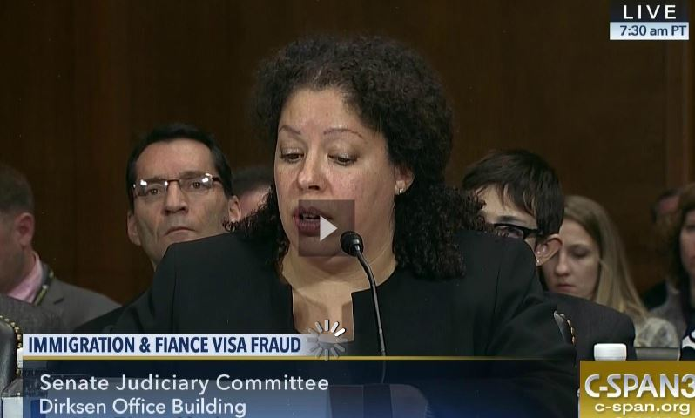
Mr. Chairman, Madam Ranking Member, esteemed members of the Senate Judiciary Committee, my name is Elena Maria Lopez, and I was tricked by the love of my life.

In 1998, I met a Dutch man doing business in the U.S. We immediately hit it off and started dating long distance. He was romantic, kind and generous, or so I thought. During one of our many visits, he proposed and pledged his love, saying he wanted to grow old with me.

Neither of us had much money. I had just put myself through college and was a freelance political reporter. He said his limited income was needed to expand a new import-export business. He suggested we get married in a civil ceremony, giving us time to save up for a full, formal wedding and honeymoon on our first anniversary.

When my step-mother objected, Erik assured my entire family that we’d have a church wedding the following year.

I took a higher-paying job out of my field to afford the sponsorship obligation required for a K-1 fiancé visa. I borrowed money from my momto furnish our new apartment and get him a computer so he wouldn’t be so isolated in his new land. When his K-1 visa was approved, he came to the states for good and we married.

Once married, I thought we were happy. I conscientiously paid the bills, set up retirement accounts, and started paying back my mother. When I asked about child support, he said he paid through a Dutch account. He also put off saving for that promised wedding and honeymoon.

Through my family’s contacts, Erik eventually found work, yet still kept putting off the wedding and honeymoon. I became disturbed as Erik repeatedly broke promises.

Then out of the blue -- on the night before our second anniversary -- he coldly announced we were divorcing. I assumed we were having marriage problems and suggested counseling. He refused. And then came the cruelest words I’ve heard in my entire life: He said our marriage was nothing but a practicality so he could get a green card. He mocked me for working so hard to save the marriage.

I was stunned and immediately filed for a separation.Within days, Erik’s parents confirmed what he said.

When Erik caught wind of my legal proceedings and knew I was withdrawing my immigration sponsorship, he became violent. He tried to strangle me and threatened to kill me if I ever contacted immigration officials. When the police arrived, he had already calmed down and I was told to brush it off. I was forced to flee my own home.

A couple of days later, Erik came home while I was packing. He insisted that no one would believe me about his violence or admissions. A few minutes later, I was looking down the barrel of a rifle. He laughed and repeatedly shot at me with blanks in his rifle. When he left the room for a phone call, I grabbed my keys and fled the house – this time for good.

Pennsylvania police again refused to take action. They were more worried about whether I was paid to marry my husband rather than if my husband was trying to kill me.

Erik’s behavior had changed so abruptly that I wondered if I ever really knew him. So I started trying to find out. I tracked down his ex-wife in Europe who hadn’t received child support in years. By then, Erik was making $148,000. During their divorce, Erik stole her car for insurance, refused to pay child support, and intimidated her into running a large-scale, illegal drug operation so she could stave off welfare. She was terrified of Erik, yet she was even more terrified of having her toddler taken by Dutch child services. She eventually fled to another country to escape Erik’s nefarious network.

I tracked down Erik’s former business partner who confirmed all this. Then I found Erik’s former boss who suspected him of embezzling company funds but could never quite catch him red handed.

I started digging through my own files. I discovered the loan on my car changed, he applied for credit in my name, and he lied on his immigration forms.

When I contacted immigration investigators, they said they get cases like mine all the time. But Erik’s pretty much guaranteed U.S. citizenship since we were married for two years.

I was running out of options -- and Erik was still threatening me -- so I hired a retired FBI special agent as a private investigator. If the Department of Homeland Security wasn’t going to do its job, we were going to do it for them. I figured if we clearly documented that Erik was inadmissible to get a green card in the first place, involved in criminal activities, lied on immigration forms, tried to kill me, repeatedly threatened me and committed marriage fraud, the feds would have to do something.

I was wrong. Immigration officials refused to take our sworn statements or accept our evidence. I was however, able to get a protected address reserved for domestic violence victims.

I’ll never know the extent of the fraud or criminal activities that Erik committed, but I did my best to warn our government once I found out. My life has forever changed. I’m now in hiding. And I’ve financially cleaned myself out. With the help of the government, I’d been made victim of a one-sided sham marriage. And although it is difficult to relive the trauma of this experience, I want to be a voice that speaks in the hope of preventing others from going through this.

Thank you.

