Is proud to host
Eric Salas/ Panagenics Workshop
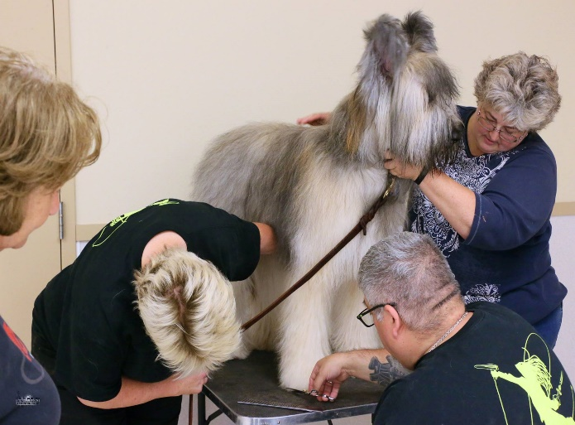
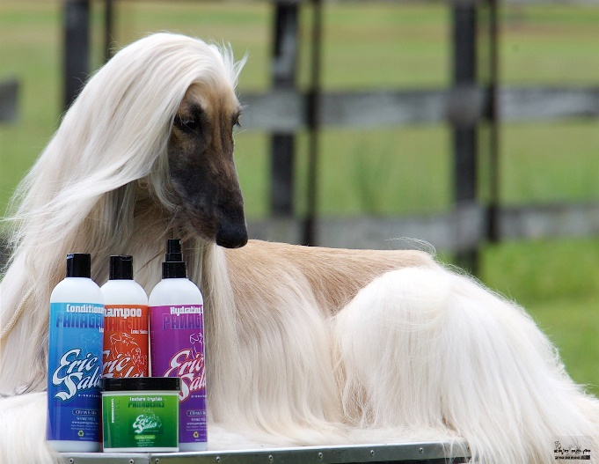

July 20, 21 & 22nd, 2018
Location: Sleepy Creek Pet Lodge
1406 Handschke Drive New London, Wisconsin 54961
Each day is a separate workshop and price applies to each day- Participants - $200 or Audit- $150
All prices are in US currency and includes lunch that will be provided at no extra charge.
A non-refundable deposit is due upfront; deposit is 1/3rd of your total workshop fees—This will guarantee your spot (you can pay the full amount upfront as well if you choose.)
Deposits in by Dec 1st 2017 will go into a drawing for a free 1-hour private session on Thursday with Eric prior to the workshop!!!
Full payment is due by May 1st,2018
All prices are based on Cash/EMT price
Contact: Candy Janke or Hannah Ralston
920-250-5012
Email: sleepycreekpetlodge@gmail.com Visit www.panagenics.com for grooming and handling videos
Eric Salas / Panagenics Workshop - New London, WI
July 20, 21, and 22, 2018
Registration Form
Please check the workshops you are attending,
Friday July 20th, 2018 All Breed Part I Handling: Participant $200 _____or Audit $150 _____
Saturday July 21st, 2018 All Breed Part II Handling: Participant $200_____ or Audit $150_____
*Please note, to take Workshop Part II Handling, you must take Workshop Part I Handling as they build on each other.
Sunday July 22nd, 2018 All Breed Grooming Workshop: Participant $200_____ or Audit $150_____
__________________________________________________________________________________
Your first payment will guarantee a spot in the Workshop, as long as further payments are paid in full by May 1st, 2018.
Each payment is considered a non-refundable deposit.
Contact us by email: sleepycreekpetlodge@gmail.com subject line: Eric Salas workshop
Visit our website www.sleepycreekpetlodge.com for more information or contact Candy Janke or Hannah Ralston - 920-250-5012
Fill out this form, email to sleepycreekpetlodge@gmail.com or fax to 1-920-250-5542 – subject line: Eric Salas Workshop

Name:_____________________________________
Address:_______________________________________________________
________________________________________________________
Phone:______________________ Email:_____________________________

I have read the full Workshop form and am submitting my form with payment
Signature:____________________________ Form of payment:______Check______Credit Card
If you would like to pay by credit card please complete below, Please indicate above how you are paying
Credit card #:_____________________________
Expiration: MM/YY______________ 3 digit CVV code on back____________
Name on Card:_______________________________Signature:________________________________
I authorized Sleepy Creek Pet Lodge Ltd to charge my Credit Card.

Sleepy Creek Pet Lodge Release Form

Initial the box that you understand the terms below:

Waiver: I, undersigned have enrolled myself and my dog in a dog training seminar offered by Sleepy Creek Pet Lodge. By signing hereunder, I certify that I have been informed and understand that there is always some unavoidable risk of injury involved when working with dogs. I hereby except and assume, without reservations, all risks associated with my participation in the seminars including, but not limited to: the risks of any and all injuries to myself and my dog, and any member of my family or third parties who may attend; and the risks that my dog may cause injury to other persons and or dogs involved in the seminar; and the risk that saliva, water, food and other devises may be present in the training area. As lawful consideration for participating in the seminar, I, my heirs, executors, administrator, legal representatives hereby waive, release, discharge and agree not to sue and indemnify, defend and hold harmless, Sleepy Creek Pet Lodge, the owners, managers, volunteers, employees, seminar presenters, speakers from any and all injuries, losses, claims and damages to any person of any nature whatsoever, all costs including attorney fees, vet costs, medical fees arising from my participation in the seminar. This waiver of liability and consent release shall be legally binding on the releasing party. I represent that I am at least 18 years of age, Eric Salas and Sleepy Creek Pet Lodge reserve the right to dismiss any dog from the seminar that displays aggressive behavior towards other dogs, or seminar participants. The handler my stay but no refund will be given.
I understand the above conditions.
Name (print)_______________________________________
Signature__________________________________________ Date____________________________

