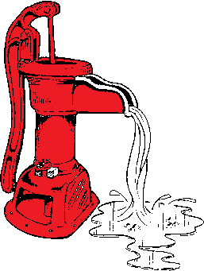,

Rock Creek Mesa Water District

Newsletter

**Publisher – Elizabeth McCowen**

**Issue –January 2019**

***DISTRICT UPDATES***

**.**

**The 2019 Budget passed unanimously by the Board of Directors.**

**You can view this online at www.rcmwd.com.**

**Effective January 18th 2019 there will be an Operations and Maintenance Fee on your water bill. If you have any questions regarding this please call the office.**

**All the exposed lines in the district area have now been fixed.**

**The Districts buildings that received damage during the hail storm back in June have all been repaired.**

**Due to lack of rain and snow the last few months our water levels are a little low. We are not on any restrictions at this time but we would like for everyone to be conservative with their water usage.**

# Foreman’s Report

# Water usage per month:

October 2018: 1,008,060 gallons

November 2018: 1,206,640 gallons

December 2018: 880,980 gallons

**Glenn Butts, President**

**Lee Armstrong, Vice President**

**Elizabeth McCowen,**

**Secretary /Treasurer**

**Sharon Blanding, Operations Assistant**

**Billy Joe Stephenson,**

**Public Relations**

**Jim Olson, Water Manager**

**Kathy Olson, Business General Manager**

**Jay Jones, Water Foreman**

**Robert Rogers, On Call Water Operator**

**Rates for water usage are as follows:**

**NON CME RESIDENTS:**

**Water rate increase Effective January 18 2018**

**0-5,000 gals $ 20.75/1,000 gals**

**5,001 – 10,000 gals $ 21.75/1,000 gals**

**10,001-999,999 gals $ 22.75/1,000 gals**

**Cheyenne Mtn. Mobile Home Park:**

**Meters 83&84:**

**0-985,000 gals $21.10/1,000 gals**

**985,001-999,999 gals $22.10/1,000 gals**



**MONTHLY WATER BOARD MEETINGS – 6:00 pm**

Your Rock Creek Mesa Water Board meets every

**2nd**Wednesday of each month at:

180 Rock Creek Mesa Road

Email at [rockcreekwater@wildblue.net](mailto:rockcreekwater@wildblue.net) or

Website [www.rcmwd.com](http://www.rcmwd.com)

Office: 719-576-0746.