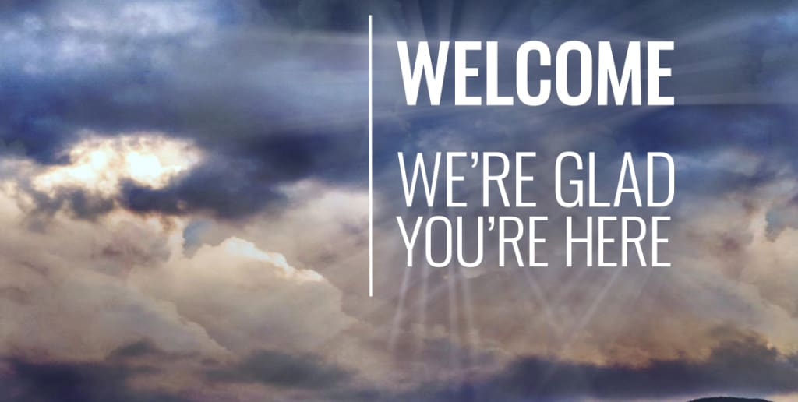
ISSUE
Jan
2022

CCUMC NEWSLETTER
In This Issue
Pg. 1 Pastor’s Page
Pg. 2 Coming Up Next
Pg. 3 Bible Studies & Small Groups
Pg. 4, 5, 6 & 7 Keeping You Informed
Pg. 8 Calendar for Jan 2022
Pg. 9 Church Information

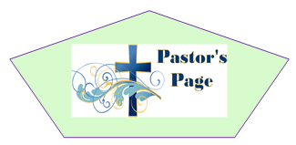
As 2021 draws to a close and we begin 2022 we have two options we can listen to the world as dark forces continue to divide people into various groups of those who belong and those who don’t belong. We can let the world snuff out the light within us our hope, our peace, our joy, our love and even the light of Christ within us or we can remember that the season of Advent culminated in the fulfillment of all God’s promises made in the Old Testament in the birth of Christ. I issued a challenge this Advent to not let the world put out the light with in us in 2022. We need to remember as much as we are counting on Christ, Christ is counting on us. In John 14:12-13 Jesus says,” Very truly I tell you, whoever believes in me will do the works I have been doing, and they will do even greater things than these, because I am going to the Father. And I will do whatever you ask in my name, so that the Father may be glorified in the Son.”
In 2021 through our partnership with World Mission to provide solar Bibles for people in the 10/40 window of the world which forms a band encompassing Saharan and Northern Africa, as well as almost all of Asia (West Asia, Central Asia, South Asia, East Asia and much of Southeast Asia). Roughly two-thirds of the world population lived in the 10/40 Window, and it is predominantly Muslim, Hindu, Buddhist, animist, Jewish, or atheist. Many governments in the 10/40 Window are officially or unofficially opposed to Christian work of any kind within their borders, we collected $360.13 which provided 9 solar Bibles that reached 1296 people. Out of those 1296 people, some will be called by the Holy Spirit to get their own solar powered bible and share the Good News of the Gospel with others reaching even more people. This is the power of what pocket change in a little Blue box can do with the power of God behind it.
Look back at John 14:12-13, did you ever think that Jesus was talking about something as simple as setting pocket change aside in order to provide solar bibles might be something great? In areas where the Gospel isn’t welcomed or tolerated God finds a way through people like you and me to spread his message. So this upcoming year let us all continue to spread the word of God with pocket change and do something great for the Kingdom of God.

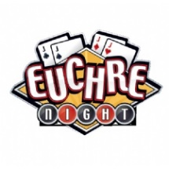

Join CCUMC for fun and
fellowship Saturday,
Jan 8th. Potluck Meal at
5:00 pm. Cards to follow.

UMW Soup Luncheon
on 2/18/22 @11:00 am to 1:00 pm
in the CCUMC Fellowship Hall

Commission On Aging Meals
Every Tuesday & Thursday @ Noon
In the CCUMC Fellowship Hall
Contact COA @ 989-831-7476
For reservations & cost

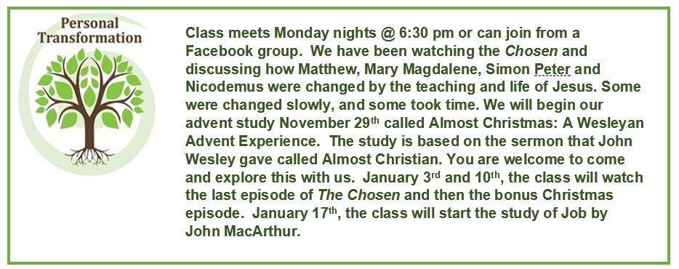

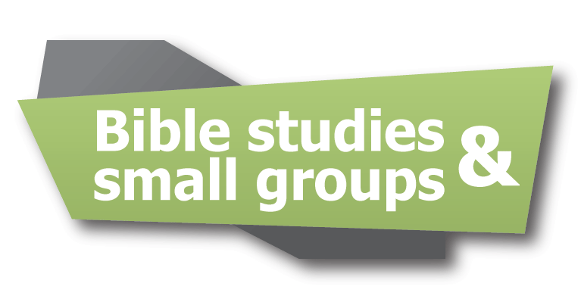

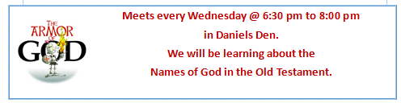

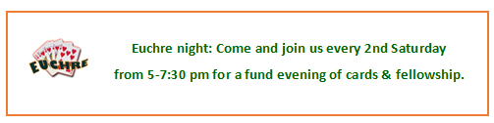
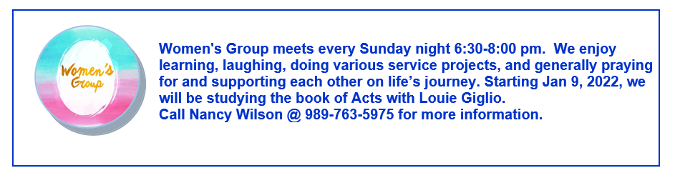

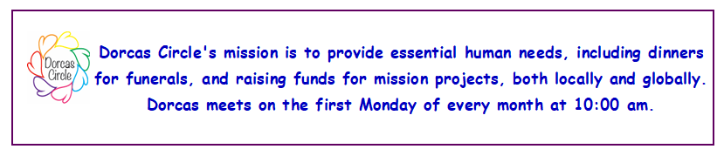

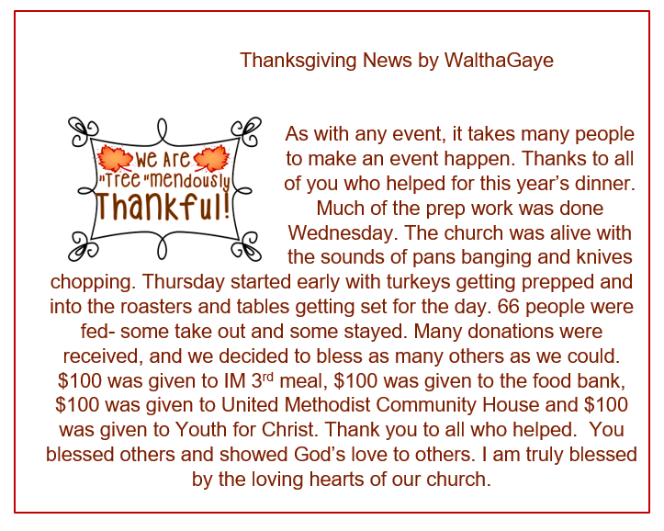
Dorothy Sherd has moved: she has moved to her daughter’s house, Bonnie’s. That address is 4465 Lutheran Church Rd, Kent City, MI 49330. She will have her cell phone with her, and that number is 517-282-3353.

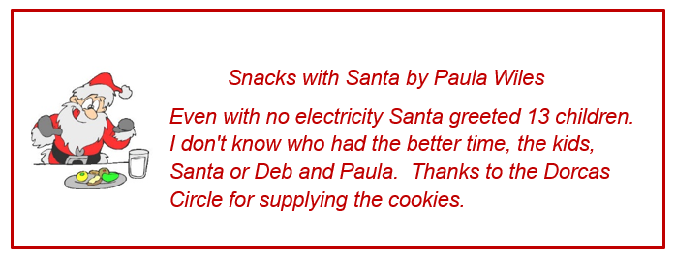
Just a Friendly Reminder
The adult class in the Ambassador’s Room at 9:15 am Sunday mornings started back up on 1/2/22. The book is called-Living the Five by Jim and Jen Cowart. It is based around 2 key scriptures that are given to us directly from Jesus. We know these core texts as the Great Commandment and the Great Commission. Come explore these teachings. For more info see Walthagaye

To the CCUMC Church Family,
Thank you for the beautiful poinsettia that was delivered to us during the Christmas holiday. We were so very surprised to receive it. The plant brings lots of smiles.
We love you all and are glad to be part of your family.
Love, John & MaryEllen Smith

To the Children's Ministry,
John & I were so very surprised to receive the bag full of love that was delivered to us during the Christmas holiday. Thank you so very much for all the goodies inside the Christmas bag.
Love, John & MaryEllen Smith

Keeping you informed cont’d
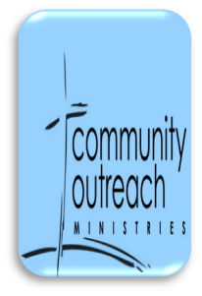

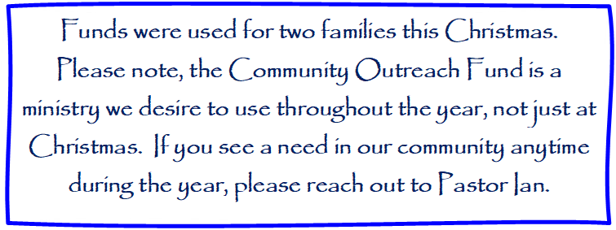

Relief in the Face of Crisis

As a few of us sat in Church at the Craft sale, December 11th and watched the storm come up and the power go off, I heard many say- “I am glad it wasn’t tornadoes”. As we looked at the reports on the devastation and the deaths from those tornadoes that ripped through Tennessee, Kentucky, and neighboring states- our hearts go out to them.
Through the UMCOR (United Methodist Committee on Relief) supplies and money is available to immediately go to sites of disaster. Within 24 hours a 28-foot trailer loaded with cleaning buckets, shovels, flashlights, water, nails, tarps. totes, and much more was driven to the area from the Midwest Mission Distribution Center. $21,000 of Humanitarian relief was sent to sites set up to handle aid.
This is why UMC is a Connectional church. We are ready to help those in trouble. UMCOR is the first there and the last to leave. The emotional trauma caused by these storms, doesn’t end when shelter is found, and food is on the table.
So- what can we do? Prayer is the immediate answer, but through donations to UMCOR, we need to keep the relief services ready and available for the next storm or flood that rips through the lives of our brothers and sisters.

Keeping you informed cont’d

What do we know about the Mexican/ US border?

A group of United Methodists wanted to find out. They named themselves “We the People Ride’ and rode bicycles along the border wall looking at the wall and talking to folks about immigration policies. They are doing this to raise awareness about our immigration policies and the need for change. Policies that do what our faith asks of us: to welcome the foreigner and the stranger. (Lev 19:34) and to remember this land is not our- it is God’s, and we are all immigrants. (Lev 26:23).
The border wall stretches across 3200 miles. Its purpose is not to just deter immigrants. It is meant to permanently harm and kill people. It is also meant to instill fear- fear of the stranger, fear of immigration policies and fear of death. The term is “Deterrence by Death.” The border wall has grown from its original 10 feet high to 30 feet high. If one falls from 30 feet, one can’t get up and walk away. Many stories are told of those who tried…
The US Government does not track migrant deaths, but the communities on the border do. The cities and towns on the border care deeply for the immigrants and refugees. Groups travel into the desert frequently to leave food and water hoping that they will survive. More than 4000 immigrant bodies have been found in the desert. An accurate count is had to come up with as it takes about 3 weeks for a body to disappear in the sun and heat and scavenger animals.
Tens of thousands of asylum seekers are in make-shift camps without money or resources. Many have sold all their possessions to cartels for safe passage. Without money, they can go no further and their families where they came from are in danger. People waiting in camps are trapped. They can’t go home, and they can’t cross the border. We have strengthened the influence of the cartel and we have created more desperation, which will lead to more people taking more chances…which will lead to more deaths.
Our immigration policies have been and continue to be literal death sentences for thousands of innocent people. We need Common Good immigration policies. Learn more- raise awareness…our faith demands it!
For further information- check out We the People Ride

Keeping you informed cont’d

January 16, 2022, is:
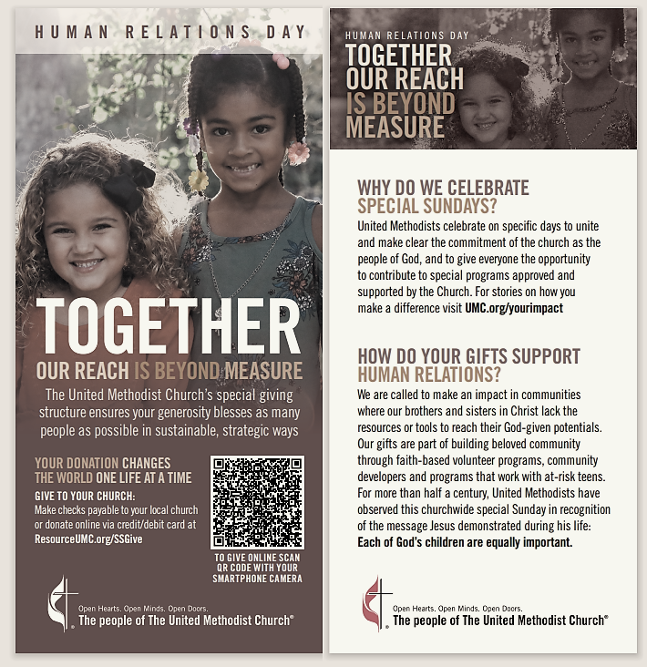

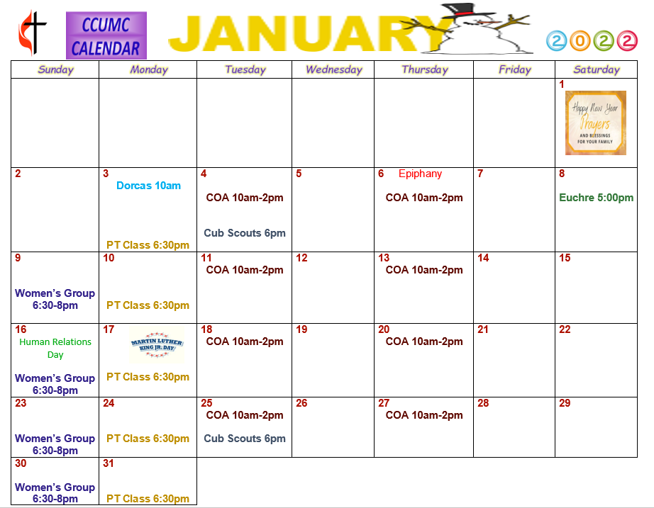

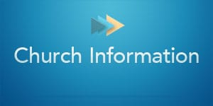

Stay connected! Follow us on:

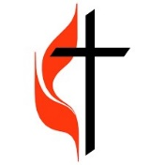
Join Us Each Sunday

Worship Services 10:30 am

(masks are optional)
Carson City United Methodist Church
Phone: 989-584-3797
Email: carsoncityumc@gmail.com
Website: carsoncityumc.com
Sunday Worship Service: 10:30 am
Office Hours: Monday to Thursday, 9:00 am-Noon
After hours by appointment
Pastor: Ian McDonald (906) 322-5318
Secretary: Bonnie Seaman (989) 763-1674

Online giving available: Website: http://www.carsoncityumc.com/donate.html

Carson City United Methodist Church
Phone: 989-584-3797
Email: carsoncityumc@gmail.com
Website: carsoncityumc.com
Office Hours: Monday to Thursday, 9:00 am-Noon
After hours by appointment
Pastor: Ian McDonald (906) 322-5318
Secretary: Bonnie Seaman (989) 763-1674

Weekly Sunday Bulletin now available on our website
at www.carsoncityumc.com

