How do I… navigate Flexible Spending Open Enrollment?

You will not have to complete this enrollment if you do not wish to enroll in a Flexible Spending Account (FSA).
You can access the FSA Open Enrollment guided process by selecting the “Benefits” option on the menu panel.
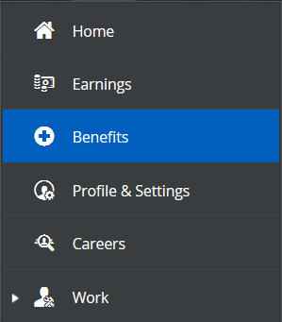

Under “Enrollments,” click “Start Enrollment” to begin the process.
- Note: this enrollment will expire the last day of open enrollment, December 7.
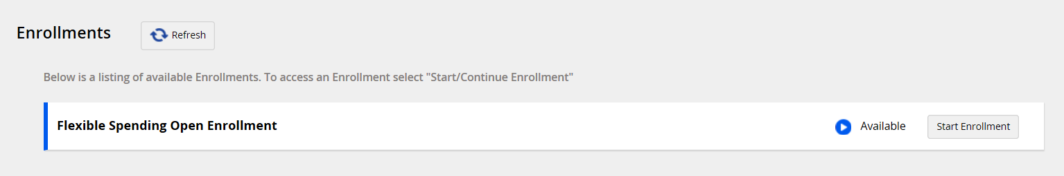

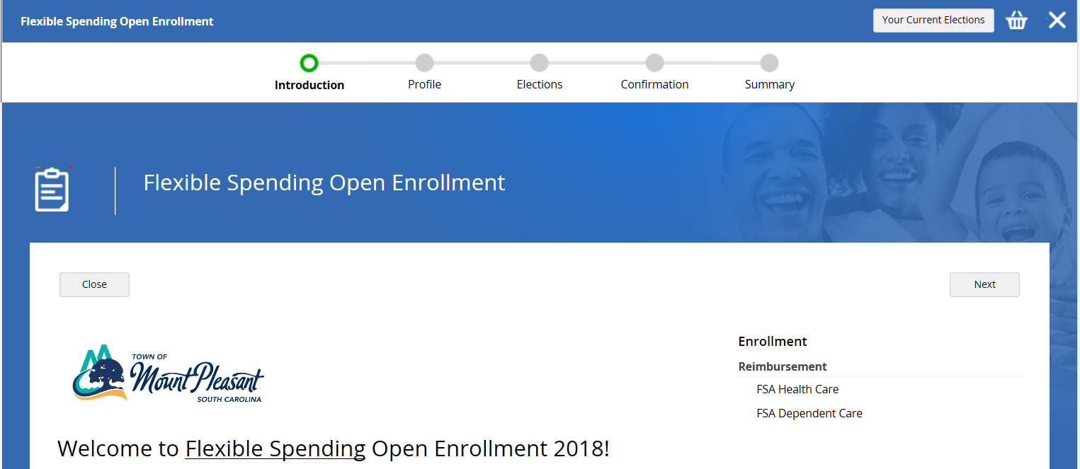
Once you’ve reached the Open Enrollment welcome page, click “Next”.

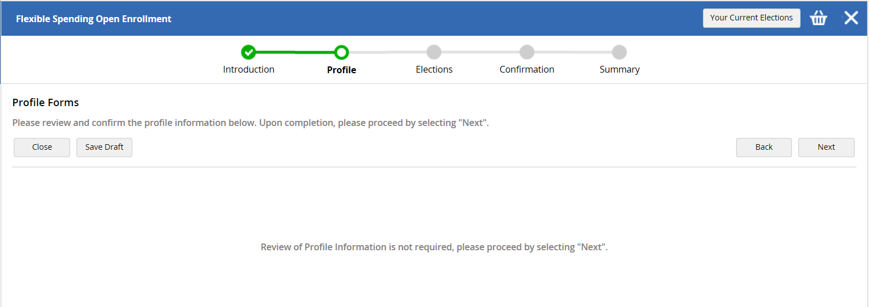
On the next screen, click “Next”.

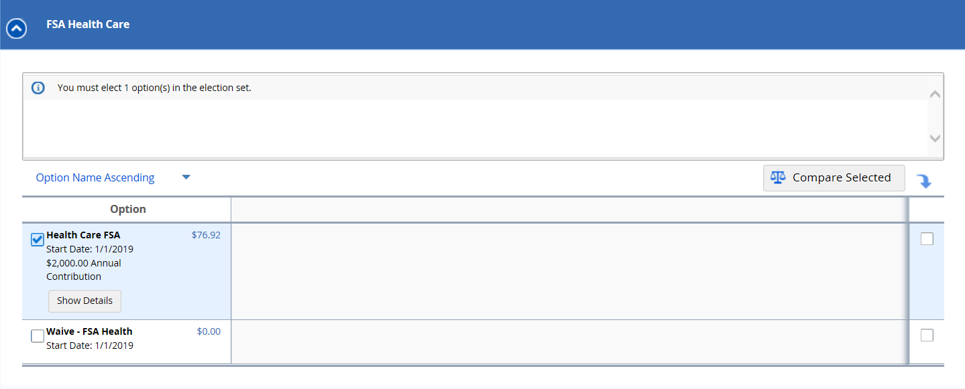
To enroll in FSA Health Care, click the checkbox next to the option.

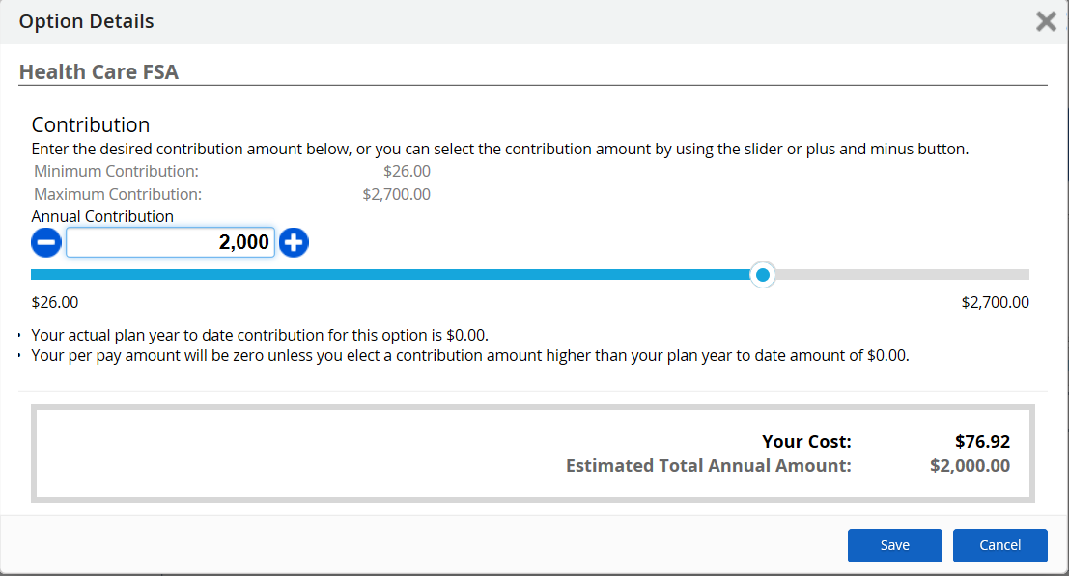
To select your annual contribution, you can either type the amount into the box, move the slider, or using the plus and minus buttons.

Your bi-weekly contribution is the “Your Cost” amount.
Click “Save”.
To enroll in FSA Dependent Care, select the blue arrow next to the option, then follow the same instructions as above.
Once you are done, click “Next”.
Note: If you do not enroll in one of the FSA plans, you will have to select the “Waive” option to move forward.
Example: if you enroll in FSA Health but not FSA Dependent, you will have to select “Waive – FSA Dependent Care”.
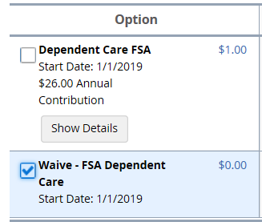
Click “Submit Enrollment”
