Saving a Google Form to Your Phone’s Home Screen

These instructions are for an iphone, but saving to an android is similar.
1. Email or text yourself a link to the form. Open the link on your phone.
2. Click the “Share” icon at the bottom of the screen.
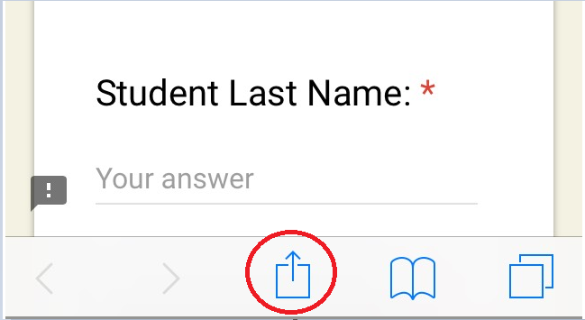

3. Choose “Add to Home Screen” and then choose “Add.”
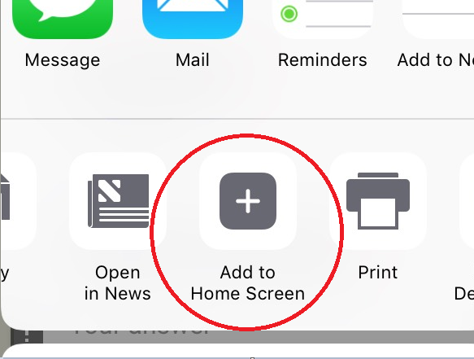

4. The form will now appear as a purple icon with white stripes:
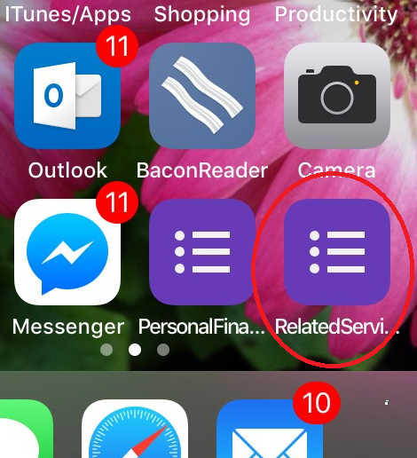
Just click it to be taken directly to the form.

