Nick Marino
ENGL 360: The Rhetoric of Fashion
Secs. 010, 011
23 September 2021
Fashion Brand Rhetorical Analysis (FBRA)
Your task is to study the branding of a company that produces clothing as well as has an online presence and then write an analysis of how the company and brand persuade you to purchase their products. Your analysis must use evidence from both print and online sources, meaning that you must purchase a piece of clothing to do this assignment (unless you already have a piece of clothing with the tags and packaging intact). You must document your print evidence through either photographs or scans attached to your analysis. Your final draft should be at least 5 full pages of writing (not including the required attached images).
Consumer as Identity
Throughout our lives we inhabit various identities. Some are permanent. We are all sons or daughters of our parents, even if we do not know them or if they are no longer alive). Some are recurring but temporary. When we are in a car, we are either a passenger or a driver. When we are persuading someone else, we are rhetors. When someone is persuading us, we are the audience. A consistent and recurring identity for modern people is that of the consumer.
One way to understand modernization and globalization is to be aware of how traditional cultural artifacts like clothes, grooming supplies, and cosmetics are no longer handmade by humans or directly harvested from nature by humans.
Instead, we rely on workers (and machines) to harvest commodities, which are raw, agricultural material that can be purchased or combined with other substances to make a product, like the cotton that is used to make a t-shirt or the coffee beans that are ground and roasted into a can of coffee sold to consumers. Increasingly consumers purchase products from online sellers, but the shift to online shopping has not made consumerism as ethical as it is convenient. In the 1990s there was widespread backlash against sweatshop production of clothing marketed to westerners, which led to movements to boycott certain brands like Nike, and allegations of unfair abuse of workers has continued even since the widespread adoption of the internet. An example of this is the “suicide nets” found at Foxconn factories in China (Foxconn is a Taiwanese electronics manufacturer known for making iPhones).
Knowing Who We Buy From
Before industrialization it was not uncommon to know where the consumer goods a person owned came from. Even today, it is possible to replicate the experience of buying directly from a supplier, like in the case of farmer’s markets, where consumers can interact with farmers and their employees. But increasingly this type of purchasing is uncommon because it is inconvenient, and because harvesters of commodities want to increase their profit margins by selling to people from increasingly distant lands.
Globalization, or the widespread movement of goods and services thanks to technologies like air travel and the internet, has created a situation where we rely on retailers (middlemen businesses that buy products wholesale from factories and suppliers and then resell them at a higher per unit rate to consumers) to buy goods, whether online or at brick-and-mortar stores. This means that our connection to those who make our products is minimal. This lack of connection arguably allows exploitative labor conditions to continue in factories that produce goods for the Western markets.
Consumerism and Choice
Consumers in capitalist countries like the United States almost never have a single choice for a given product. Whether we buy in brick-and-mortar stores or online we can almost always choose between brands. Our criteria for choosing can depend on price, name recognition, or even the aesthetics of the packaging or company logo. The distinction of consumer choice has traditionally been a way of distinguishing capitalist, first world countries from so-called second world communist nations like the Cuba and the People’s Republic of China.
Consider how companies know that consumers have choices for anything that they wish to buy and how companies to respond to questions such as “What is the best way to sell identical products across multiple borders? What voice should advertisers use to address the whole world at once? How can one company accommodate cultural differences while still remaining internally coherent?” (Klein 115).
Considering how brands differentiate themselves from their competitors in order to influence consumer choice is not simply a matter of comparison of the materials or subjective quality of two competing garments. Rather, sometimes it is the image of the label that persuades the consumer to buy one brand and not another, as Tamsin Blanchard notes:
The fashion industry is one of the most overcrowded and competitive industries. What makes one designer’s white shirt stand out from another’s is not necessarily the design. An architect might be attracted to a shirt by Comme des Garçons because of the message it is communicating to him or her. The way that message is communicated is carefully coded in language he will understand, through the advertising, the label, the packaging, the story design – it’s a matter of presentation rather than fashion. Likewise, a businessman might buy his shirt from Hugo Boss because the logo speaks to him. It is confident, direct and has a very clear, corporate message. However similar the shirts may be, their customers live in totally different worlds (Blanchard 145).
Criteria for choosing a brand
Your brand must produce a product that exists outside of cyberspace but that also has an online presence. Your brand must produce clothing, even if the company also produces other goods (like a fashion brand that also produces towels and bedlinens). Your brand does not need to be a luxury brand or make expensive products. Your brand can be either a private company or a publicly traded company with shareholders. Your brand does not need to be either manufactured nor headquartered in the United States, though obviously choosing a foreign brand which does not have English language materials on its website would not work for this assignment.
Brands are not necessarily the same as companies. The company owns the brand and the trademarks to it, but when you buy a product, the brand is often more visible than the company. For example, Cheetos is a brand owned by Frito-Lay, which is itself owned by Pepsi Co. A fashion example is The North Face brand, which was originally an independent company but was purchased by the VF corporation.
Ideally you should choose a brand that you have purchased in the past or that you currently buy. Consider choosing a brand that produces clothing in a branch of the industry that interests you (like Nike for sportswear, Levi’s for denim, etc.).
Required rhetorical terms | Optional but recommended Rhetorical terms
Appeals (logos, ethos, pathos)  Audience  Color  Rule of thirds (images only)  Foregrounding  Representation | Syllogism and Enthymeme  Kairos  Rhetorical Situation (exigence, audience, constraints)  Symbols  Metaphors  Intertextuality  Tone (videos/commercials only)
Must be mentioned in your analysis (your brand should use all 3 appeals, albeit not necessarily evenly). The analysis should focus primarily on ethos. | May be mentioned in your analysis depending on the brand

Required Rhetorical Terms
Your task is to identify rhetorical moves made by the brand, even if you disagree with the arguments that they present for why someone should buy their products. All the claims made by the company should be accepted at face value for their rhetorical potential.
Note: the way these questions are grouped under each rhetorical term is in some cases arbitrary. You should ask yourself these questions while studying your company of choice but you do not need to group them the way they are grouped here (a lot of the ethos questions can be considered pathos or logos as well).
Appeals
Logos
- How does the company use the brand to promote products that make sense and solve everyday problems?
- How does the company argue that its products are better than that of the competition?
- How does the company show that its products have been replicated by competitors (the assumption being that imitation is the highest form of flattery and thus imitated products are typically of high quality)?
- How does the company show that its products are unique and separate from competitors (in fashion this is called the USP or unique selling proposition/position)?
Ethos
- How does the company discuss its history as a source of credibility?
- How does the brand discuss ethical labor practices?
- How does the brand discuss ethical environmental practices?
- How does the brand manifest a sense of social justice?
- How does the company highlight (or not) where its products are made?
- If the company manufactures its products in its own country, then why would consumers from that same country want to purchase such products?
- How does the company show its social media savvy?
- How does the company make the consumer aware of awards its products have won?
- How does the company tell consumers about endorsements they have won? (“Good Housekeeping magazine recommends”)
- How does the company stand behind its products through a warranty or something similar?
- How does the company show evidence of its sponsorship of events or organizations? (like Adidas’s sponsorship of the NHL and MLS and Coca-Cola’s sponsorship of the FIFA World Cup)
- How does the company show the celebrity endorsements for its products?
- How does the company promote its good character by discussing charities it donates to?
- How does the company discuss how it values user/customer feedback for its products?
Pathos
- How does the company rely on emotions to induce people to purchase its products?
- How do the depictions of human beings on the company’s website or printed on its product manifest emotion and what types of emotions do they manifest?
Audience
- Who are the types of people most likely to purchase products from this company? (it is never everyone)
Color
- What colors feature in the brand’s logo, products, packaging, and website?
- Why do you think the company uses these colors?
Rule of thirds
- Does the company website or print images from the company follow the rule of thirds for image composition?
The rule of thirds is a concept from photography and applies only to images and not commercials. The idea is that an image should be divided into 9 sections horizontally and vertically. The image should be read from left to right by moving from one space to another with the eye.
Pretend the above image is superimposed on the image you chose to analyze. Does the left, center, and right columns all contribute to the visual text’s argument? Or is most of the argument found only in one square or column?
The rule of thirds is never exact in that the exact center of the image contains the story or argument. The reason for this is that if the subject in the foreground is not positioned exactly in the middle the viewer will pay attention to the background more than if the image does not follow the rule of thirds and the foregrounded subject is exactly in the middle. The center focus of an image or commercial should be near the four intersections in the above image. The center focus should not be in the middle square.
If the flag of Mali above was superimposed behind an image and the focus of the image was in the yellow portion, then the rule of thirds would not be respected.
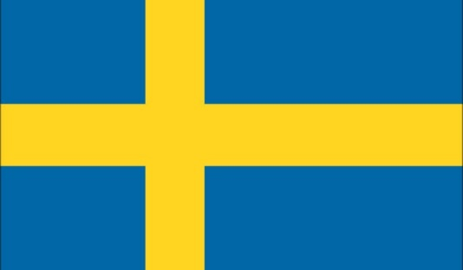
If the flag of Sweden above was superimposed behind an image and the focus of the image was in the vertical yellow portion or in the square intersection between the vertical and horizontal yellow portions, then the rule of thirds would be in effect.
Foregrounding
- An object is foregrounded visually when it is clearly shown while the background of the image shows other elements of it less clearly. The foregrounded image appears clearly while the background appears blurred. Why does the rhetor focus on one part of the image at the expense of the other parts?
- How does the company use foregrounding to highlight the most important parts of an image that they disseminate on their website or on their social media websites?
Representation
- What types of people are represented in images and commercials of the company? (note: the commercials and videos you include in your analysis should be located on the company website, not on YouTube)
- Who appears to be left out of the company’s visual materials?
- What about for the employees and management? (not all companies disclose this information to consumers).
- How does the company show a commitment to social justice through the composition of its staff?
Optional Rhetorical Terms
Syllogism and Enthymeme
- How does the reasoning of the company, either online or in print, use syllogism or enthymeme?
Kairos
- How does the company state that it is the opportune time to purchase their product(s)?
- What is it about the company’s products that seems relevant to a contemporary audience?
Rhetorical Situation (exigence, audience, constraints)
- How does this brand present a rhetorical situation to convince you to purchase their products?
Note that the rhetorical situation can sometimes be created by the company and not by the actions of the consumer. An example of this in fashion is the old adage that consumers, especially women, should not wear white clothing in the Fall or Winter, or after Labor Day. Faced with having to change from white clothing to something more seasonally appropriate, fashion companies urge consumers to consider usually darker colors for their winter offerings, while reserving lighter colored pieces for the warmer months of the year.
Symbols
- Does the company use their products as symbols standing for some quality or idea? If so, what products and what qualities or ideas?
Metaphors
- Does the company make comparisons between their products and some other entity that is seemingly unrelated? If so, what products and what seemingly unrelated entities?
Intertextuality
- Does the website of the company or its packaging, tags, etc. assume awareness of another brand or image or quotation?
Tone
- If the company has videos on its website, what emotions do these videos convey?
- How does the music affect your interpretation of these videos?
What is evidence for this project?
Evidence should come from the following sources:
- Language from the company’s website (presumably written by its employees)
- Images from the company’s website
- Videos from the company’s website
- Any combination of language, images, and videos from the company’s social media platforms (these texts must be accessible to anyone with an internet connection; no login or signup required)
- Print materials from the company (labels, logos, tags, inserts, flyers, packaging)
The latter category must be documented through scans or photographs (see below examples) added to your analysis document or attached to the Moodle submission space for the final draft and for the first draft (the latter should be posted on the discussion boards for this assignment).
Documentation
There are four methods to document evidence for this project:
1. Quote from the company website
2. Paraphrase from the company website
3. Use screenshots of the company website
4. Use photographs of the products, receipts, packaging, tags, and other representations of print materials from the company
You must include documentation from more than one of these methods and one of the methods must be 4. In other words, you need photo evidence, but you can choose between whether you quote (1.) or paraphrase (2.) from the company website. All screenshots and photographs should be labelled with a caption that describes the image as below:
Citation
You must include both in-text and works cited citations for all online sources that you either quote or paraphrase from. Most of the time for company websites the citation format is for what Purdue OWL calls “A Page on a Web Site” @ https://owl.purdue.edu/owl/research_and_citation/mla_style/mla_formatting_and_style_guide/mla_works_cited_electronic_sources.html. “A Page on a Web Site” describes the likely citation format for company sources because companies rarely identify an author other than the company itself. Often they also don’t include the date of publication so if that information is not there you can omit it from your works cited. Press releases from a company will generally include the date and sometimes the author. The title of the webpage and the source (in italics, usually the company’s name) and the URL should always be stated because those parts of a website are almost never absent.
You do not need to cite in-text or in the works cited section of your analysis for photographs and references to print materials from the company. However, you should be clear which print materials you are referring to when you discuss them in your analysis.

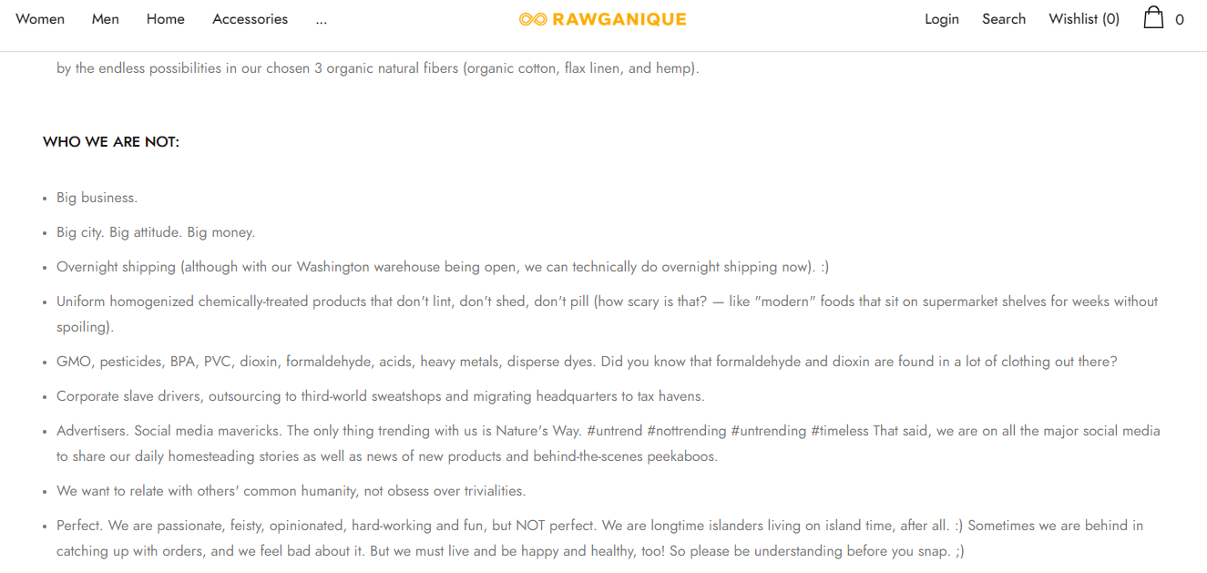
Figure 1 – Screenshot of the "About Us" page from Rawganique @ https://rawganique.com/pages/about-us.

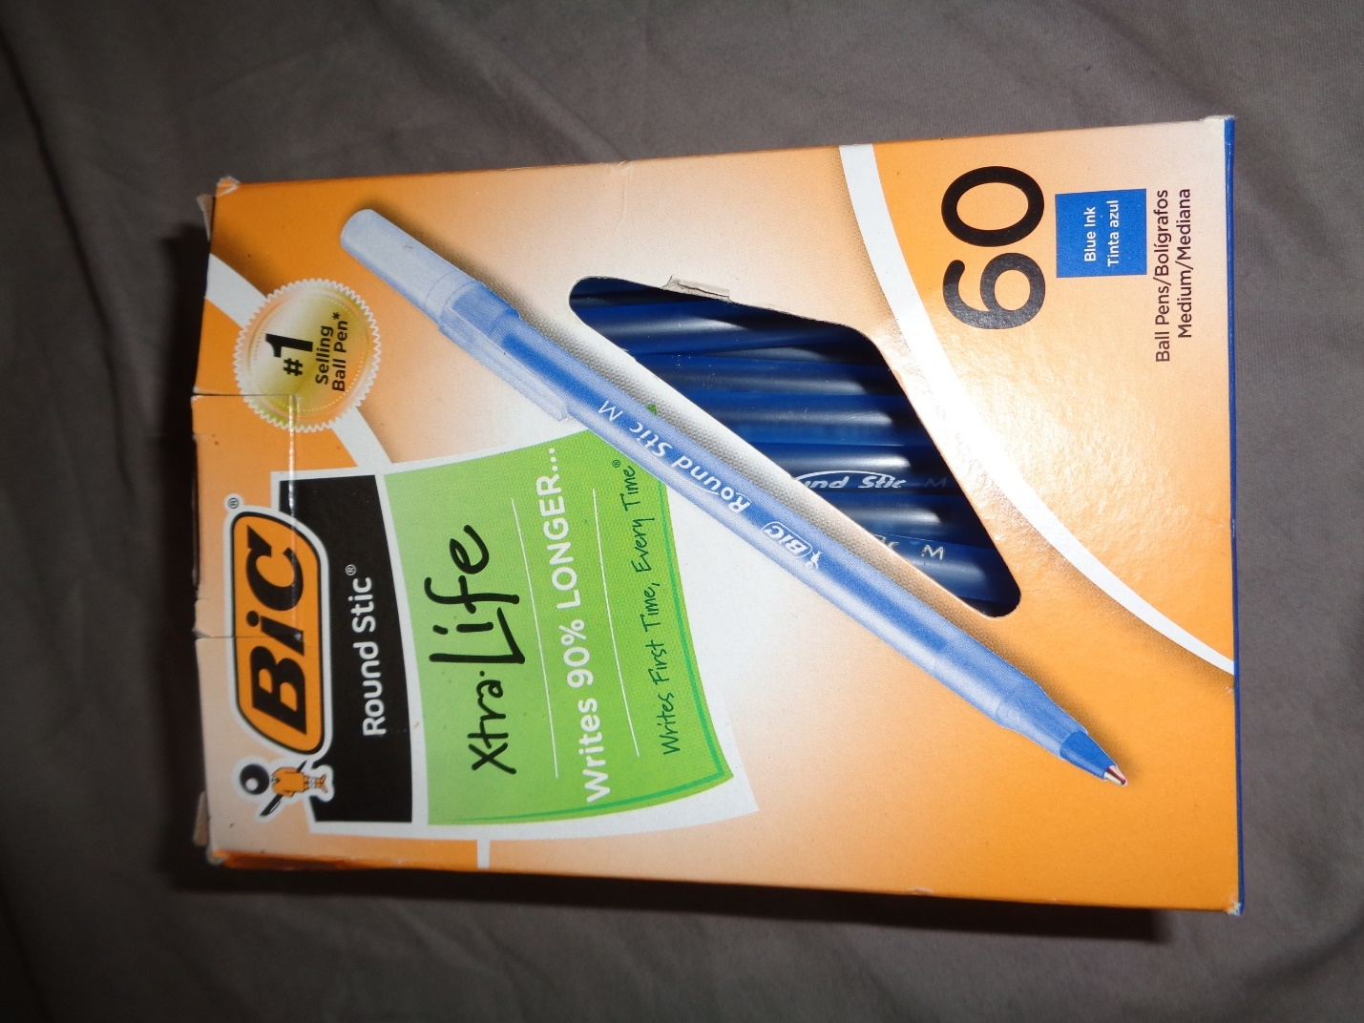
Figure 2 - Packaging of Bic Round Stic blue pens
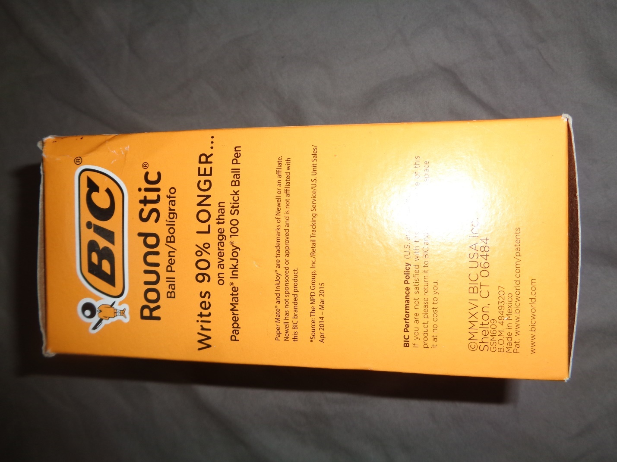
Figure 3 - Side view of the Bic pen box
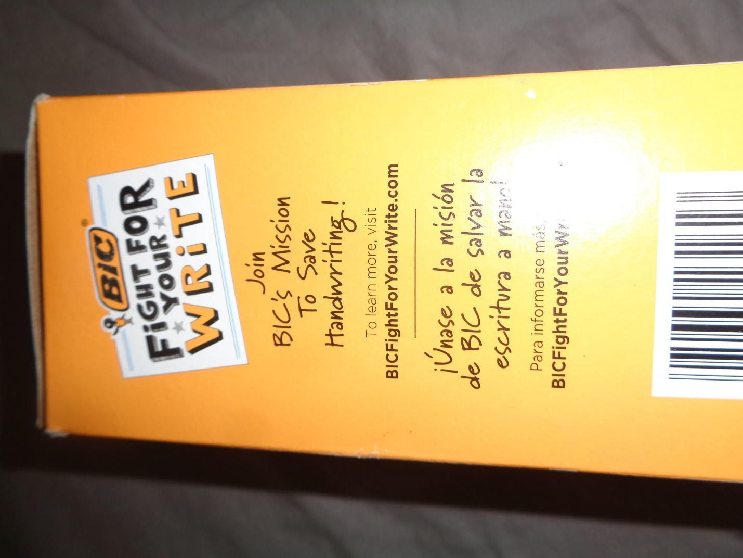
Figure 4 - Side view of the Bic pen box showing activism by the company
Figure 5 - Front view of Cariaggi hang tag for cashmere hat
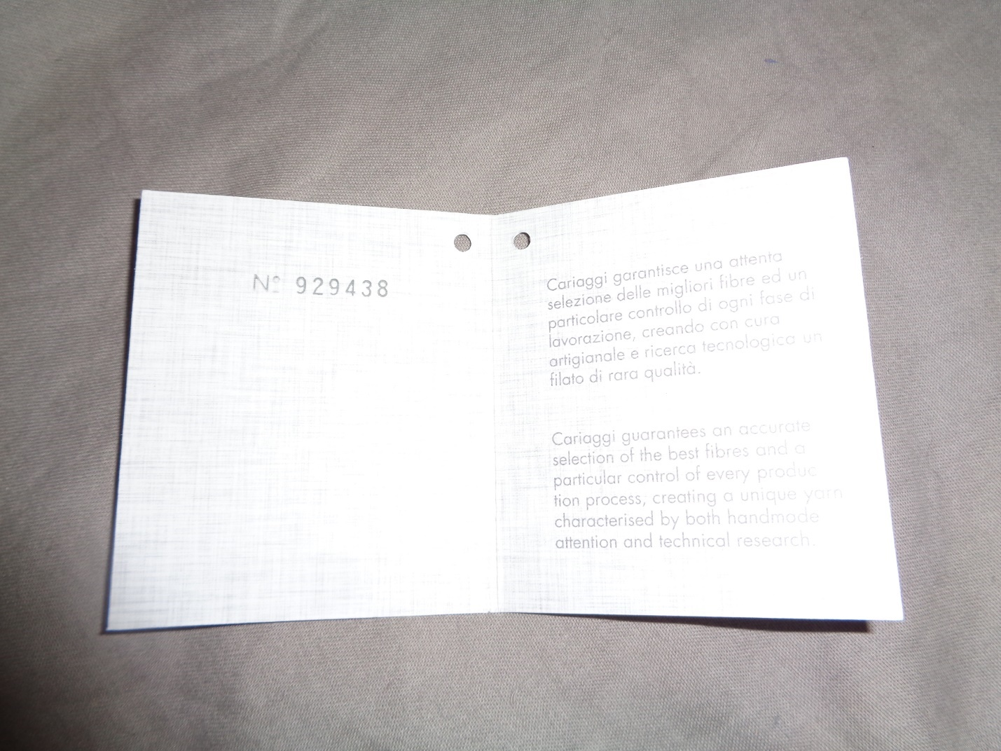
Figure 6 - Contents of Cariaggi hang tag
Figure 7 - Back view of Cariaggi hang tag showing company contact information
Style and Format
Please follow the format in the Sample Fashion Brand Rhetorical Analysis which is available on Moodle. For the required rhetorical terms, fill in your discussion of how the print and online representations of the company show them. For the optional rhetorical terms, fill in only those terms that are evident from the company you chose.
For the reflection section at the end, please discuss some of the similarities and differences between the online and print representations of the company. In that section also discuss what representation of the company (print or online) persuaded you more to buy the company’s products and why that is so.
The last part of your final draft document should consist of the images you include in your essay (these images should come after the works cited).
Your essays should be in 12 pt. type and double spaced and should be in MLA format. Your final draft should be at least 5 full pages double spaced. Your name should appear on the first page and in the header of every page along with the page number. Please include a Works Cited section at the end of your essay (it does not need to be on a separate piece of paper). Please include a URL for each online citation.
Due dates
Rough draft: 12 October 2021
Rough draft peer review feedback: 19 October 2021
Final draft: 21 October 2021
Please submit your drafts digitally via Moodle.

Klein, Naomi. No Logo. 10th Anniversary Edition. Picador, 2010.
Blanchard, Tamsin. “Introduction: Aboud Sodano and Paul Smith.” Fashion Theory: A Reader, 2nd edition, edited by Malcolm Barnard, Routledge, 2020, pp. 144-155.

