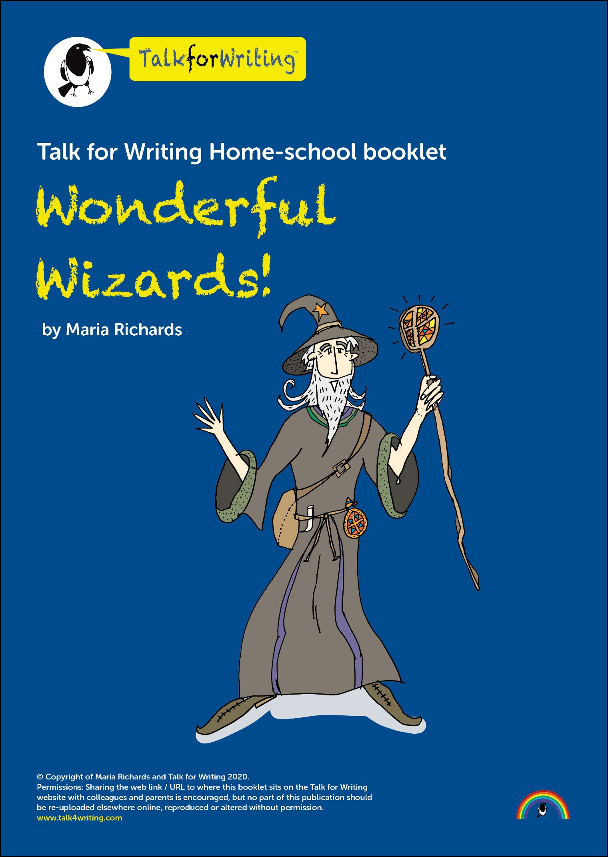

Welcome to the wonderful world of wizards! Come with me and explore things that will help you with your writing skills and build on the work you do at school.

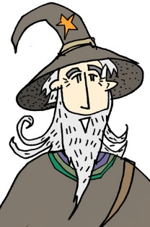
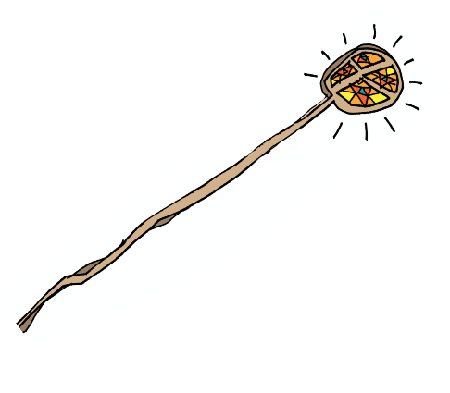
For thousands of years, humans all over the world have tried to discover the power of wizards. There are many stories about what we do, where we live and the spells we cast. I’m here to introduce you to the world of wizardry and to inspire you to write about wonderful wizards!

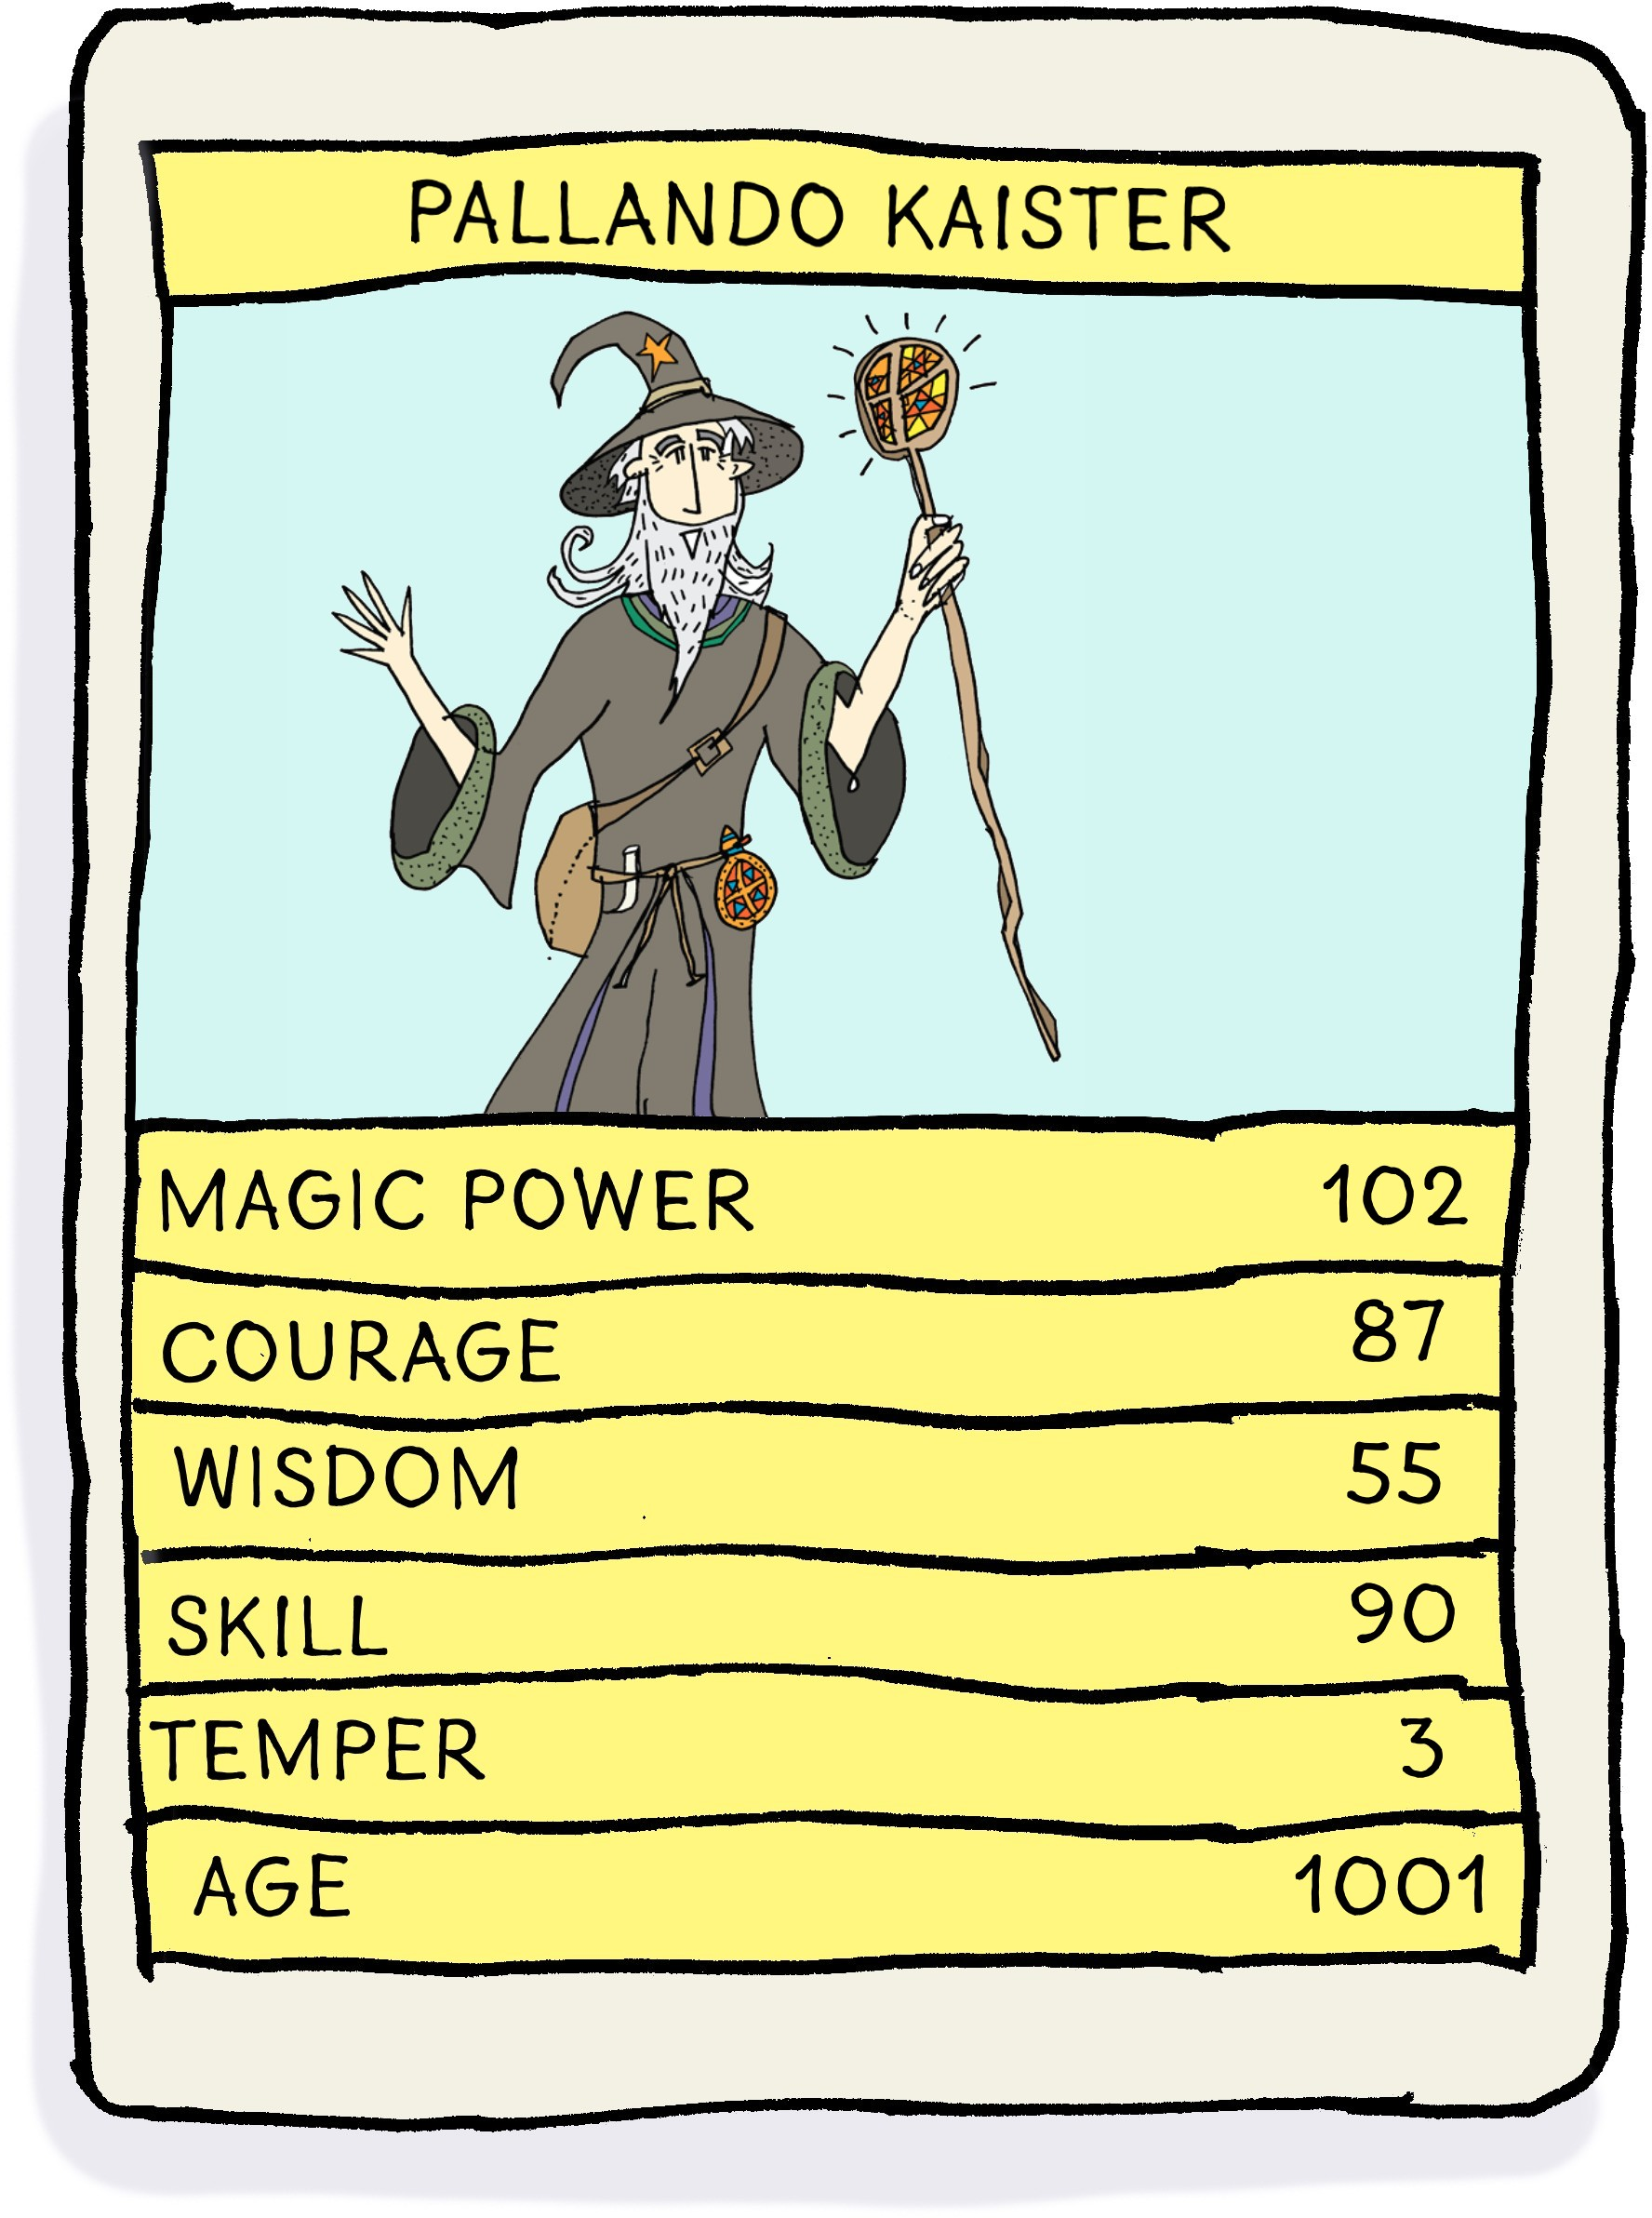
Have you ever wondered what it’s like to be a young wizard? What if you found out you actually were one? Let’s imagine you are! What would you look like? What would you wear? What special powers would you have?

Top Wizard cards

Let’s put all your ideas onto ‘Top Wizard’ cards in Top- Trump style. First, take a look at mine:

Create your Top Wizard cards here

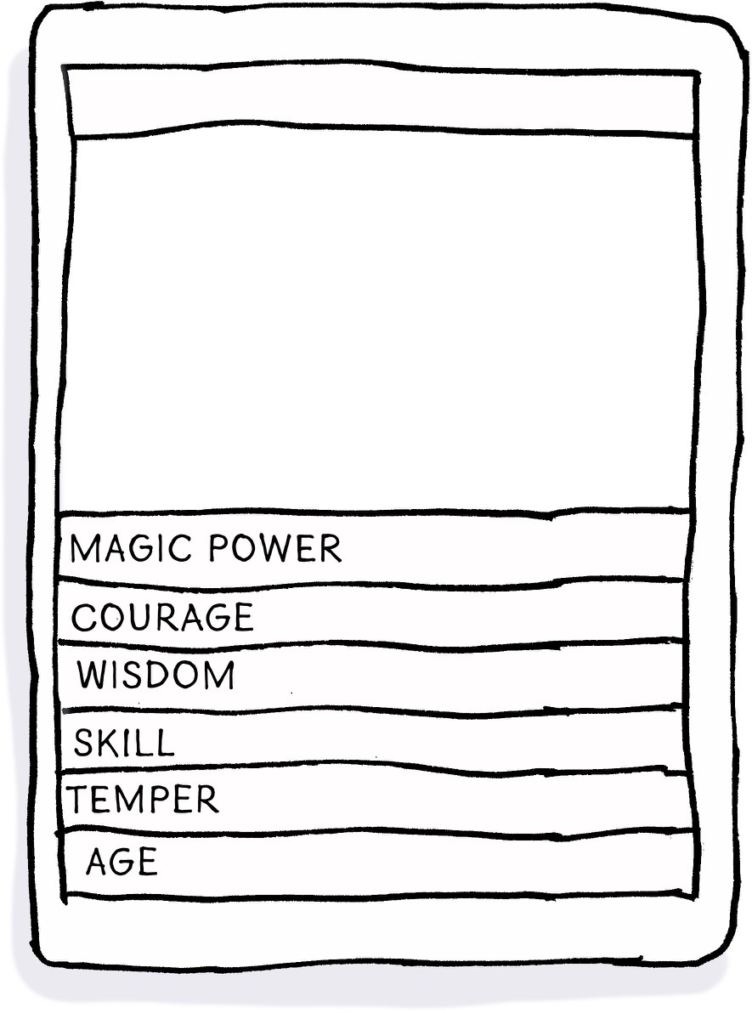

★ Creative challenge – make a set of wizard ‘Top Trumps’ and play with someone else at home or school. Here are some wizards to get you going but you can create as many as you like.

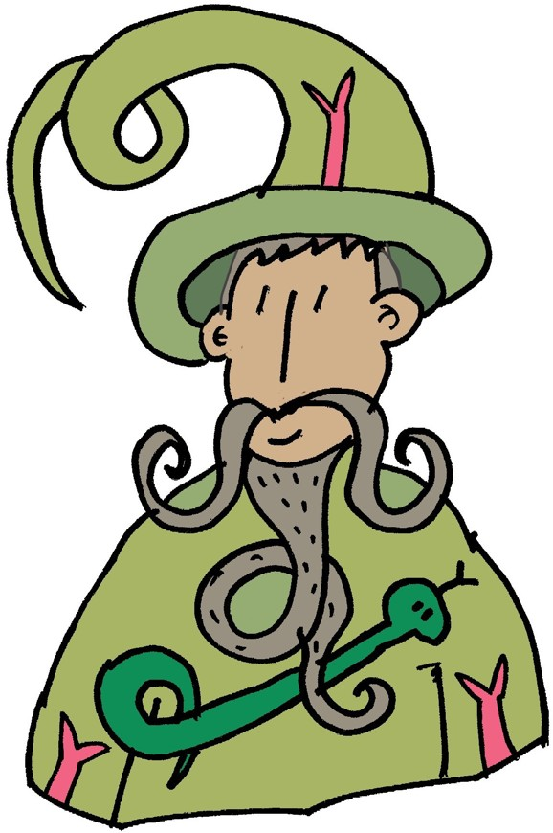
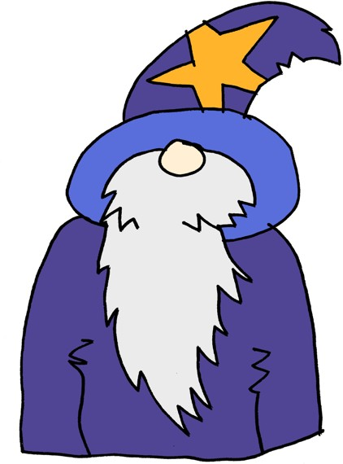
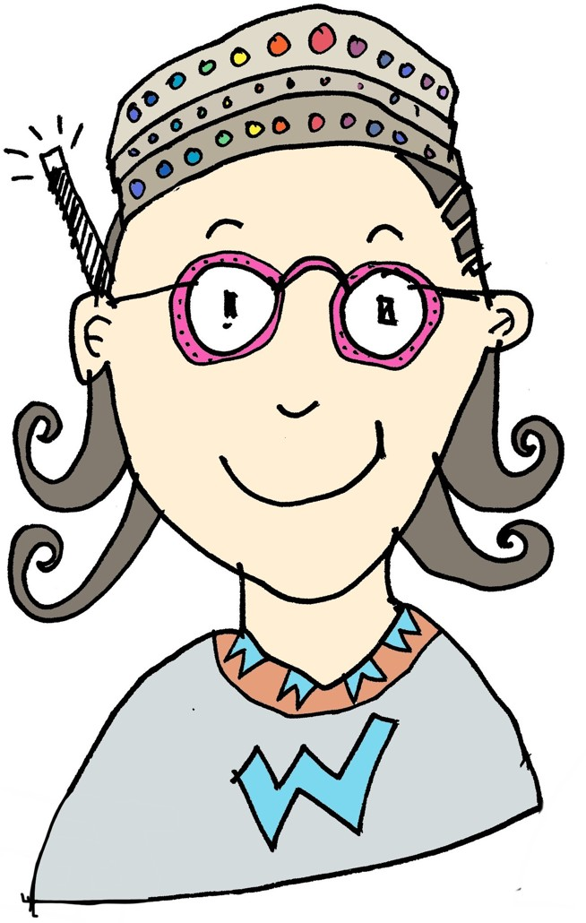
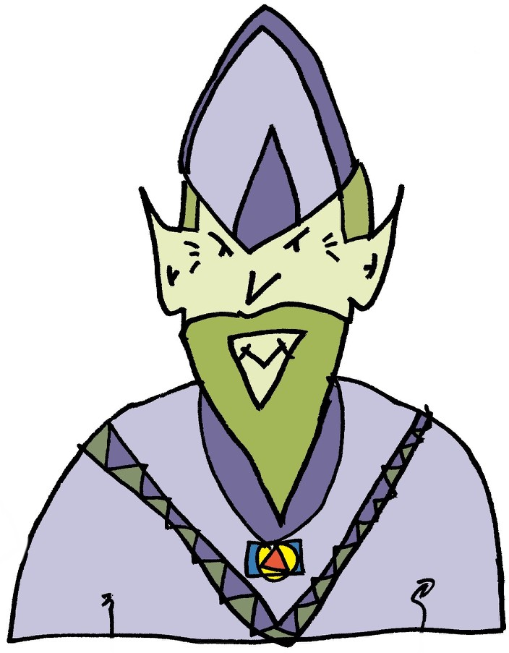

If you don’t know how to pay Top Trumps you can find out here: http://www.toptrumps.com/how-to-play-top- trumps/

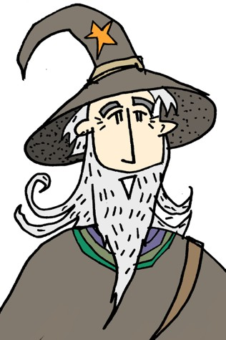
Let’s go to wizard school!

So now you are a wizard, there’s a place just for you! Take a look at this advert for The School of Wizardry. It is written to persuade you to join the school and learn to be a great wizard. Read it through and see if this is the school for you!

Welcome to the School of Wizardry

Are you a budding wizard, full of spells and magic? Do you long to be the finest wizard in all the land? If so, come along to our School of Wizardry and learn to be a Master Wizard! Don’t miss out on this once-in-a- millennium opportunity.
The School of Wizardry offers remarkable education for wizards of all calibres. Learn new skills from highly qualified professors of wizardry and enjoy our stunning curriculum, which boasts a multitude of outstanding classes. The choice of lessons here is unrivalled and includes:
- preparing magic spells and inventing potions;
- broomstick manoeuvres and expert flying skills;
- specialist invisibility and advanced disguise;
- perfection in wand-handling skills.
Our exceptional school is renowned around the globe and places are highly sought after. Study here and we can guarantee you’ll pass every wizard exam with flying colours. It is certain you’ll be the envy of all your wizard friends.
Study with the best! We have been rated ‘Super-Terrific’ in a recent inspection by the W.S.B (Wizard School Board) and you won’t find tutelage like this anywhere else in the universe. We also have up-to-the- minute equipment, beautifully decorated classrooms and the most divine, freshly cooked school dinners. What are you waiting for? Apply now!
Come, join us. Leave other wizards far behind! Win in the world of wizards!
©Maria Richards 2020
You can also listen to the text here: https://soundcloud.com/talkforwriting/wizards/s-N2Kss3KDdxd

What do the words mean?
★ Let’s investigate this persuasive text a little more. Take a look at the meaning of some of the words from the advert.

Word: | Definition:
budding | when a plant starts to develop buds or a person starts showing they might become good at something
calibre | the quality of someone’s character or the level of someone’s ability
multitude | a large number of something
unrivalled | better than anyone or anything
manoeuvres | a number of movements that require care and skill
disguise | to hide or change how you look
renowned | to be famous for something
tutelage | teaching or tuition

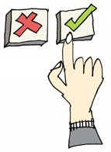
Use an example
★ Look at the definitions above. Draw a small image in each box to help you remember the meaning of the word.

multitude | disguise
manoeuvres | tutelage

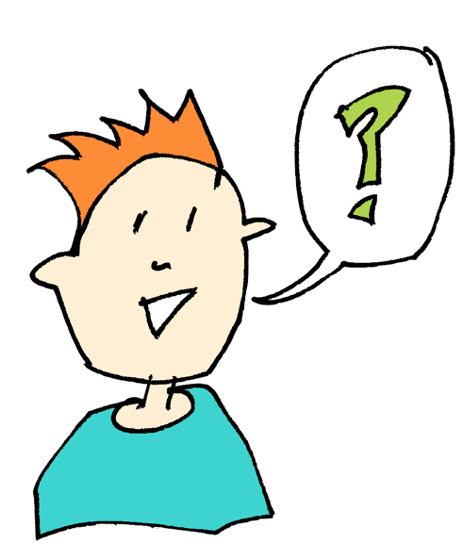
Which synonym?

★ Synonyms are words with the same or similar meanings.
★ Match the synonyms below this table to the target words.
★ Can you find any more synonyms to add into the table?

Target word | Synonyms
budding
calibre
multitude
unrivalled
manoeuvres
disguise
renowned
tutelage
Which synonyms match the target words?
supreme promising famous many teaching movements talents camouflage

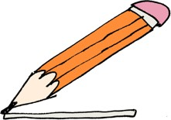
Finish the sentence
★ Using your knowledge of the target words below, finish the sentence so it makes sense.

Disneyland is renowned for Spies often wear a disguise so
There is a multitude of wildlife in the countryside, such as The budding popstar appeared on
★ Challenge: Now write some sentences using any of our new words. I have done one for you:

The driver did some interesting manoeuvres whilst trying to park.

-

-

★ Are there any other words you don't know the meaning of? Can you find out the definition? You could ask someone else in your home to tell you, use a dictionary or search the internet. On a separate piece of paper, try and think up an image that represents what they mean and then use the words in a sentence.

Wizard words
★ Let’s have some fun with words. To cast a spell, you need wizard words. Take a look at these:
‘Explode-ium’ ‘Farm-ius’ ‘Shade-iorum’ ‘Pen-iosa’ ‘Sprint-lorus’
These are everyday words turned into wizard words by adding a ‘spell’ ending. You say the endings like this:

How it is spelt: How you say it:
-ium ee-um
-ius ee-us
-iorum ee-or-um
-iosa ee-oh-sa
-lorus law-us

So, for Explode-ium, you would say Explode-ee-um. Have a go at saying the wizard words now:
‘Explode-ium’ ‘Farm-ius’ ‘Shade-iorum’ ‘Pen-iosa’ ‘Sprint-lorus’
Your challenge is:
★ Choose an everyday word from group 1.
★ Match your word with any ending from group 2.
★ Write it in the table below and say your new words aloud.

Group 1 |  |  | Group2
explore | read |  | -ium
match | care |  | -lorus
pat | exceed |  | -iosa
lamp | coat |  | -iorum
board | zip |  | -ius

The wizard word game

New wizard words for spells:

★ Challenge: Now write some spells! String THREE wizard words together and don't forget to separate them with a comma to make a list. This creates your spell. Now practise saying your spells aloud. We always say the third word the loudest, so end with an exclamation mark to show this. For example:
Farm-ius, Shade-iorum, EXPLODE-IUM!

-

-

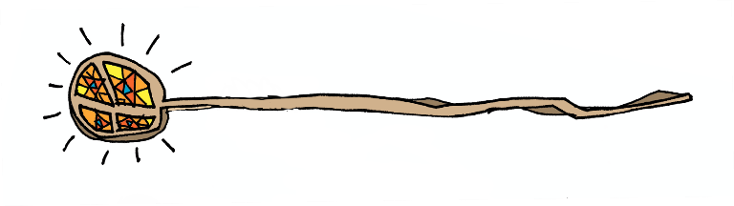

Wizard comprehension!
Here’s a quick-fire reading quiz about the wizard advert. How many questions can you answer?

How can you become the finest wizard in the land?

Does budding mean you are becoming good at something or you are old?

Anyone can go to the School of Wizardry. TRUE or FALSE?

-

Which phrase in the text means the same as latest?
-

Which two lessons will make you better at casting spells?

Find and copy four words that show you this school is great and make you really want to go.

Why might the school have been rated ‘Super-terrific’?

Why might you be the envy of your friends if you go to this school?
-

What makes good persuasive writing?
★Let’s investigate some of the words and phrases that would help make your writing persuasive and be useful when writing an advert.

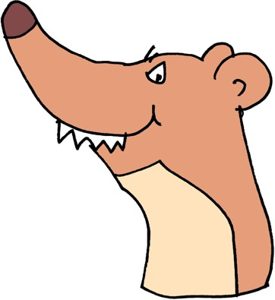
Weasel words
Weasel words are used to make you think everything is absolutely wonderful. They are boastful and they exaggerate the claims you are making. Below, the weasel words are boastful adjectives, describing the things in the School of Wizardry. Take a look at some examples:

We provide remarkable education.
Our curriculum has outstanding classes. The choice is unrivalled.
Our school is exceptional.
We have highly qualified professors. Enjoy our stunning curriculum.
Up-to-the-minute equipment. Beautifully decorated classrooms. The most divine school dinners.
Here are some more adjectives that can be used to be boastful. If you’re unsure about what some of them mean, find out the definition. You could ask someone else in your home to tell you, use a dictionary or search the internet.

astounding | astonishing | breathtaking | sensational
awesome | spectacular | extraordinary | unbelievable
wondrous | amazing | staggering | incredible

The ‘fill the gaps’ game
Let’s try to use our weasel words in another advert. Choose a boastful adjective to fill in the gaps below. Make our Wizard Hotel sound wonderful!
Come along to the Wizard Hotel. The view is

, with
skies and
scenery.

The rooms are . You can laze by

the pool and enjoy staff.
service from our

★ Why not have some fun? Swap the weasel adjectives for negative ones that make the hotel sound terrible! I’ve done the first one for you.
Come along to the crumbling Wizard Hotel. The view is

, with
skies and
scenery.

The rooms are . You can laze by

the pool and enjoy staff.
service from our

★ Writing tip: Using these boastful adjectives in a sentence of three can be very powerful. Take a look at this from the text:

We also have up-to-the-minute equipment, beautifully decorated classrooms and the most divine, freshly cooked school dinners.
Have a go at finishing this one for the Wizard Hotel:

The wizard hotel has ………………………………………………………………….

Weasel phrases
As well as weasel words, there are also persuasive weasel phrases in the school advert. These draw you in by speaking to you personally and try to make you believe everything the writer is telling you. They make you feel like you must do what the writer says or have what they are offering. Look at the ones below.
Places are highly sought after. We can guarantee …
You won’t find … like this anywhere else! You’ll be the envy of …

Try using some of them to write some sentences about our Wizard Hotel. I’ve done one for you. Remember to speak directly to your reader by using the word you.
We can guarantee you the best holiday ever!

-

-

Add in imperative (bossy) verbs
Telling your reader what to do in a bossy way is a much-used persuasive technique. For this you use imperative verbs that get straight to the point. Advertisers love them because they instruct the reader to do something.
Study with the best! Don’t miss out on … Come along to … Learn new skills …
Enjoy our stunning curriculum …
Study here …
Apply now …

★ Take a look at the passage below and underline all the bossy verbs you can find.
Join our happy crew of wizard teachers and fly into a wonderful career. Watch children grow under your expert teaching. Enjoy all the amazing resources our school has to offer. Listen to the happy chatter of your students as they engage in your marvelous lessons. Be amazing! Be the best! Be with us!

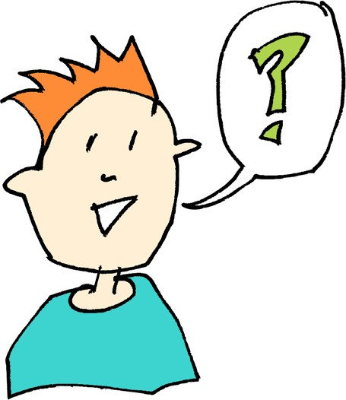
Asking leading questions to your reader Asking questions directly to your reader is another weaselly technique to draw them in to what you are saying. It tries to make the reader think or act in a certain way. For example:

Are you a budding wizard?
Do you long to be the finest wizard in all the land? What are you waiting for?

What other questions might you ask someone, if you were persuading them to come to YOUR school? Use the Are you… Do you… starters and what, why and when question words. For example:

Why go anywhere else?
Do you want to be the best writer in primary school?

-

-

Alliteration – make the words sound attractive
Alliteration is when words start with the same sound. This can
come in handy when you want to grab your reader’s attention and is also good to use for a catchy slogan or ending to your
writing. In our advert we had:
Win in the world of wizards!
What other slogans could you use to persuade people using alliteration? Let’s try with the types of things your reader would see.

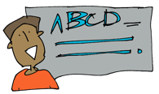
The alliteration game
Your challenge is:
★ Think of a letter e.g. A/B/C …
★ Think of a noun and adjective that starts with that letter
★ Then think of a verb
★ Put it together in a slogan starting with: See …
For example:
L - lazy/lion/lounge would become: See lazy lions lounging!
S - slippery/saucepans/sink would become: See slippery saucepans sinking!
Try out some slogans below.

-

-

-

Design your school!
What school would you like to advertise? Maybe a school of skateboarding or cycling or cookery or computer games or … ? Your school could be for something imaginary like a Unicorn school, a Troll school, a Dragon school …

Take a look at the simple floor plan below. It’s a type of map that lets you plan what the inside of a building looks like. It shows a ‘bird’s eye view’ of how the space is divided up as if you were looking down on it from above. Can you work out how the doors and windows are shown on the plan?

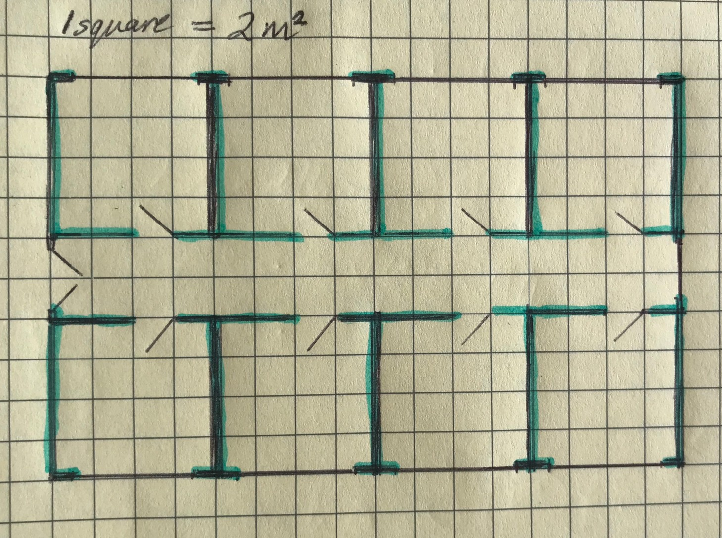
As you can see, this is a rather dull, very symmetric school plan with 8 square rooms. But you can plan your school any way you like and decide what is going to be the focus of each room. Sketch out your ideas on any old piece of paper and, once you’ve decided what you want, draw it neatly on the graph paper below as this makes drawing the plan easy.

Now advertise your school!
Look back at the weaselly language used to advertise the wizard school on page 4. Use some of the ideas there, plus the structure of the advert below, to plan how to advertise your own school.

Underlying structure | Jot down your ideas in note form
Ask questions to the reader to draw them in and then invite them to the school e.g. Do you …? Are you …? If so, …
Tell the reader what the school has to offer. List 4 or more activities on offer. Don’t forget to boast e.g.
We have exceptional …
Tell the reader what will happen if they go to your school e.g.
Study here and …
Boast about what other wonderful things your school has and include a sentence of 3.
End with a catchy slogan
e.g. Win in the world of wizards!

Write away!

Here are your persuasive tools to help you write :

★ Ask questions: Do you … ? Are you … ? What are you … ?

★ Use weasel words – make them boastful and positive: exceptional, wonderful, superb …

★ Use persuasive phrases to make your reader think: We can guarantee …
★ Tell your reader what to do by using bossy, imperative verbs: Enjoy
our curriculum, learn new skills …

★ Be extra boastful with a sentence of 3 amazing things: We also have up-to-the-minute equipment, beautifully decorated classrooms and the most divine, freshly cooked school dinners.

★ Round off with a catchy slogan using alliteration: Win in the world of wizards!

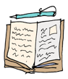
★ Now you’re ready to write your advert! Use your plan to draft it on a separate piece of paper and don’t forget to check the punctuation and flow. Does it sound persuasive enough?

Remember to:
  - read your work and check it flows and makes sense;
  - use your persuasive tools to hook the reader;
  - check your capital letters at the start of sentences, full stops at the end and any exclamation marks and question marks that are needed.

What? Wizards in the news?
Sometimes you can read about what we wizards get up to in special newspapers. Here’s part of a report about a very talented wizard!

The Magic Times
Willing Wizard
Yesterday, budding wizard Mercule Otterham, 10 years old, received the top Wizarding Award for creating the best happiness potion at the World Magic Championships in Greenland.

When? Who? What? Why? Where? openers
My favourite paragraph in a newspaper report is the first one. It's clever because it tells you the whole story without you having to read it all. It uses the 5 W’s above to do this.

Yesterday (when), budding wizard Mercule Otterham (who), 10 years old, received the top Wizarding Award (what) for creating the best happiness potion (why) at the World Magic Championships in Greenland (where).

What else could a wizard receive an award for? Maybe they won a broomstick race or defeated a terrible wizard enemy?

For example: Last week, wizard hero Henry Puttage, 134 years old, received a golden trophy for finally trapping the last dangerous Wizard Troll in his newly invented trap.

★ Now you try using the 5Ws to write a new paragraph about a successful wizard. Remember to tell me when, who, what, why and where. Use the example above to help you.

★ Challenge: Can you write another 5W paragraph about anything else? It could be something true or something you make up. Don’t forget to tell me when, who, what, why and where. Use the example above to help you.

-

-

Crazy quotes
There are usually quotes from witnesses in newspaper reports too. This is when you write down what people say about an event. Here’s what Mercule said about his award:
“This is the best day ever! Receiving this award has made me super proud,” Mercule told the WizardTimes.
★ You need to use speech punctuation when you write a quote in a newspaper, just like you do in your stories. To help you remember where the punctuation goes, use the steps below:
Speech Toolkit
- Open speech with inverted commas: “
- Write what the person is saying
- Signal the end of the speech with punctuation: usually it’s a comma but could be ? or ! (depending on what’s been said).
- Close speech with inverted commas: ”
- Say who said it. e.g. told, reported, exclaimed, informed, stated, said.
- End with a full stop.

Decide on a couple of other things your award winning wizard might say and write them down below. Remember to include how the wizard was feeling.

-

★ HAVE YOU CHECKED YOUR PUNCTUATION? Go back and take a look

Wonderful Wizard Potions
Let’s get creative. There has been a lot of talk in this booklet about magic and potions, so I thought it would be fun to create one. Take a look at what I have put in my potion:
My Wonderful Wizard Potion
Into my potion, I will drop …
Glitter from the wings of the fastest fairy, Slime from the skin of the slowest slug,
The sound of starlight bursting in a black sky, The smell of ocean mist tumbling,
A cloak made of cobwebs, Some shoes made of rain, 1000 blinking eyes,
One dot stolen from the letter i,
A spoonful of words that start with p, A touch of happiness.
©Maria Richards

Write a potion poem
Now have a go at writing your potion poem. What magical things would you drop into your potion? Follow my pattern above and think about the language you can use. Be as inventive as you can.
★ Try to make your items sound exciting by using alliteration – where words start with the same sound e.g. fastest fairy, slowest slug
★ Use precise, powerful verbs that show things in a more exciting way
e.g. bursting, tumbling
★ Choose unusual things to add to your potion. Be as inventive as you can e.g. a cloak made of cobwebs, shoes made of rain
★ Use opposites or pairs to create interest: 1000 and then 1, the fastest and then the slowest, ‘the sound of …’ and then ‘the smell of …’
★ Use a measure of something e.g. a touch of, a pinch of, a handful of, a spoonful of, a list of …

★ Use this planner to help you sort your ideas for your poem. Remember that the items go in pairs. When you have finished, use the tips above to draft your poem on a separate piece of paper.

Underlying structure | New poem ideas
Two items you would use in a potion | 1
from interesting things.
Use the pattern: … from the … of | 2
e.g. Glitter from the wings of…
The sound of something
The smell of something
Two pieces of unusual clothing | 1  2
A large number of something e.g.
1000 blinking eyes
A small number of something:
One dot
Two measurements of something e.g | 1
A spoonful of words
 | 2
Optional: Any other ideas you want to add

Let’s Publish!
Once you have checked your poem, publish it by writing it inside this bottle. outline here.
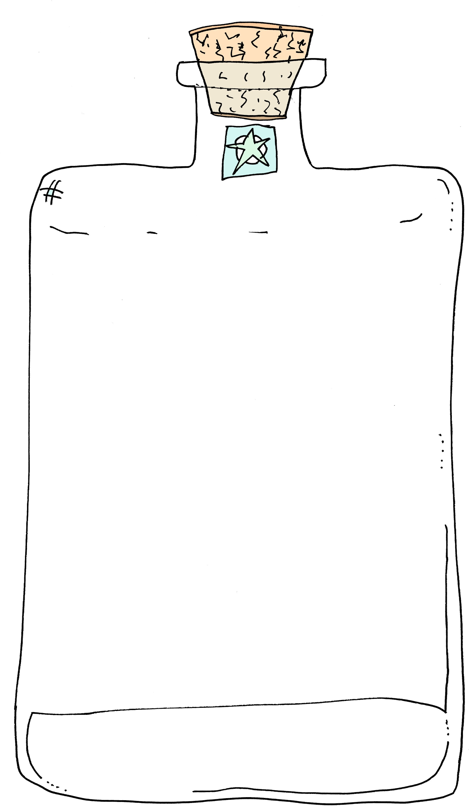

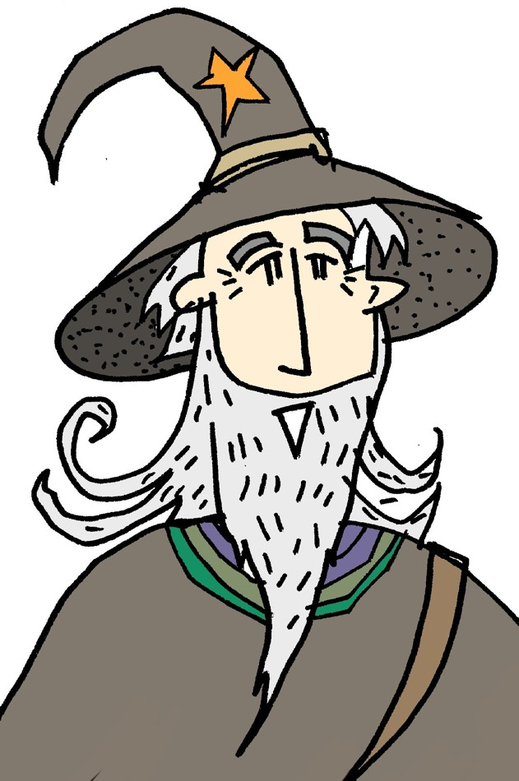
Why not try some Wizard Science?

★ I asked my friend Dr Jo, from the School of Science, if there were any science experiments that you could try out at home, that were a little like potions. She has come up with four great ones for you to try.

Make sure you take care and always do these with an adult. You may have to add things to your shopping list for some of the experiments.

If you try some, you can write about what you did using this planner to help you:

Underlying structure | Sentence starters to help with writing
State what the experiment was about. | The experiment I tried was …
Items used. | For the experiment I needed …
What was done.  (Use first, next, after that, finally to structure this bit) | To do the experiment, first I … Next I …
What happened. What was seen. | When I did the experiment I …

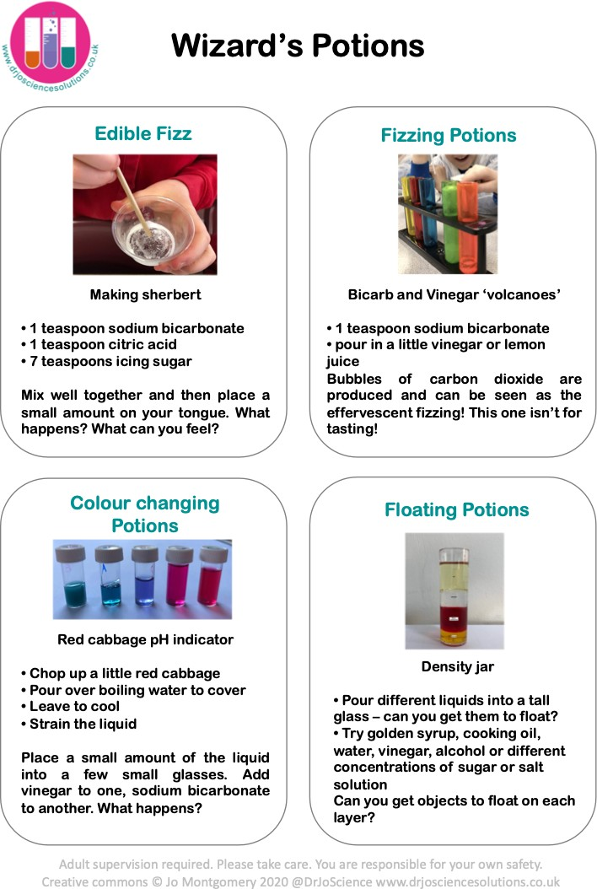

You can read lots more about these experiments here:
https://cutt.ly/syOqV9H

Invention
Well Done! We’ve reached the end of our booklet.

If you want to do more writing, you could try some INVENTING by using what you have learnt at school already. Here are a few ideas:

★ Write a set of instructions for how to make a potion of your choice. It could be a happiness potion, a potion that helps you to speak a new language, a potion that creates an instant party or …

★ Write a story that has a wizard as the main character. Use a story pattern that you know or perhaps you’d like to try this simple warning story structure:

Wizard character is warned not to do something.

Wizard character does the thing they are warned not to do. Something goes wrong and the wizard is in trouble.
The wizard has to be rescued.

The wizard is punished for not listening to the warning.
★ Write an information text about wizards. Tell the reader what they are, where they live, what they do, what their favourite things are and end on some fascinating facts.

★ Design and write an invitation, inviting wizards to an awards ceremony.

Some final Wonderful Wizard things to do:
Make wizard cupcakes
A great recipe from Cadbury’s here:
https://www.cadburykitchen.com.au/recipes/view/chocolate-wizard-hat-cup-cakes/36/

Learn some magic tricks
Check with an adult that it’s ok to do this before you start!
https://www.thesprucecrafts.com/magic-tricks-for-beginners-and-kids-2267083

Time for me to get back to teaching Wizards. I hope you’ve had fun and enjoyed your writing! Why not rate your journey with me. Put a star along the scale to show how much you enjoyed it:

This workbook has helped me learn …

My favourite parts of the booklet were …

Answers

Target word | Synonyms
budding | promising
calibre | talents
multitude | many
unrivalled | supreme
manoeuvres | movements
disguise | camouflage
renowned | famous
tutelage | teaching

Wizard Comprehension!
How can you become the finest wizard in the land? You can go to the School of Wizardry.
Does budding mean you are becoming good at something or you are old? It means becoming good at something.
Anyone can go to the School of Wizardry. TRUE or FALSE? FALSE. Only budding wizards can go.

Which phrase in the text means the same as latest? Up-to-the-minute

Which two lessons will make you better at casting spells?
The ‘preparing magic spells and inventing potions’ and the ‘perfection in wand handling skills’.

Find and copy four words that show you this school is great and make you really want to go.
Any weasel words e.g.
Remarkable/outstanding/unrivalled/exceptional/highly qualified/stunning/up- to-the-minute/beautifully/most divine

Why might the school have been rated ‘Super-terrific’?
Any plausible answer like: The school is so good at teaching. The school has brilliant facilities. The school is very modern and offers great lessons.

Why might you be the envy of your friends if you go to this school?
Any plausible answer like: You will get the best exam results. You get to go to a fantastic school. You have a choice of amazing lessons. You have the best school dinners. The school is famous. The school is the best in the world. The teaching is wonderful.

Take a look at the passage below and underline all the bossy verbs.
Join our happy crew of wizard teachers and fly into a wonderful career. Watch children grow under your expert teaching. Enjoy all the amazing resources our school has to offer. Listen to the happy chatter of your students as they engage in your marvellous lessons. Be amazing! Be the best! Be with us!

