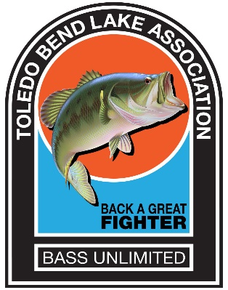



**BASS UNLIMITED**

**Toledo Bend Lake Association**

**P.O. Box 1031, Many, Louisiana 71449**

[www.toledobendlakeassociation.com](http://www.toledobendlakeassociation.com)

***‘Dedicated to Serving Toledo Bend Lake’***

DATE

Addressee

Address

City/State/Zip

RE: Toledo Bend Lake Association Bass Unlimited Banquet/Fundraiser

Dear Sponsor,

The Toledo Bend Lake Association (TBLA) is celebrating its 15th Annual Bass Unlimited – Back A Great Fighter banquet and fundraiser (BU) on Friday, April 21, 2017. This premier event is held at the Cypress Bend Park Pavilion, located on the shores of Toledo Bend Lake. For more than forty years the TBLA, a non-profit 501(c)(3) organization, has dedicated the BU funds to projects that meet our mission statement:

“Toledo Bend Lake Association is dedicated to maintaining and/or improving the quality of Toledo Bend Lake and the amenities surrounding it. TBLA shall provide financial and/or volunteer assistance to promote stewarding the environment and aquatic integrity of the Lake to perpetuate it as a world class fishery and recreational resource area.”

In both 2015 and 2016 the Lake was selected as the #1 B.A.S.S. fishing lake in the United States, partly due to the projects funded and completed by the TBLA. Without the support of individuals and organizations like you, these projects would never get off the ground.

Volunteer members of the TBLA are helping to secure donations and/or items for the BU raffles/auctions held during the banquet. We ask that you partner with us by donating __________________, or whatever level of donation that you feel is appropriate. In return, your business name will be shown as a sponsor in our banquet program and auction guide. Securing all donations by April 1, 2017, will allow us adequate time for media coverage, as well as time to meet all printing deadlines in order to publicize your contribution. Our Federal Tax ID number is 30-0101272. Donation receipts are available upon request.

Your donation will help to contribute to another successful BU event, and to help us to make Toledo Bend Lake a great place to visit and enjoy, as well as a great place to retire. For information about the TBLA’s history, projects and accomplishments, visit our website at [www.toledobendlakeassociation.com](http://www.toledobendlakeassociation.com). Should you need additional information, please contact YOUR NAME at EMAIL ADDRESS, PHONE NUMBER.

Thank you for your help in supporting the 15th annual Bass Unlimited Banquet – Back A Great Fighter fundraiser.

Deborah Pennington

Bass Unlimited – Back A Great Fighter Coordinator